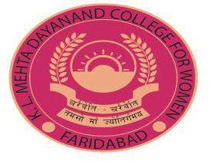

5.1.3 Capacity building and skills enhancement initiatives taken by the institution include the
Following
- Soft skills, 2.Life skills (Yoga, physical fitness, health and Hygiene), 3. ICT/computing skills,4. Language and communication skills

INDEX

SUPPORTING DOCUMENTS FOR 5.1.3
S.no. Proof of Documents Page No.
- Soft Skills Courses 3-45
  - E-Karma
  - Cut and Stitch
  - Saundarya Beauty Training
  - Fashion Designing
  - ECCE
- ICT/Computing Skills Courses 46-50
  - Accounting on Computer

- Life Skills Enhancement Initatives 51-71
  - Yoga
  - Taekwondo
  - Health and Hygiene



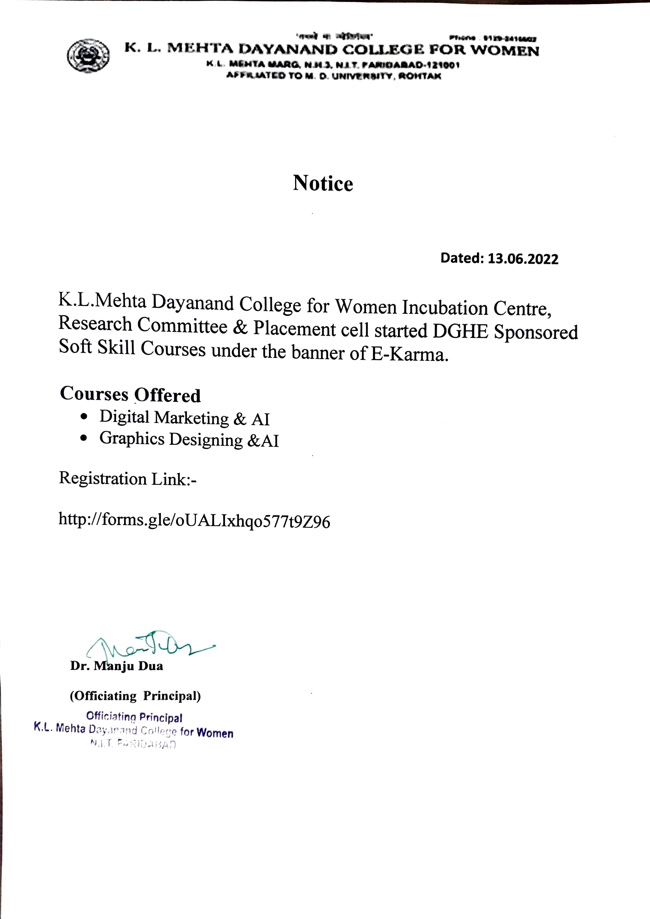

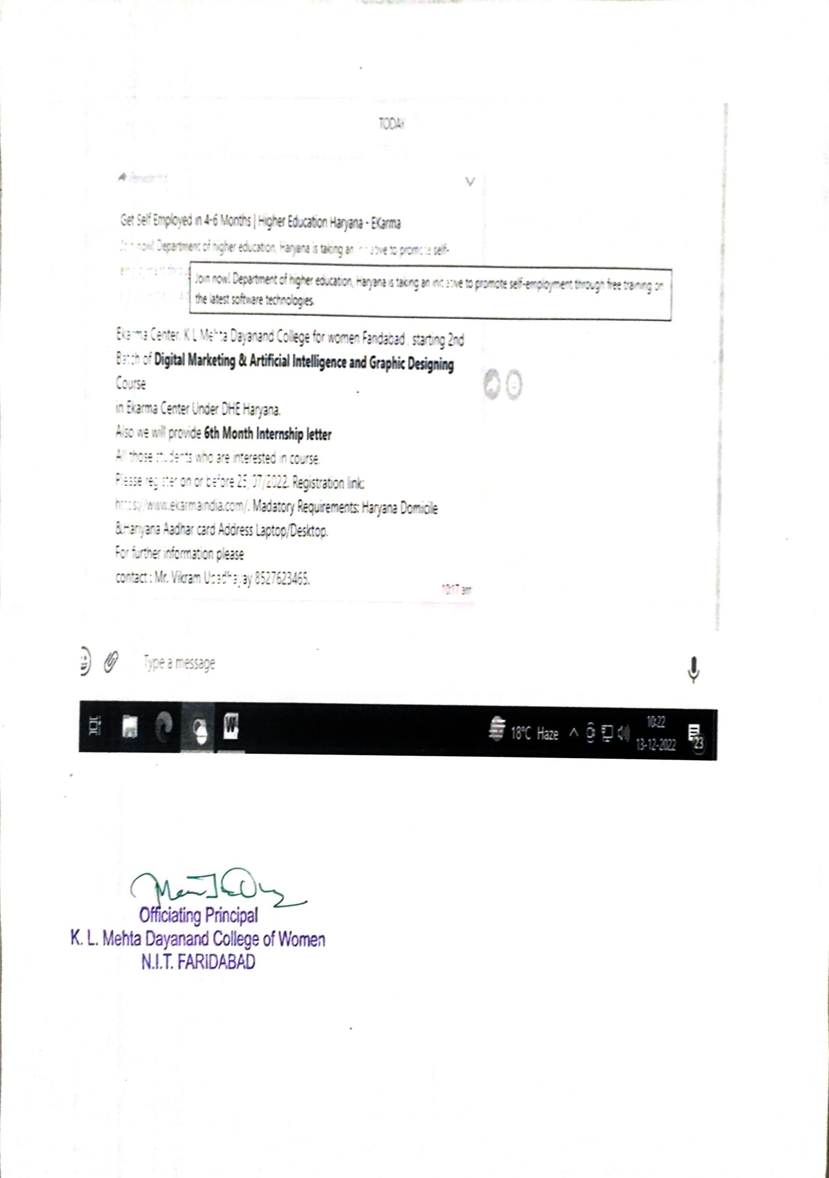

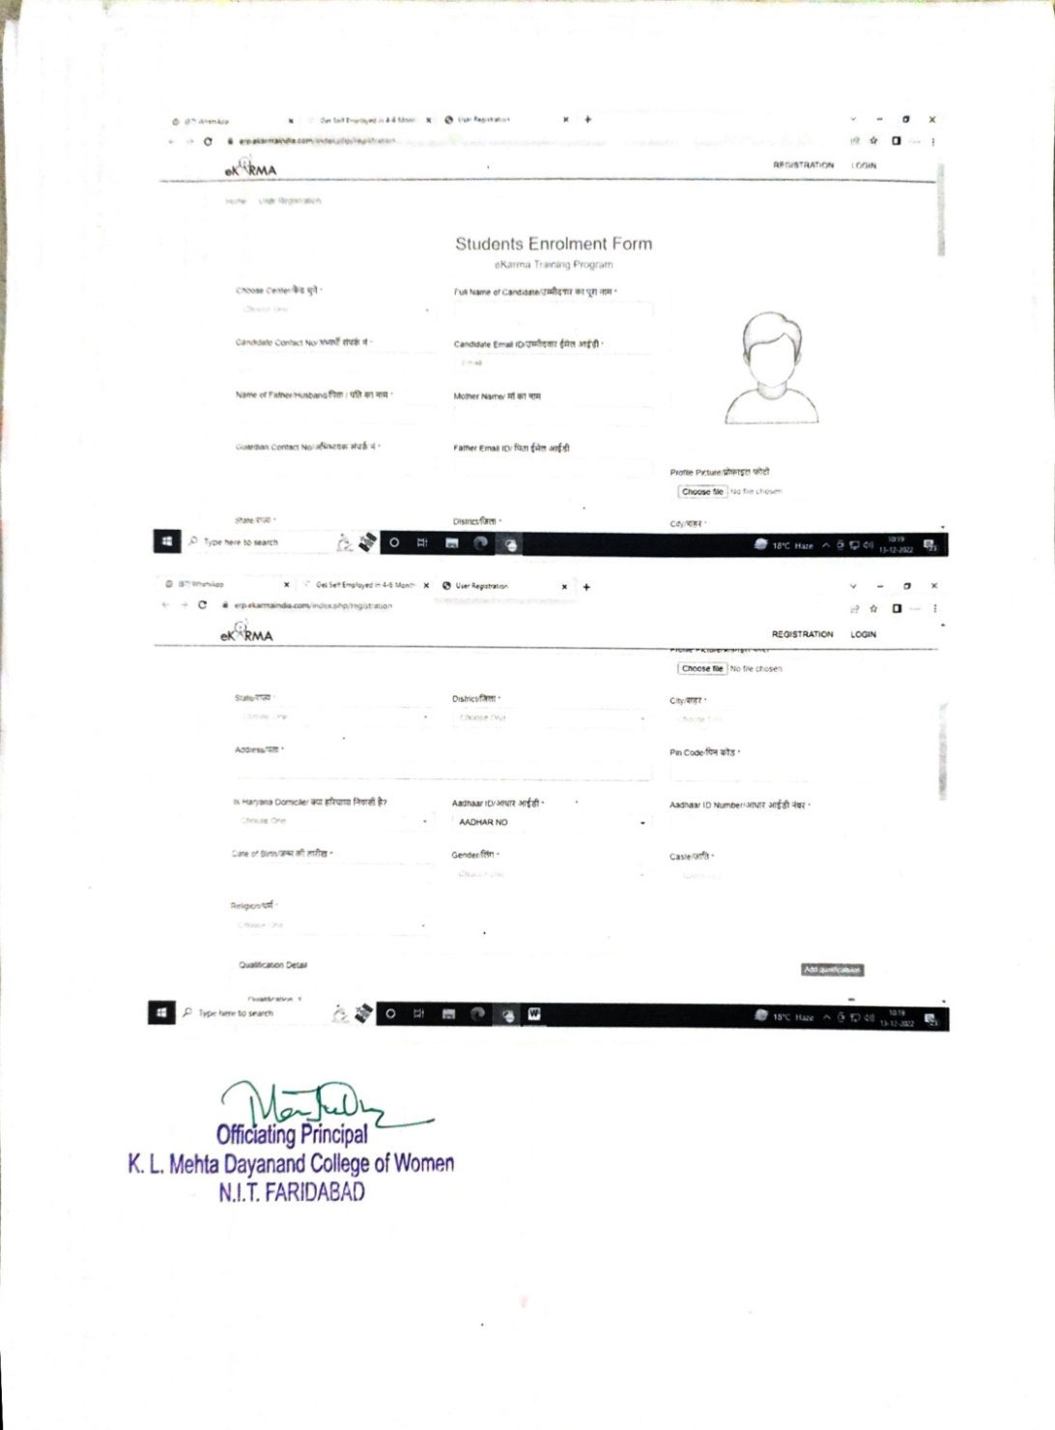

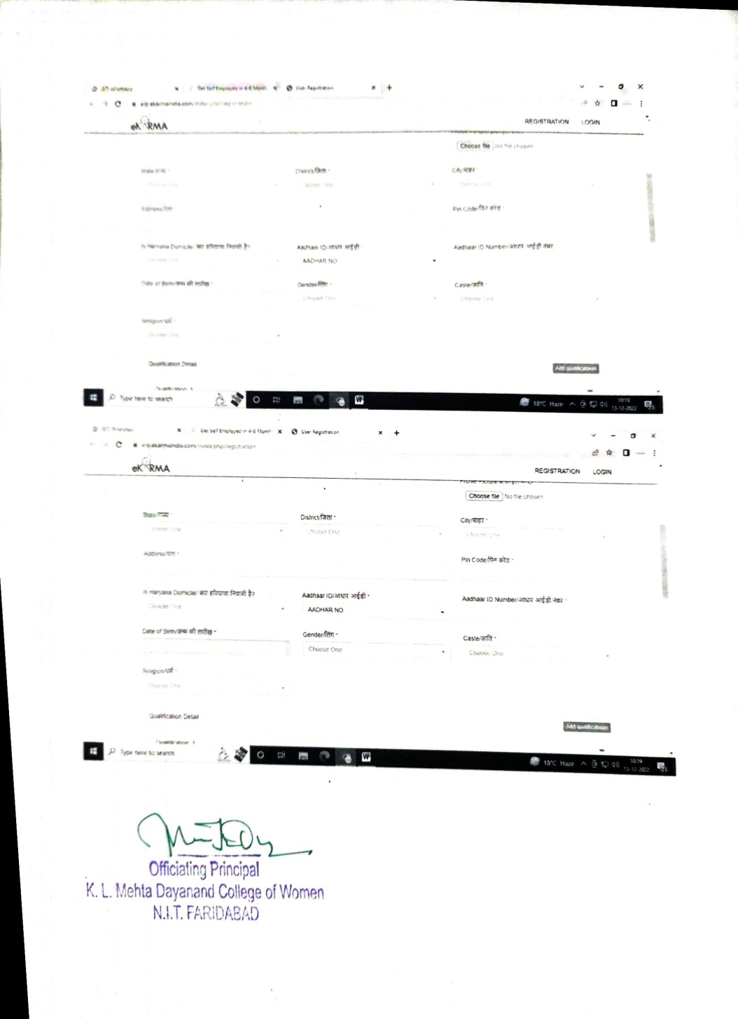

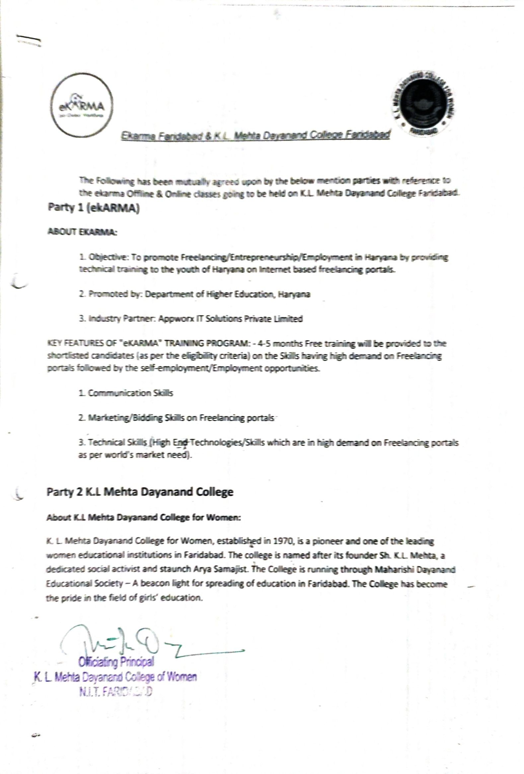

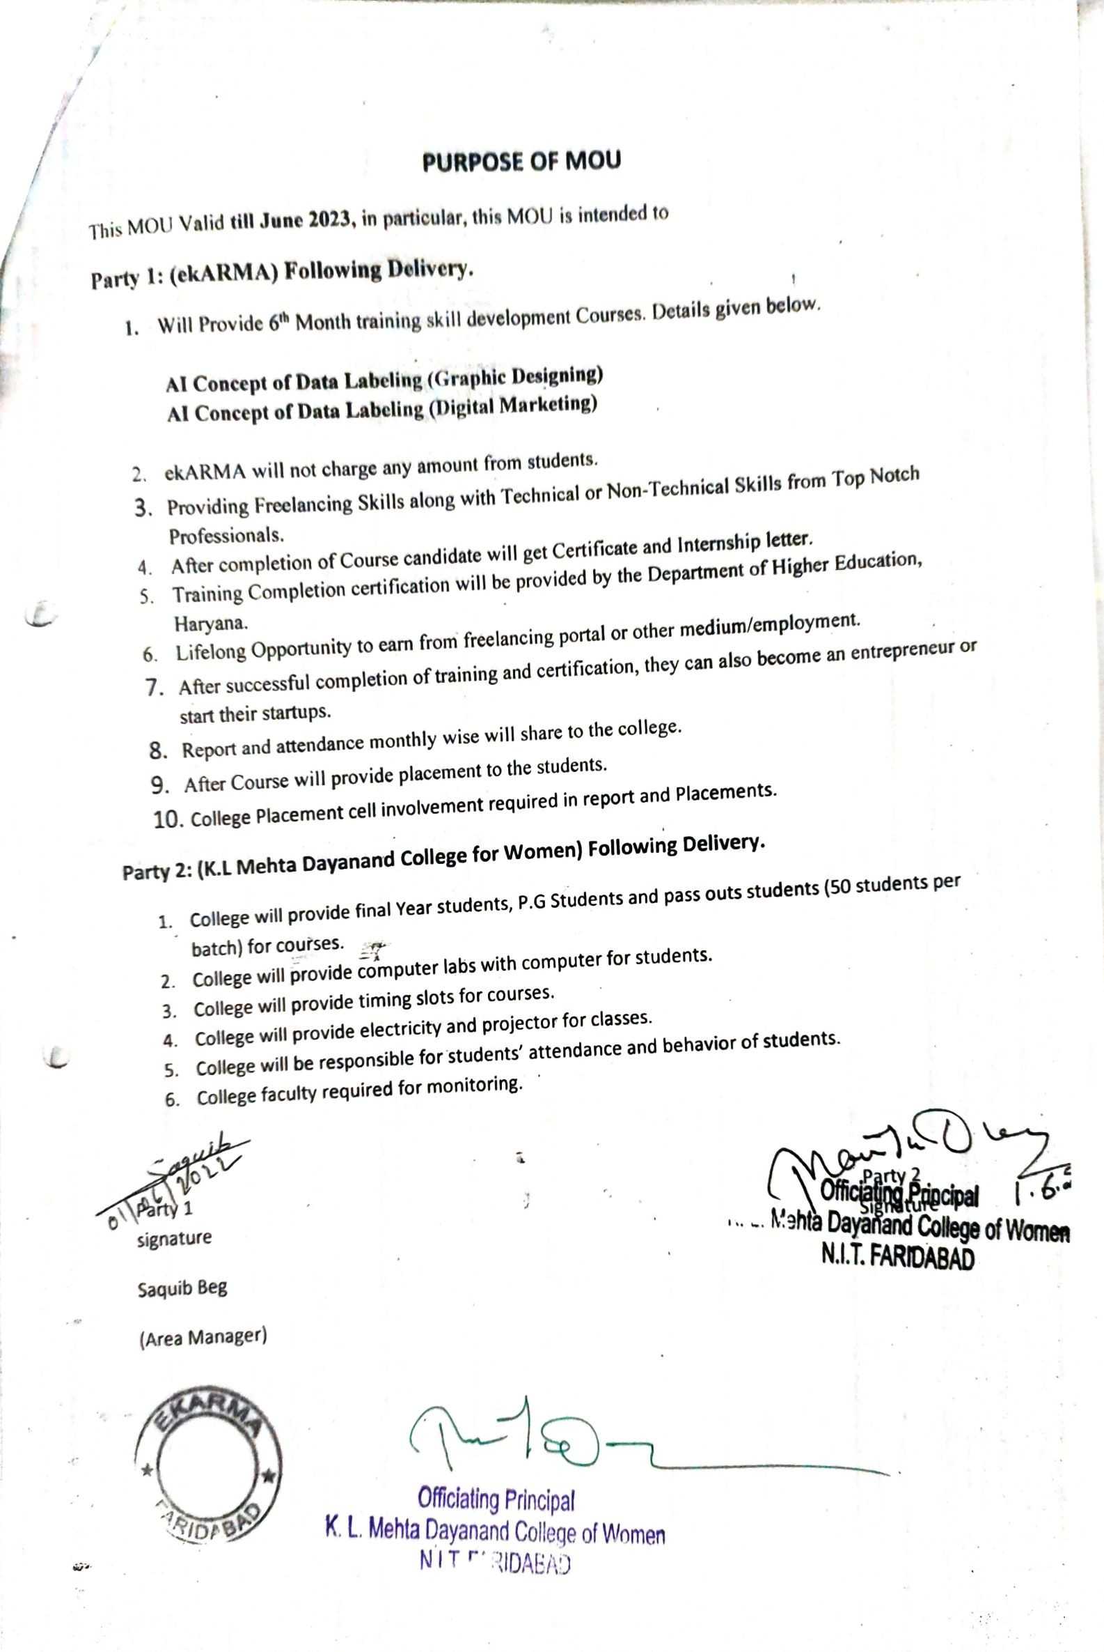

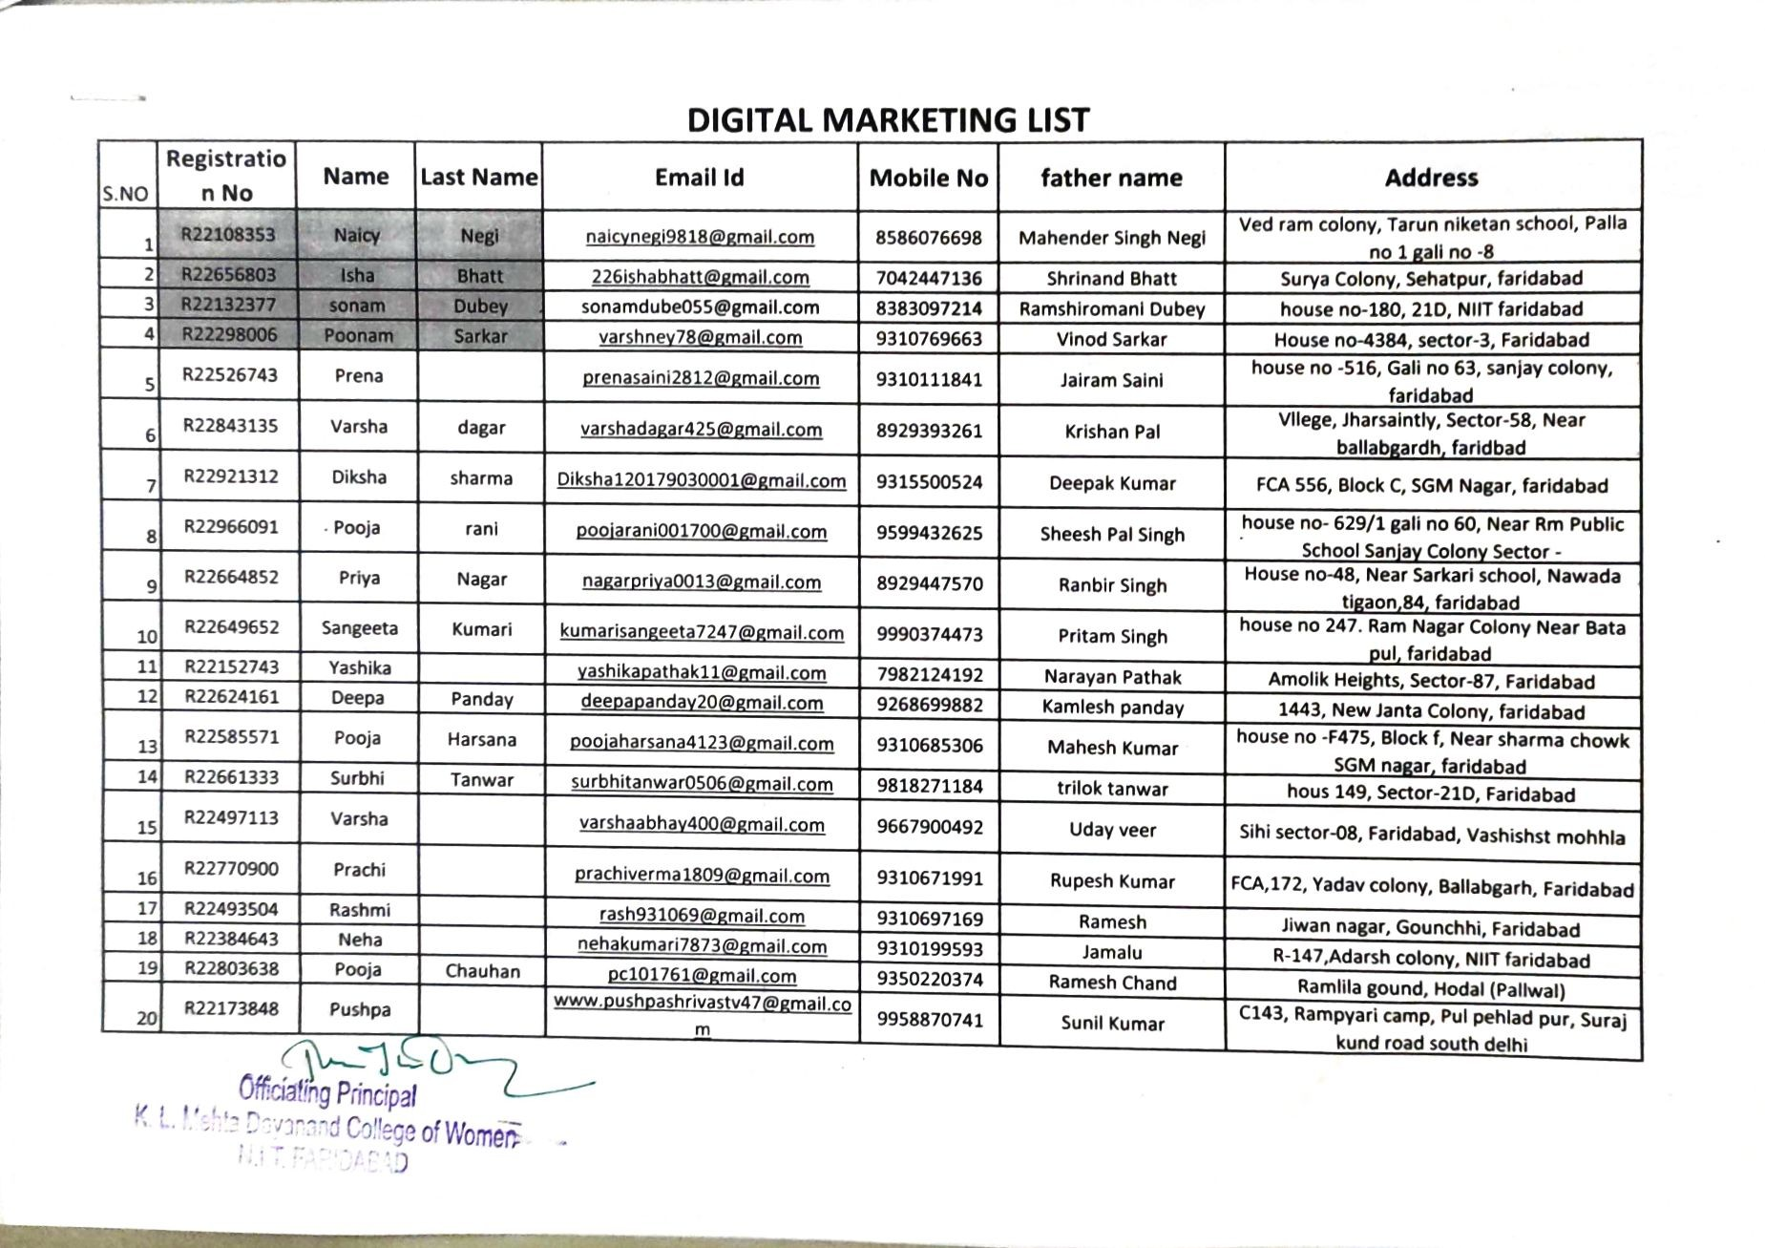
Digital Marketing and Graphic Designing Enrolled Students List (2 Batches)

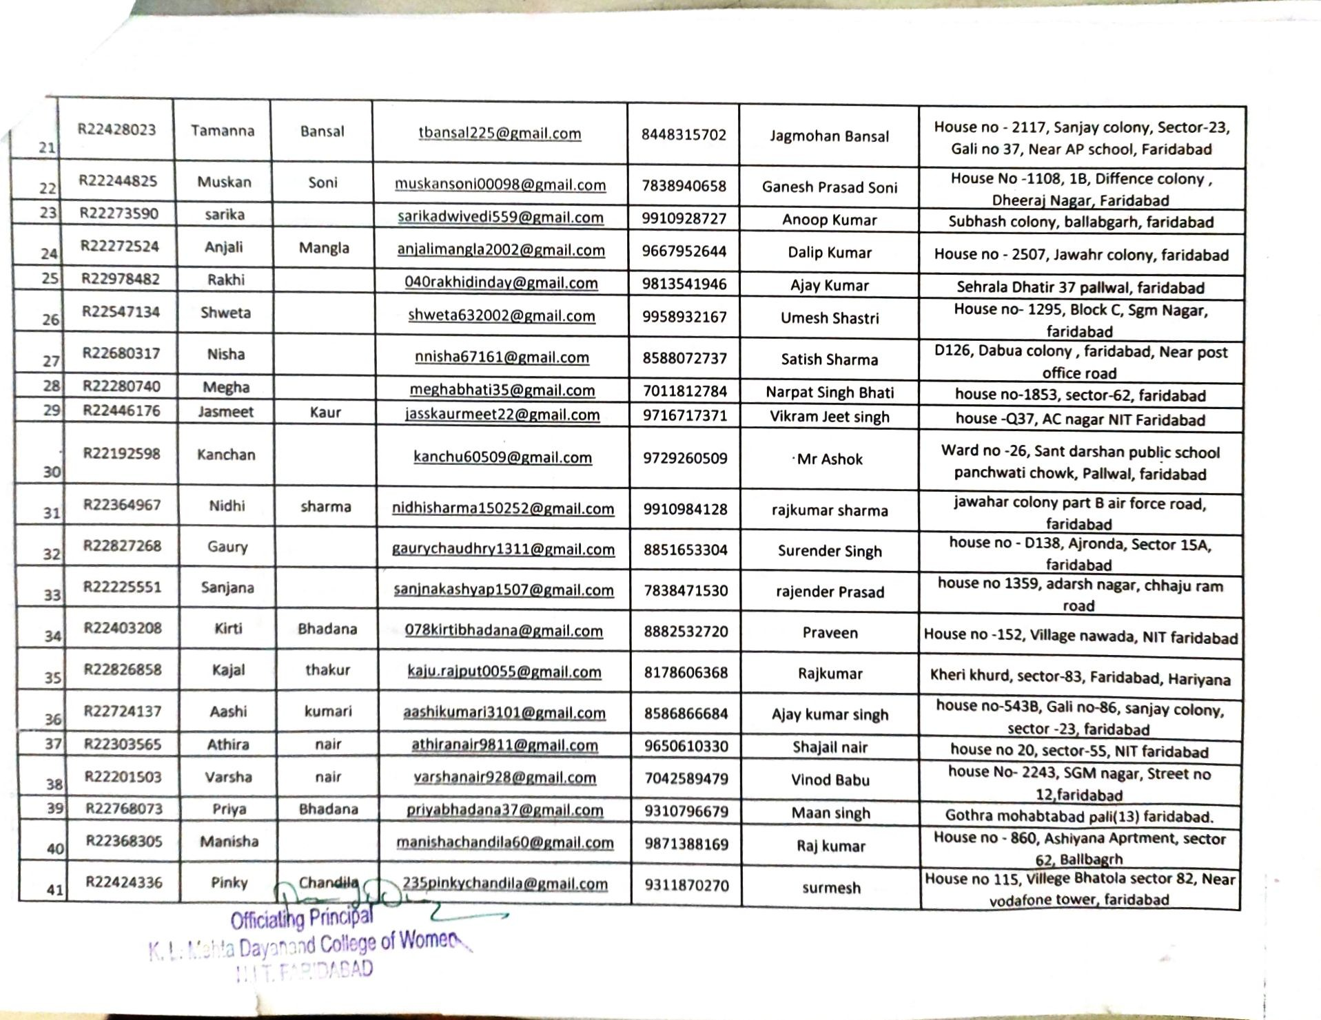

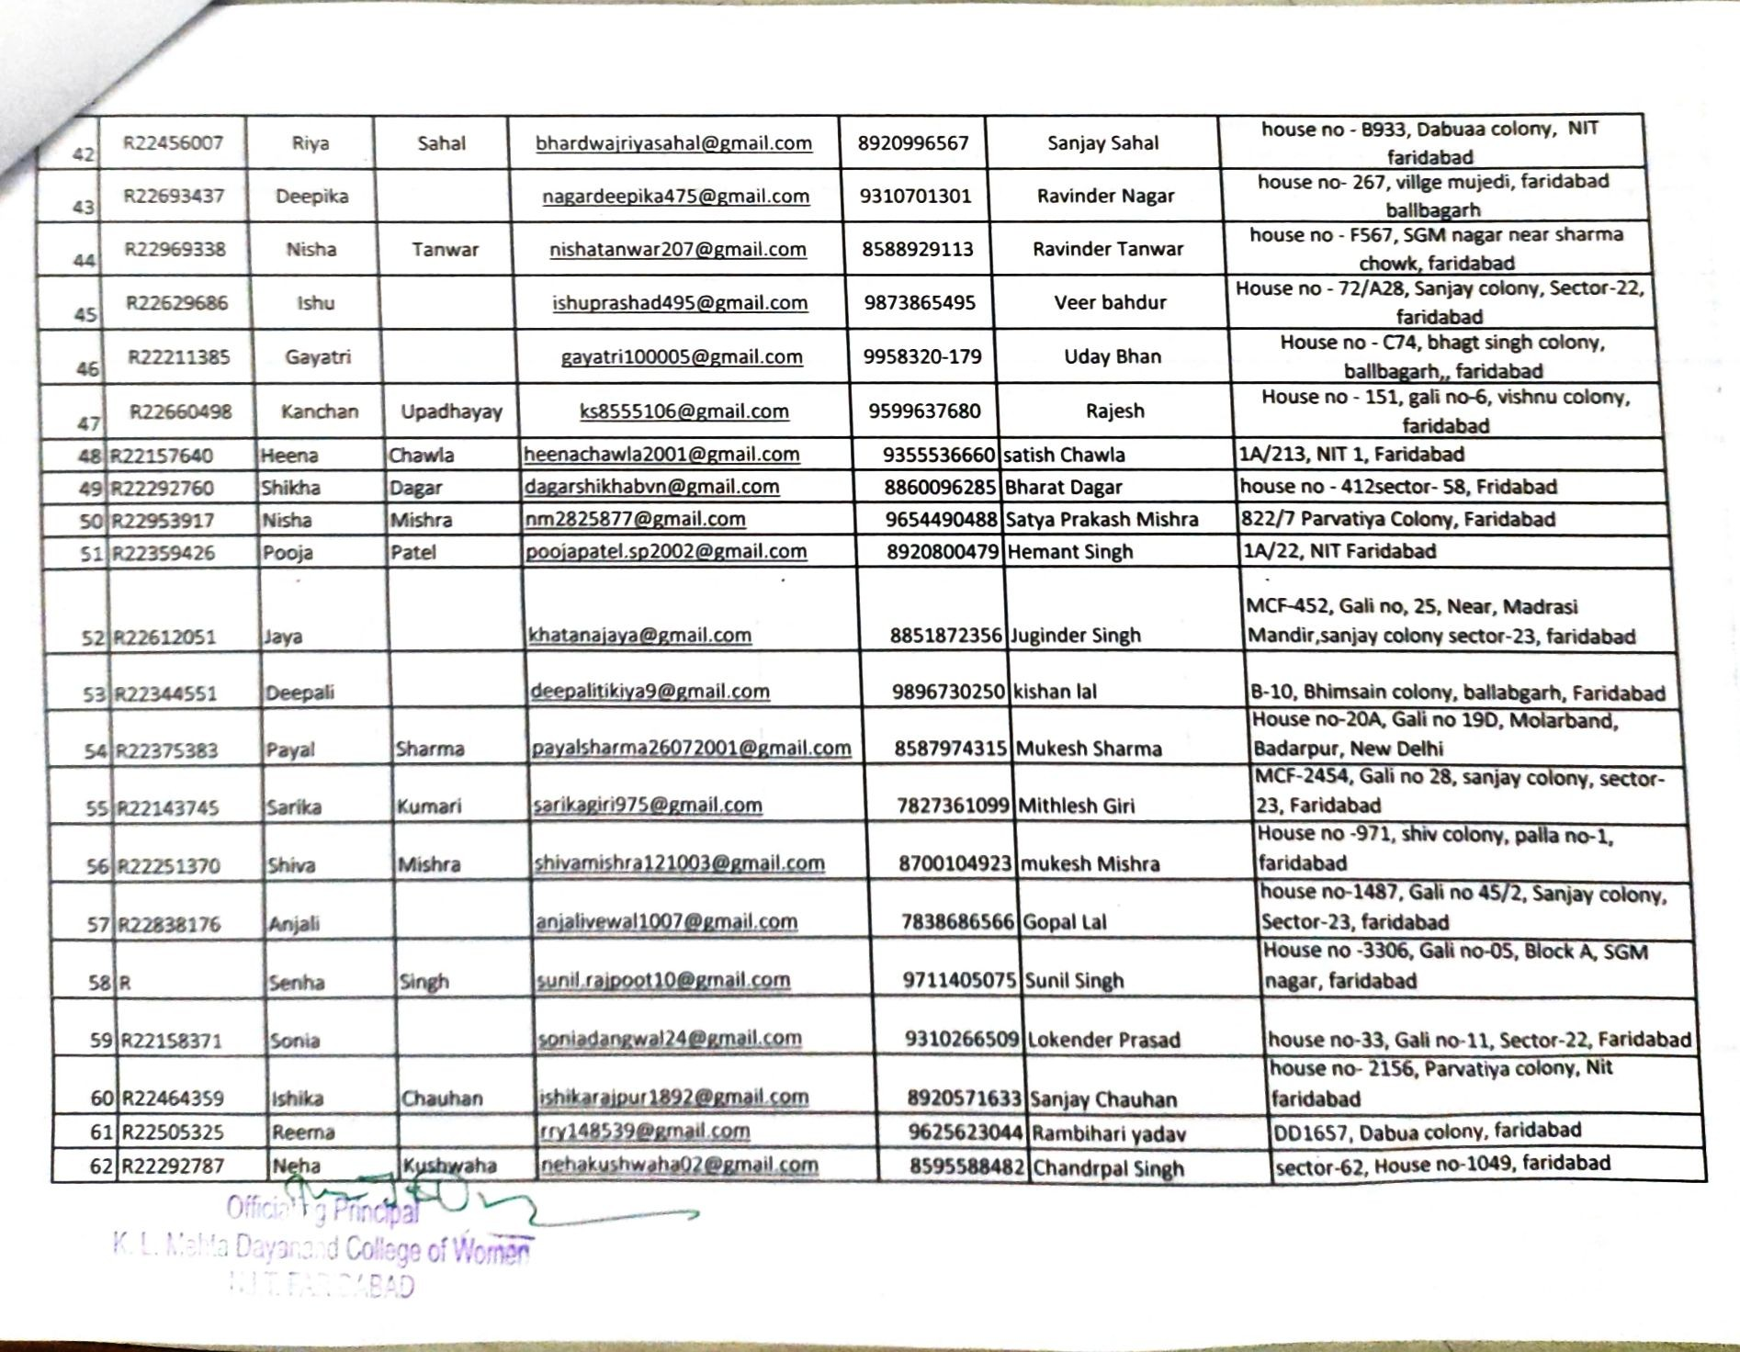

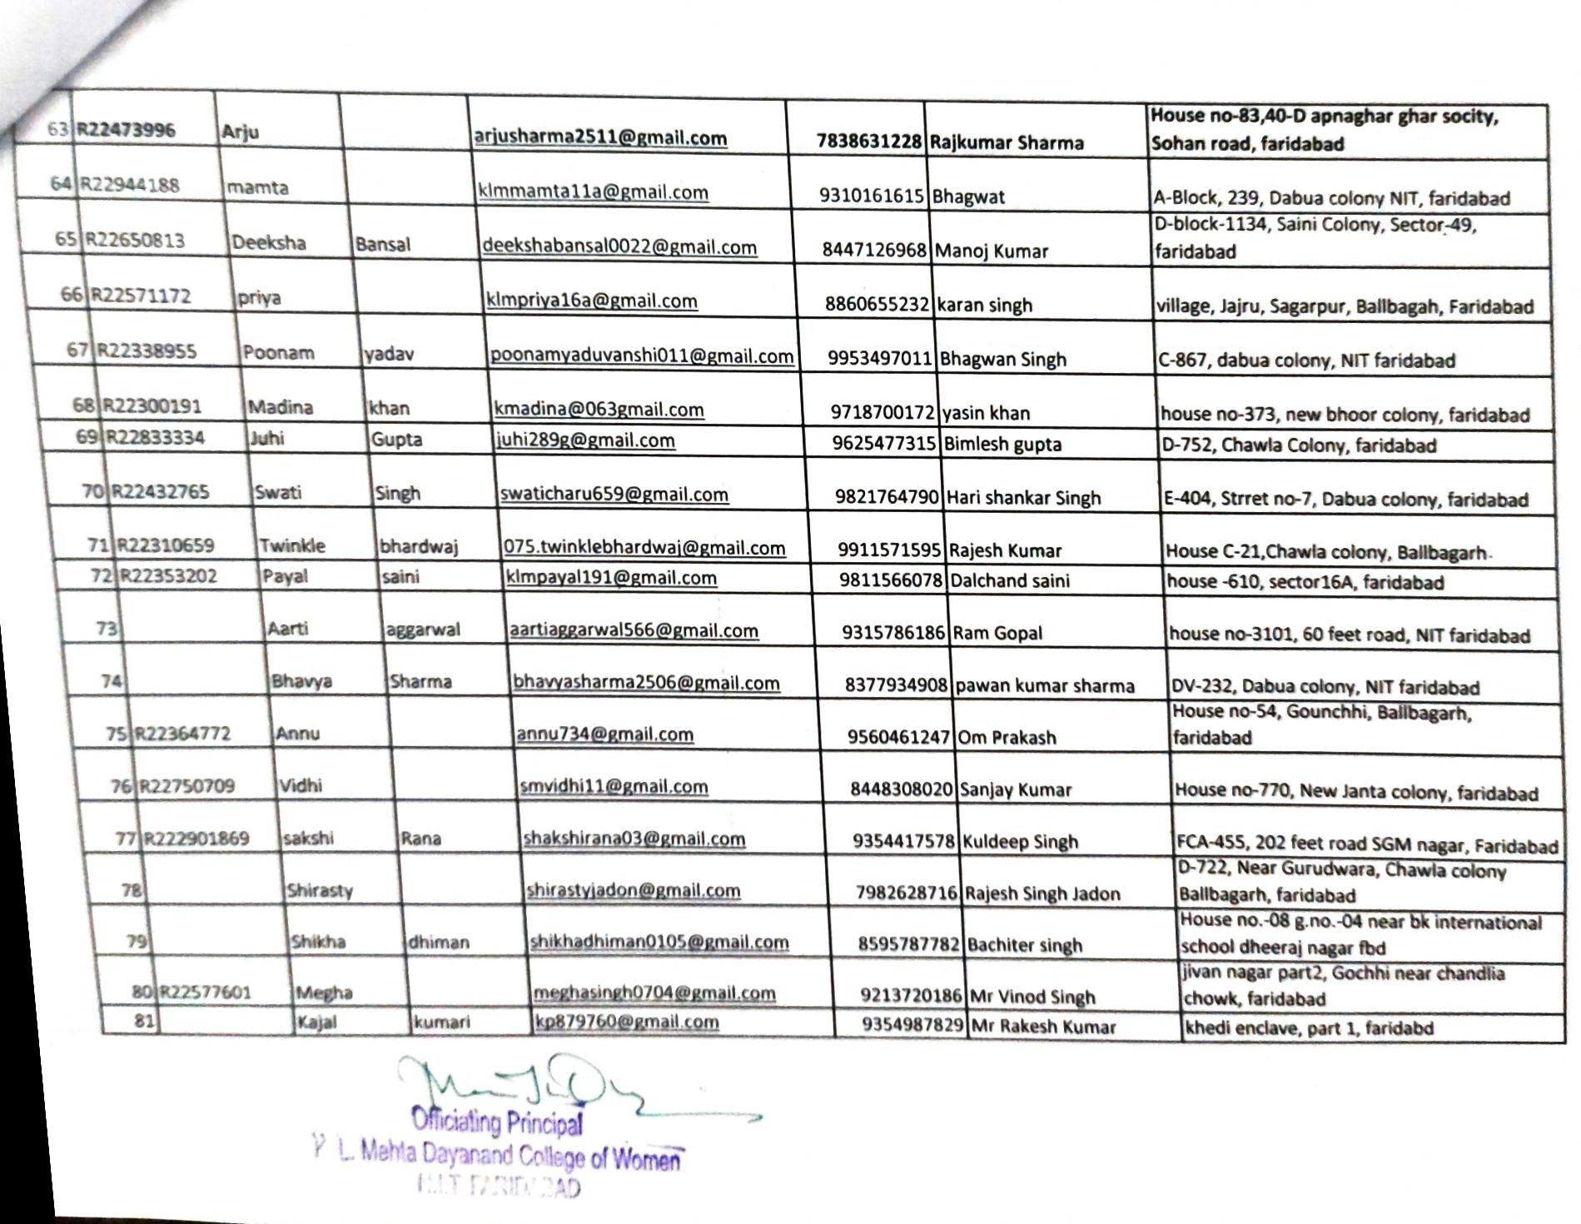

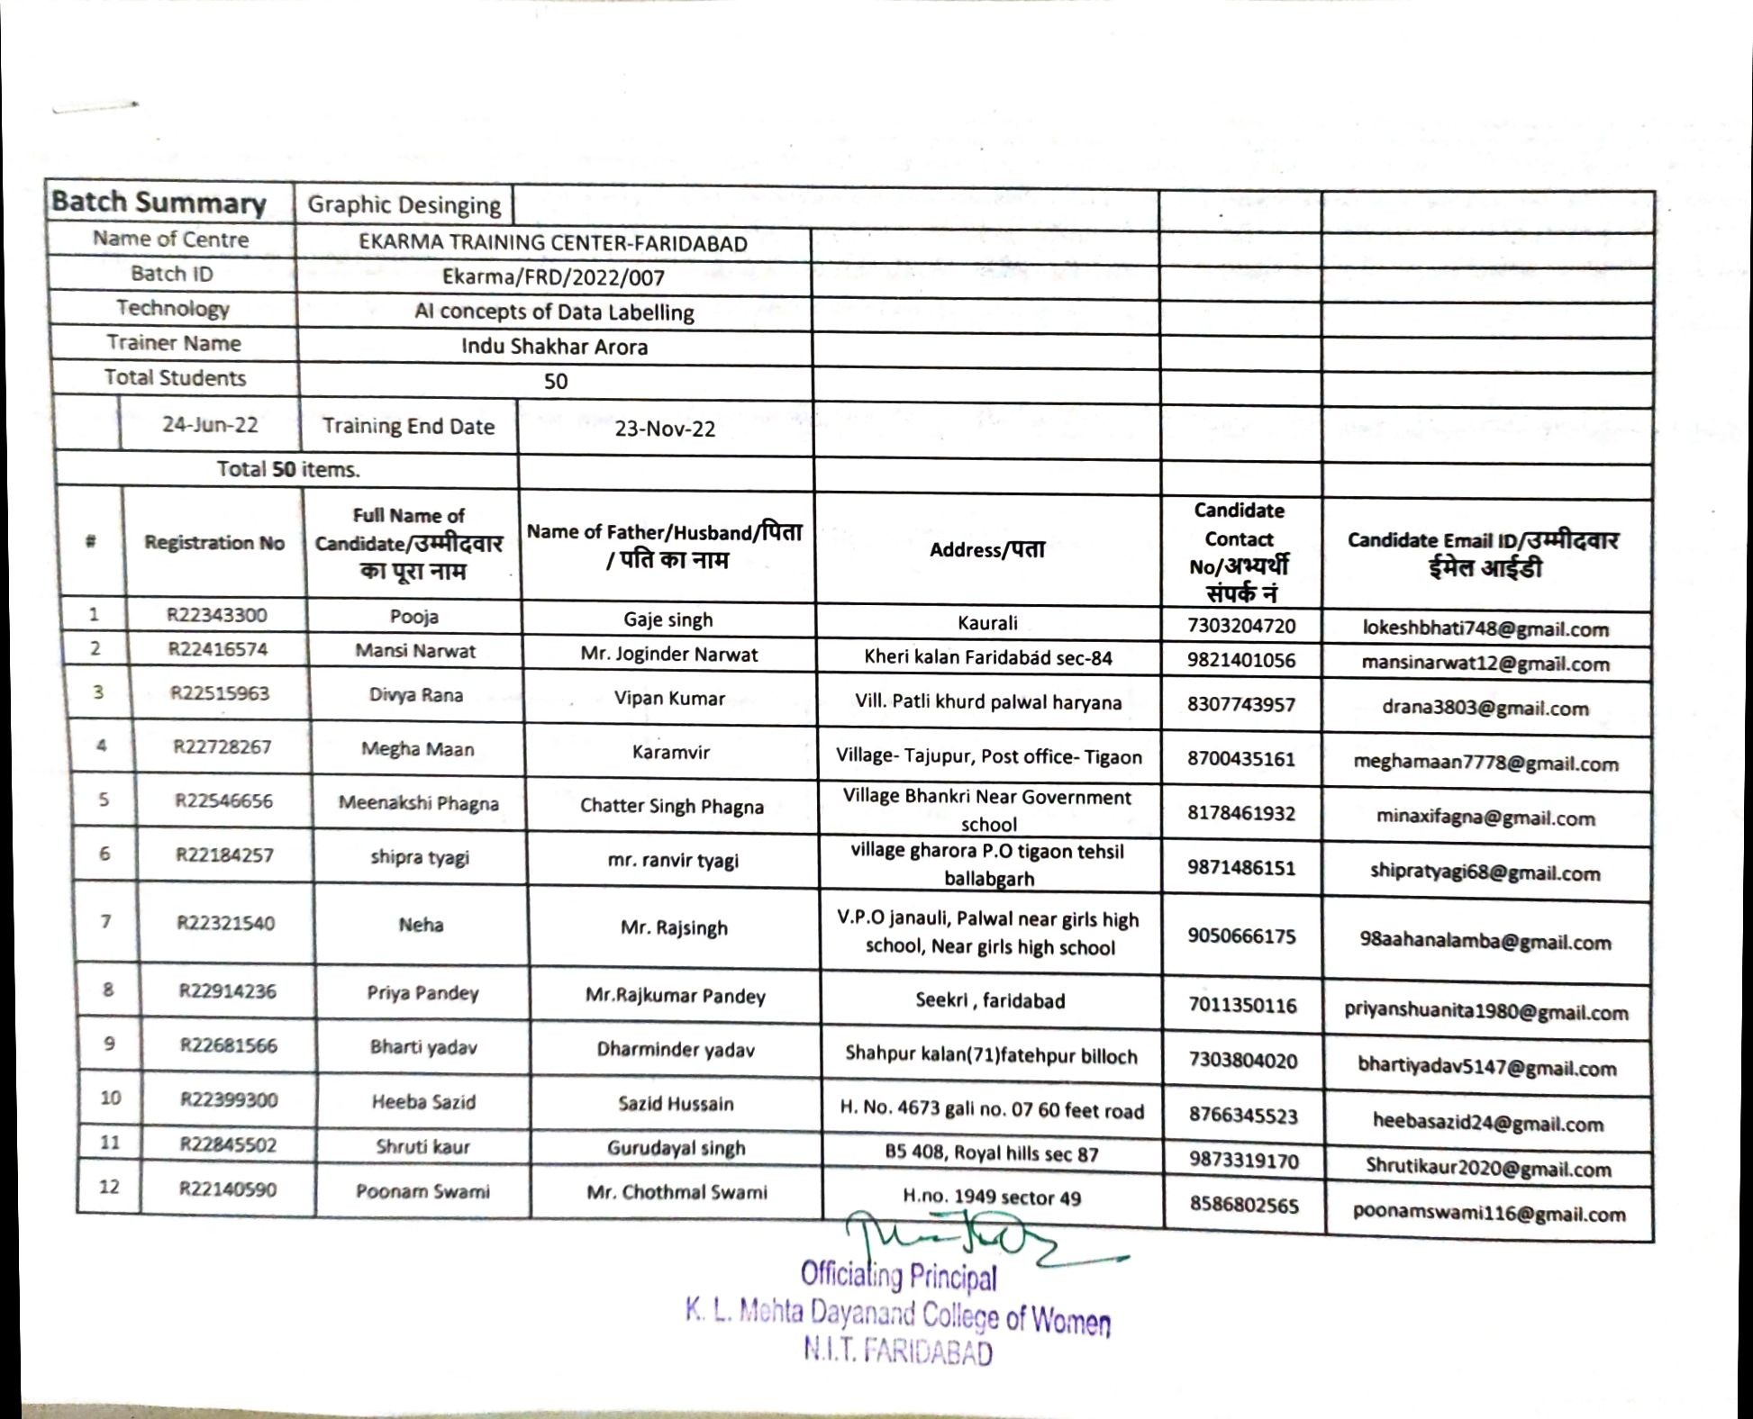

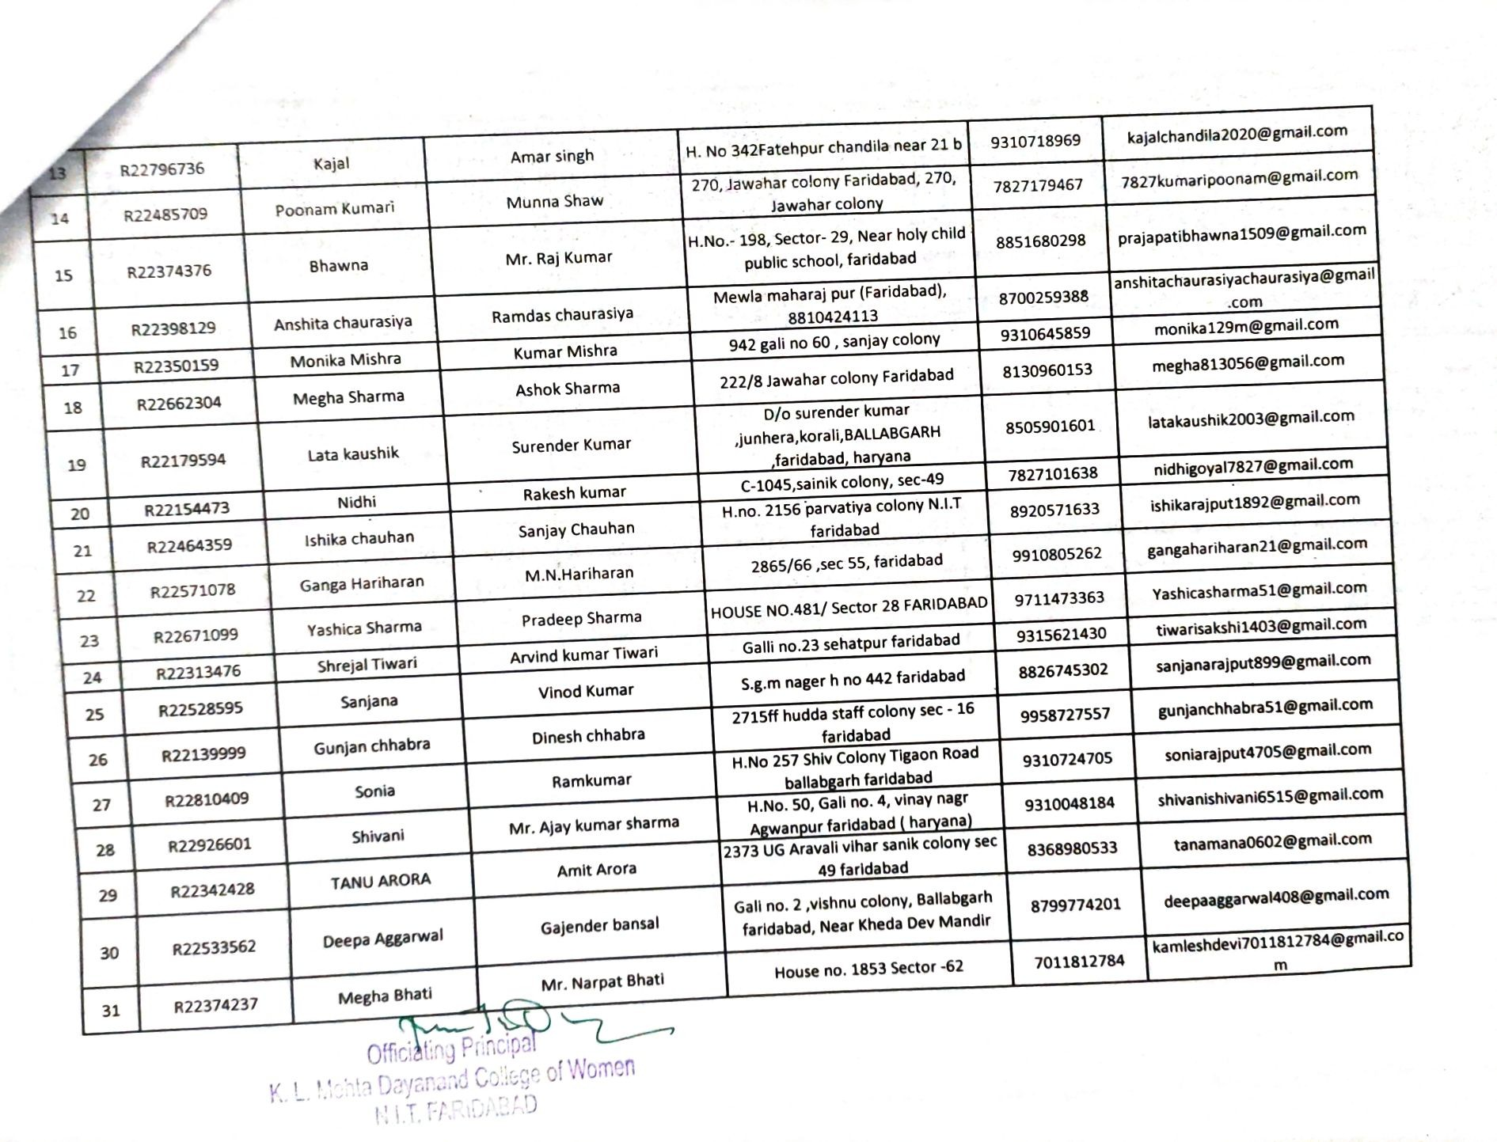

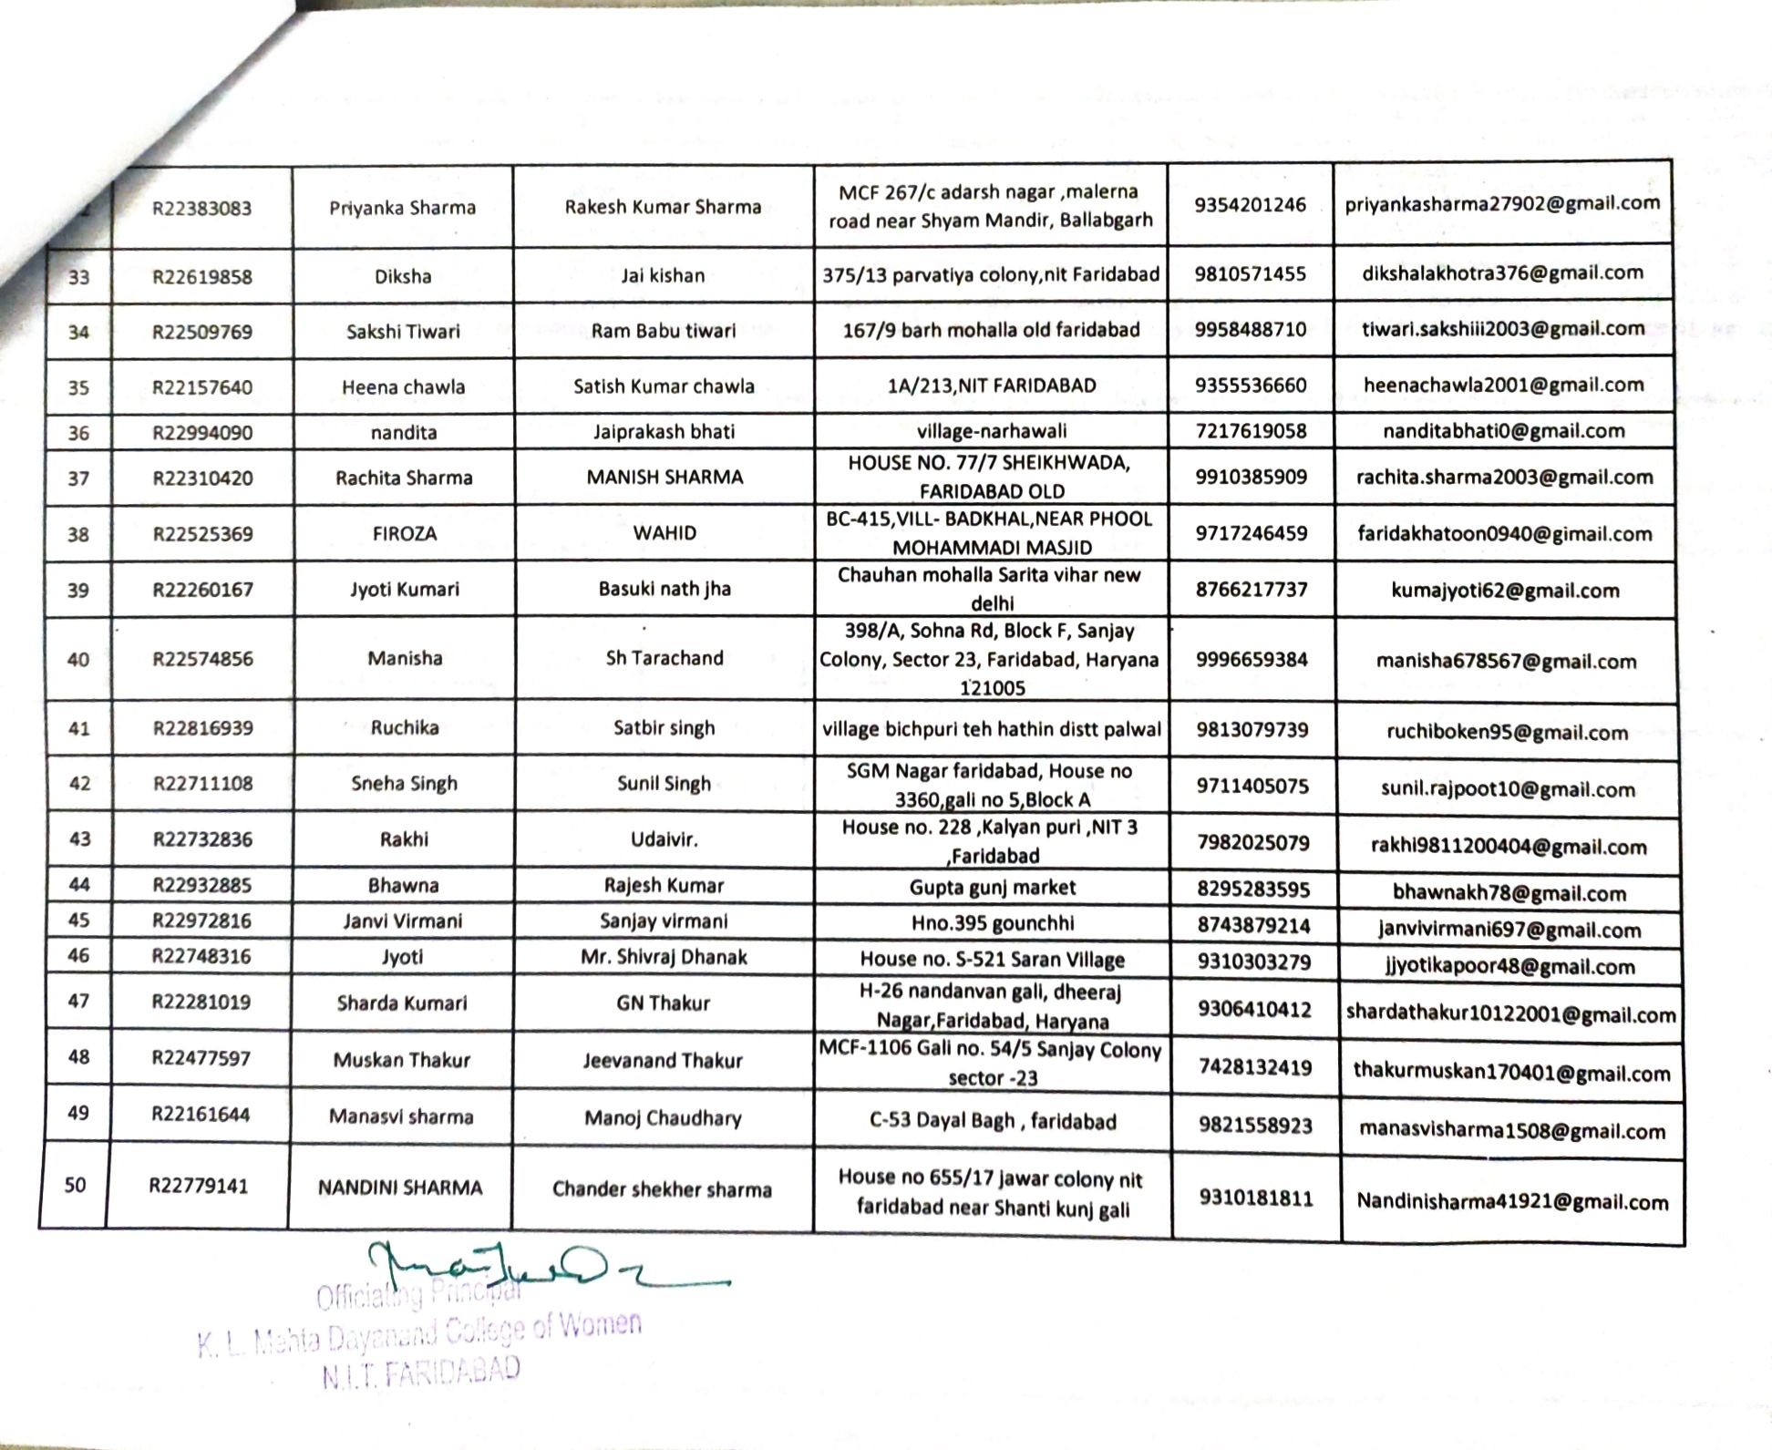

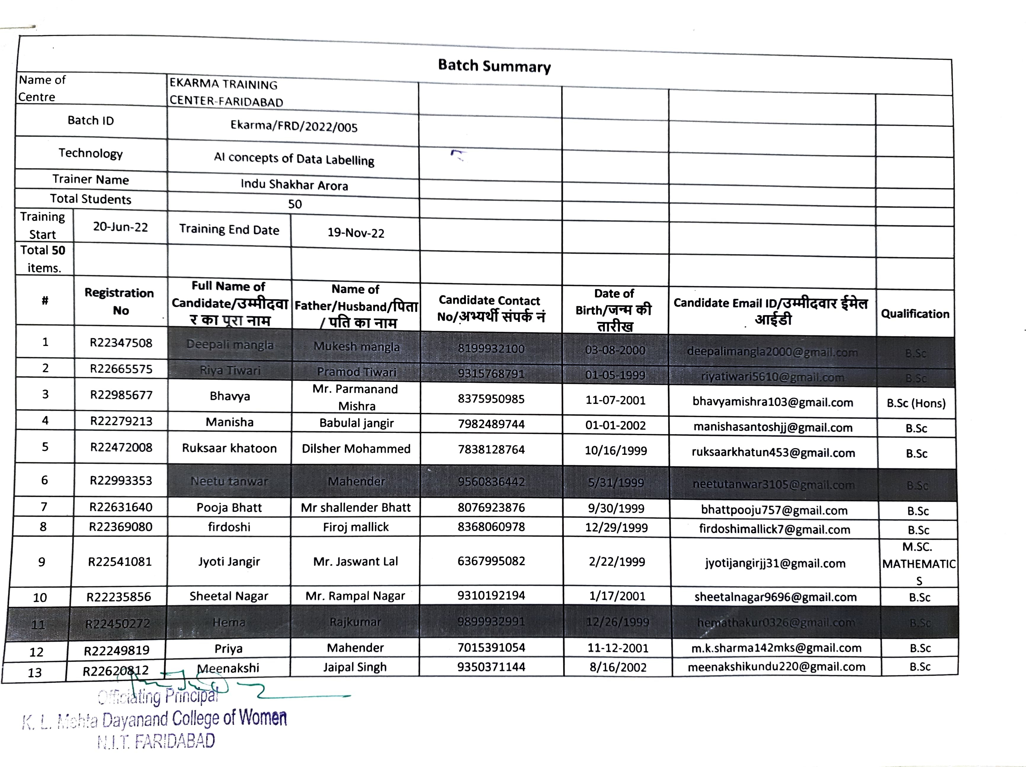

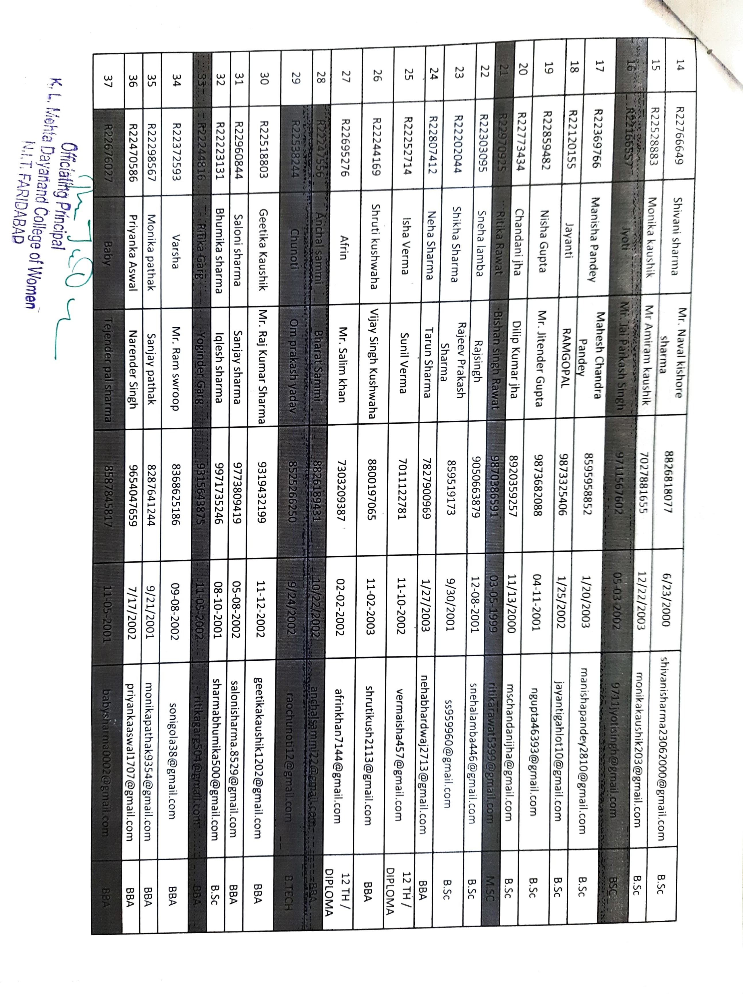

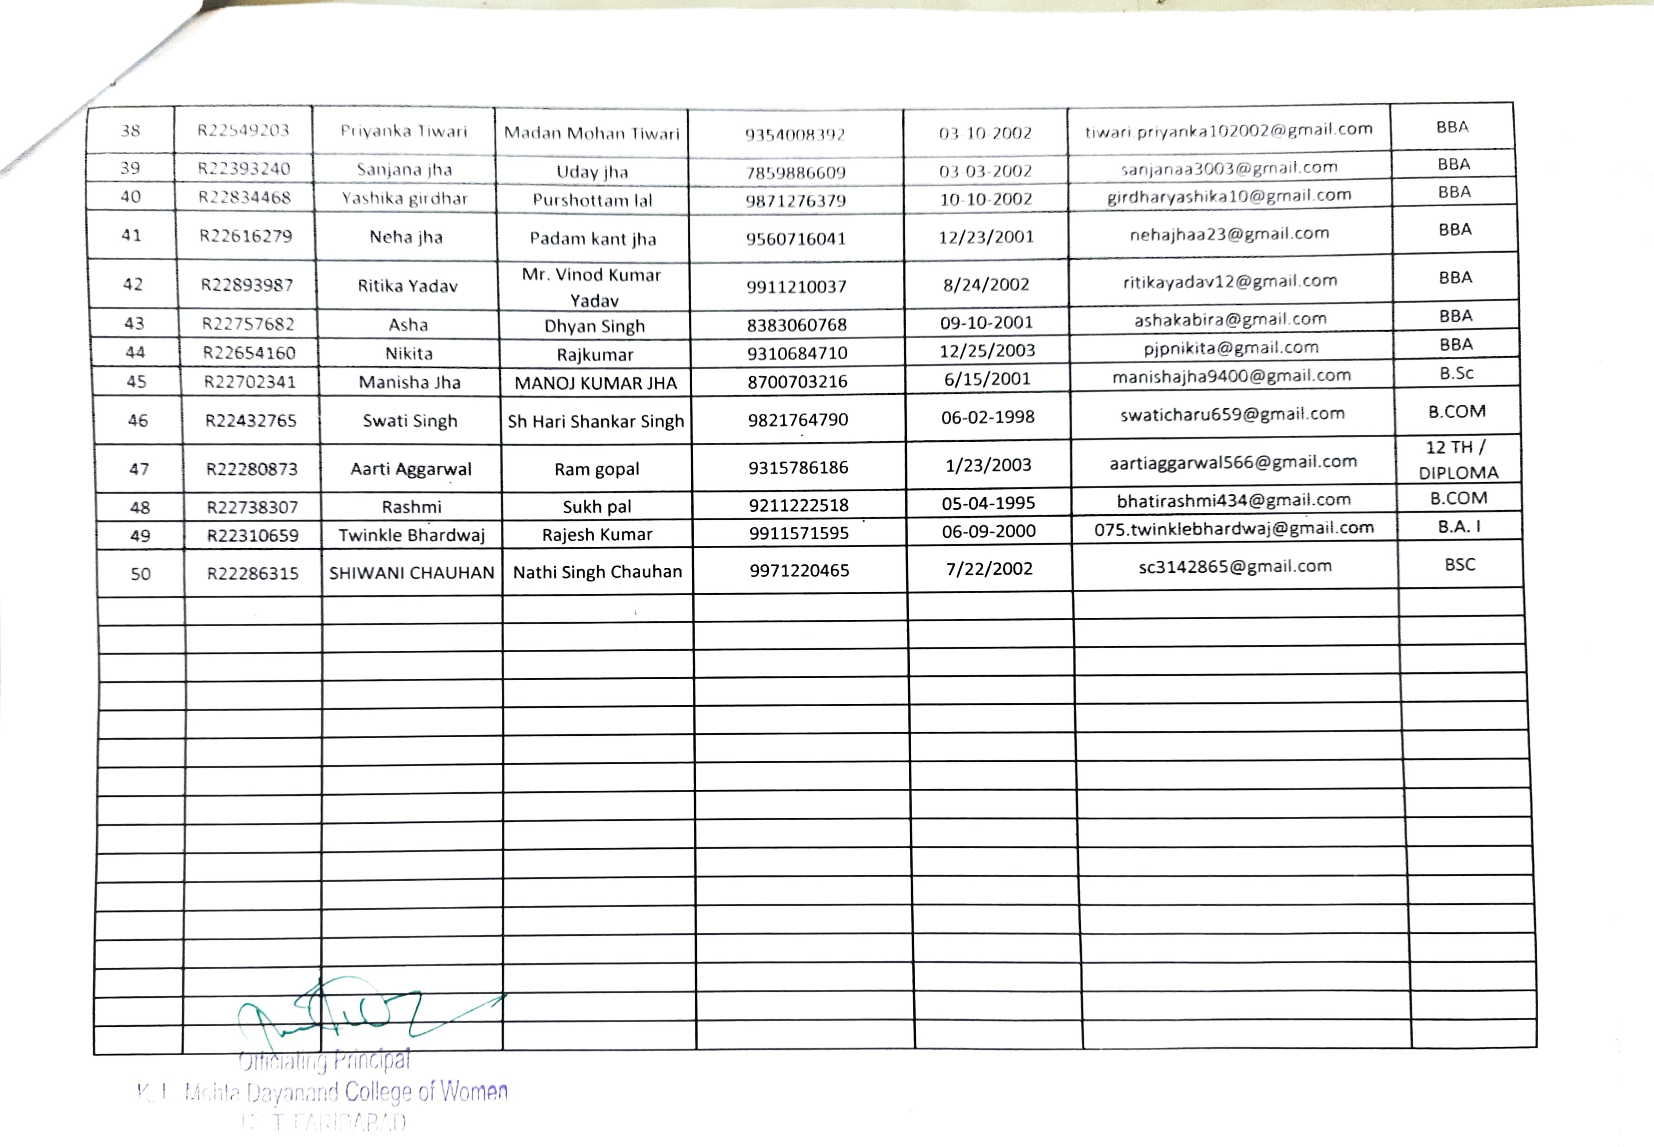

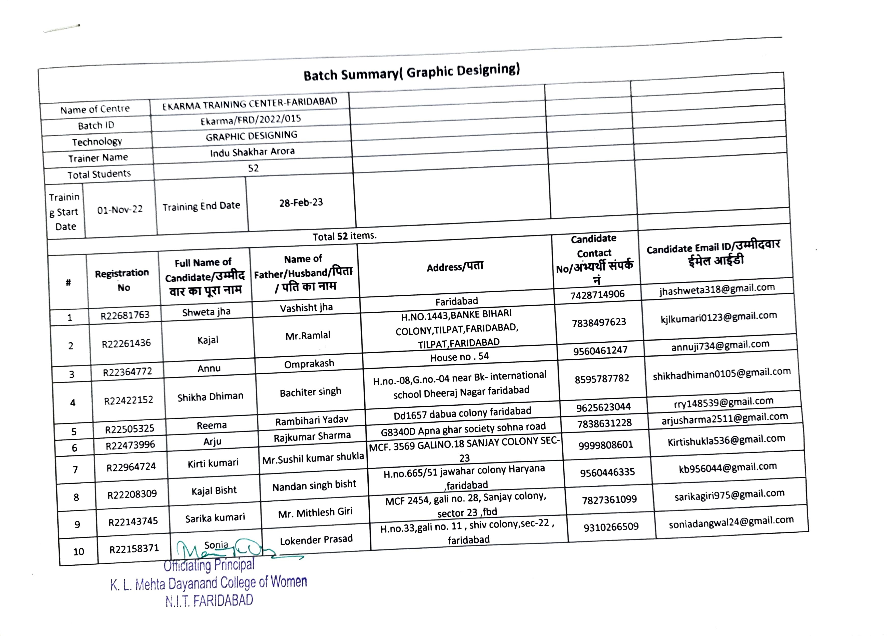

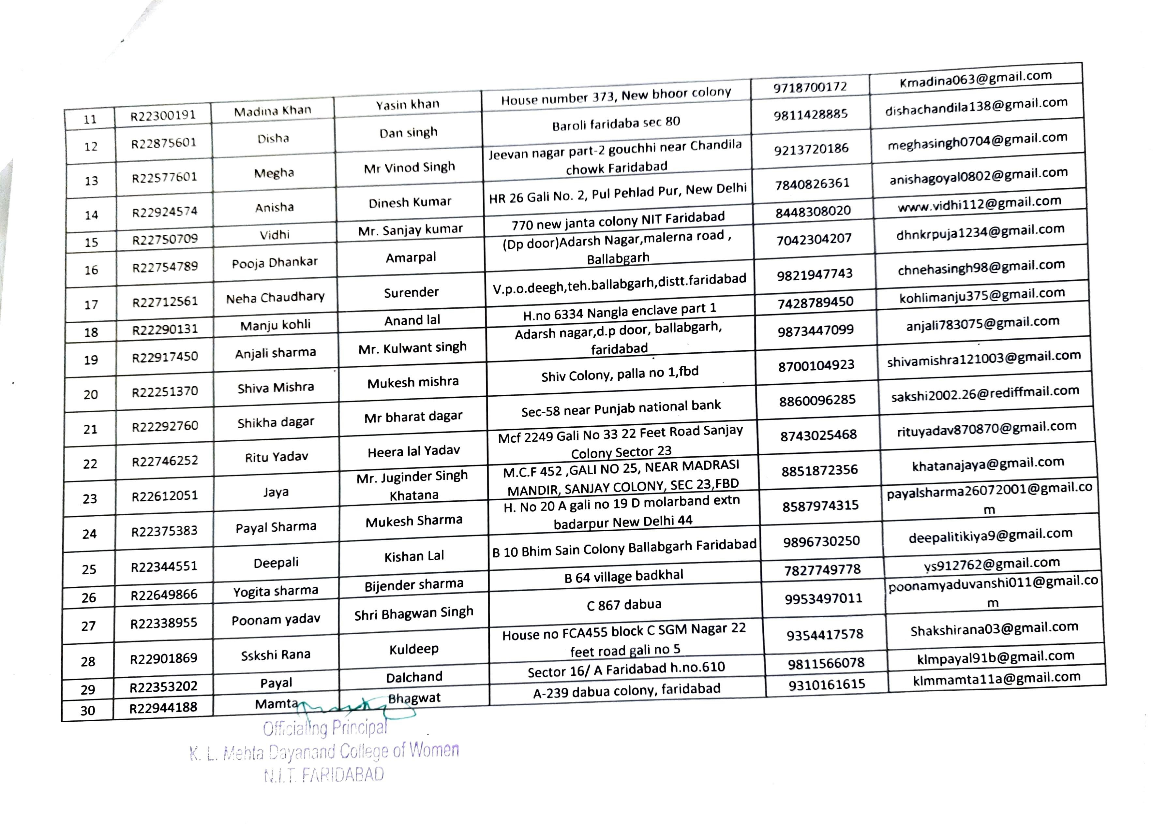

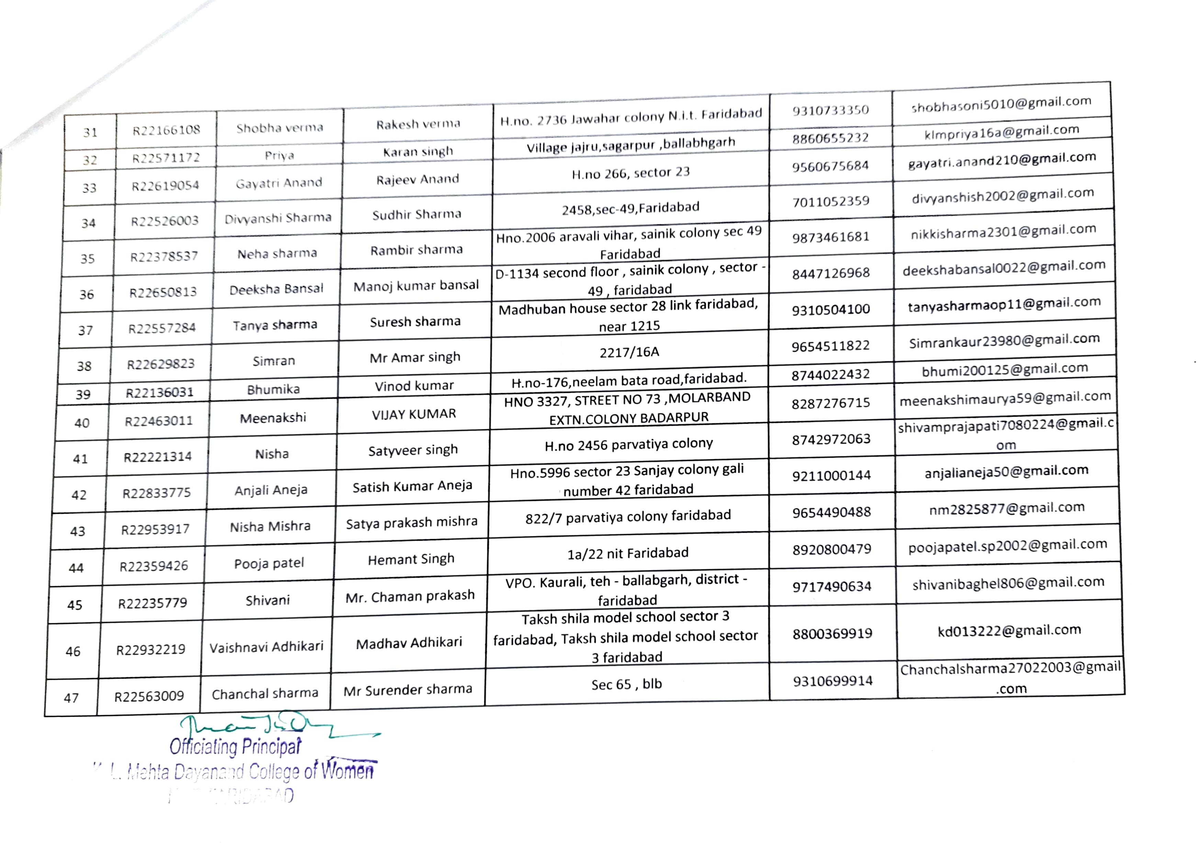

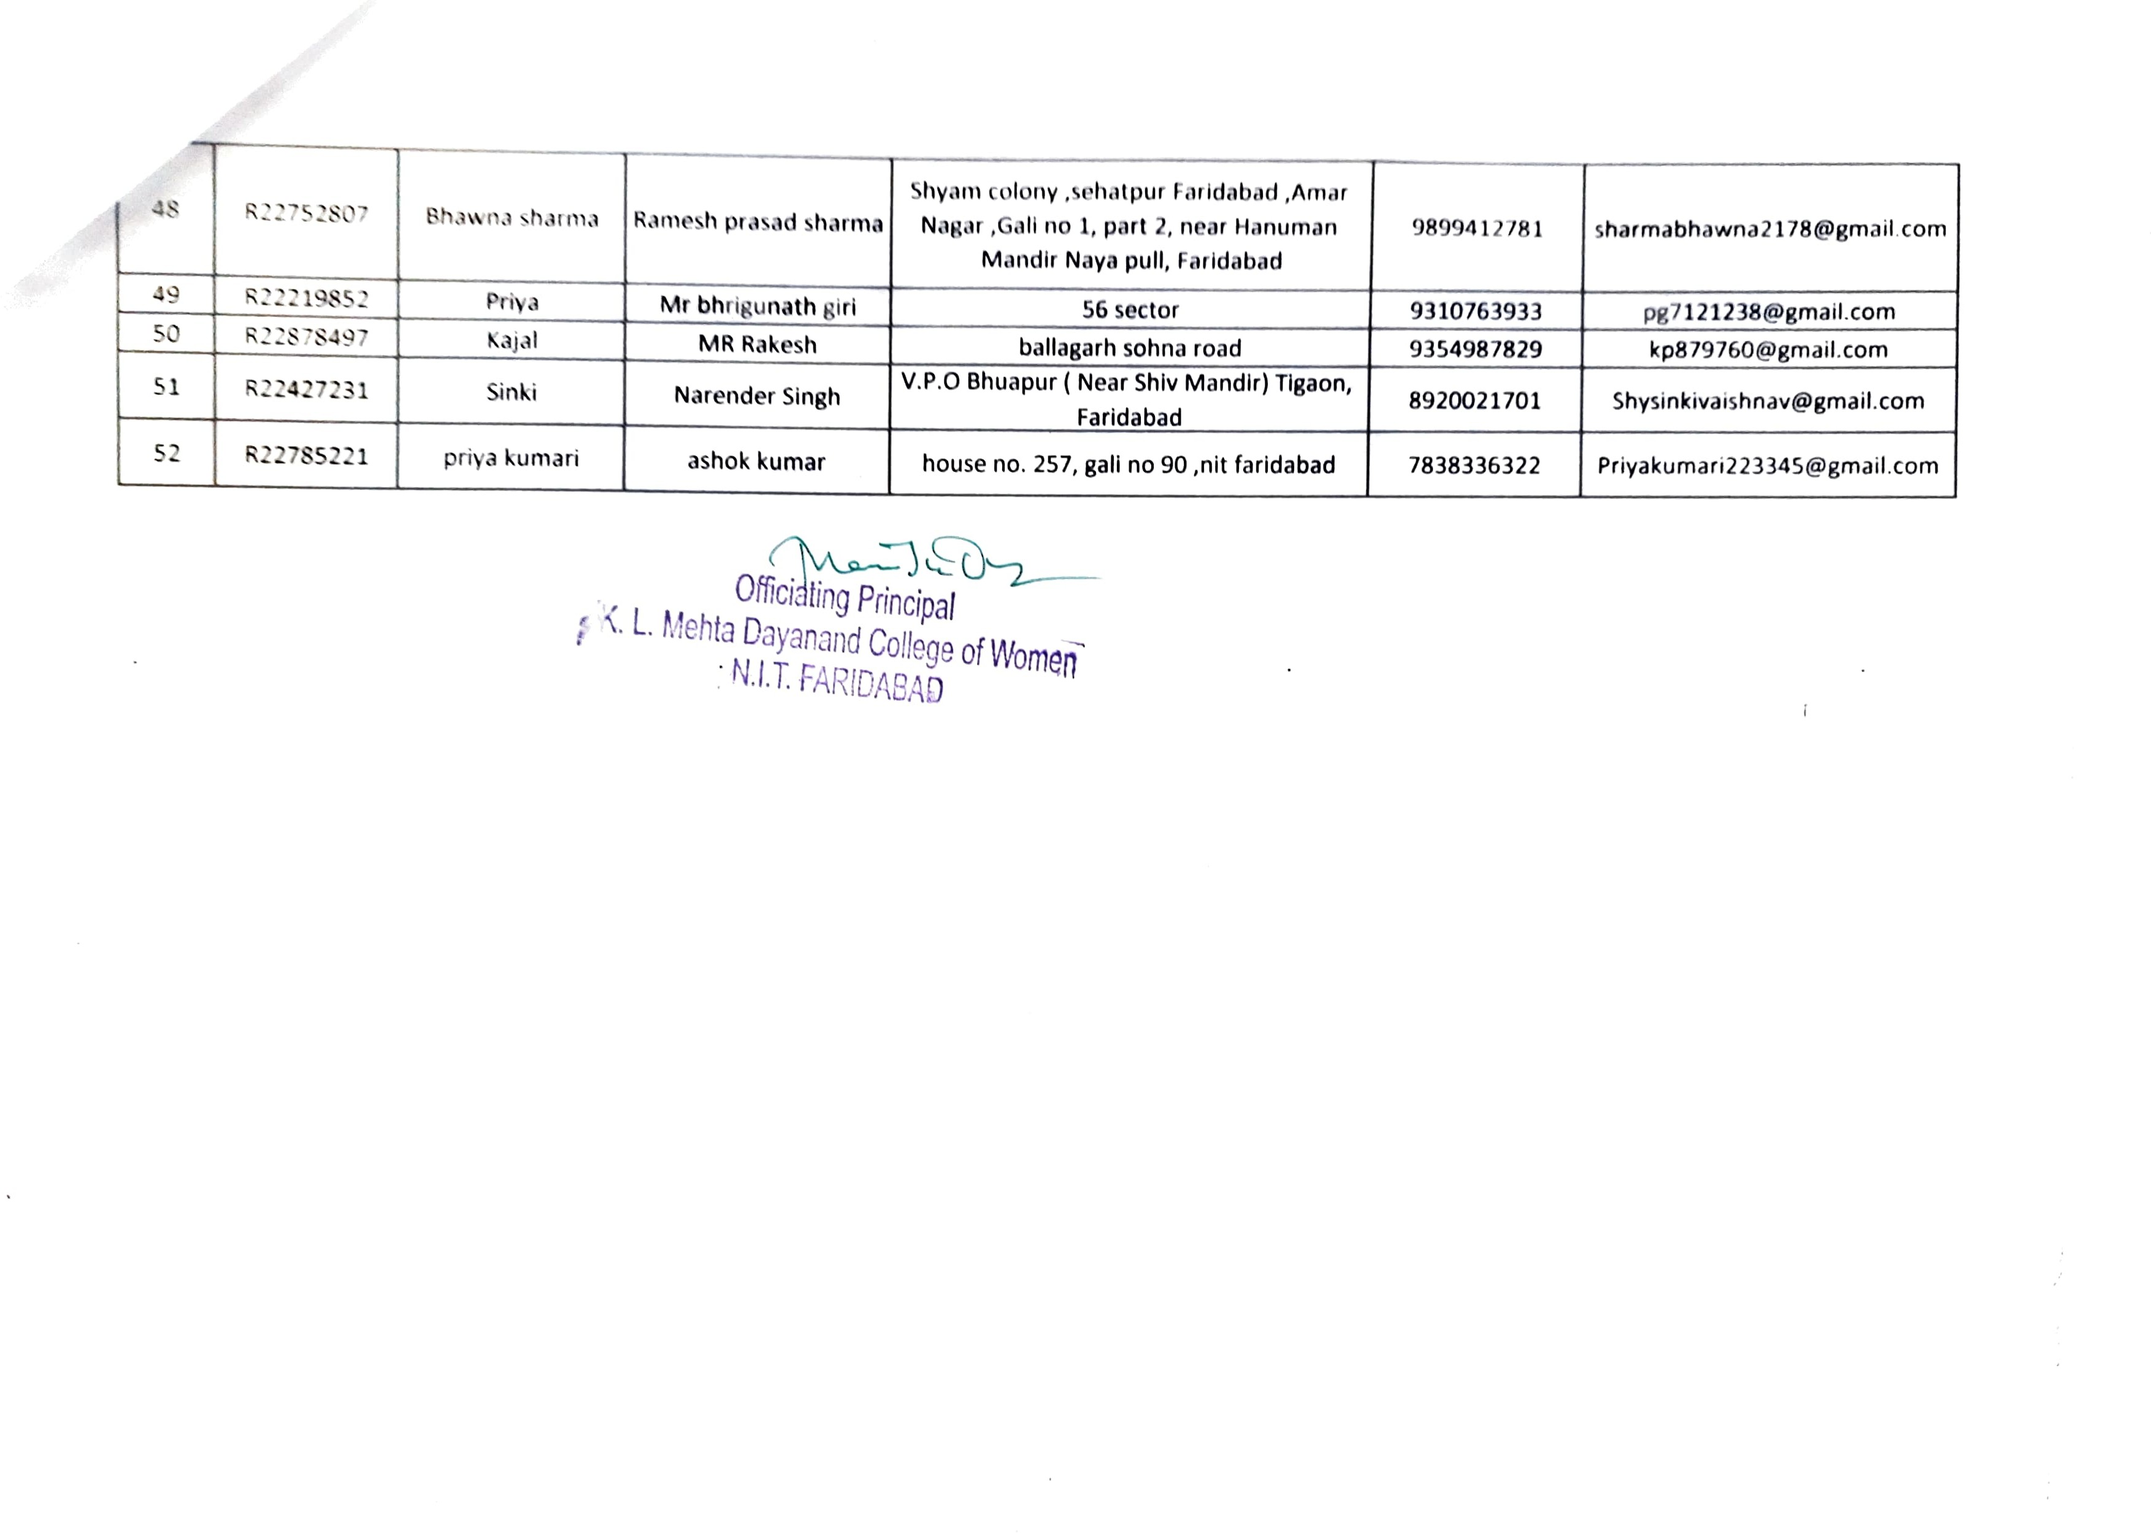

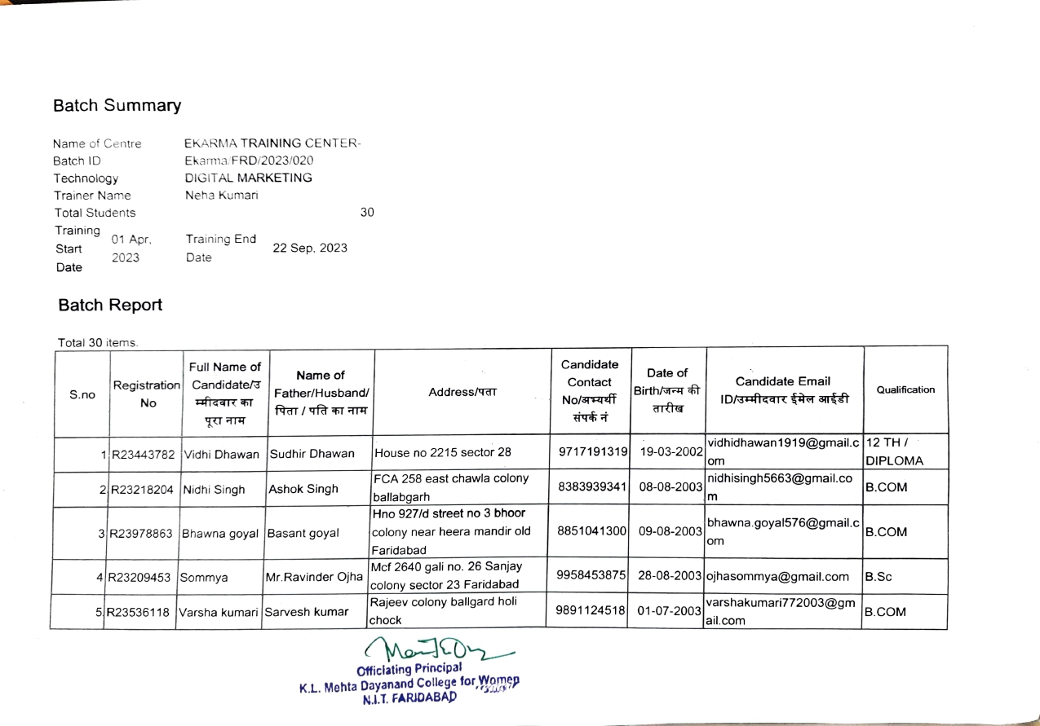

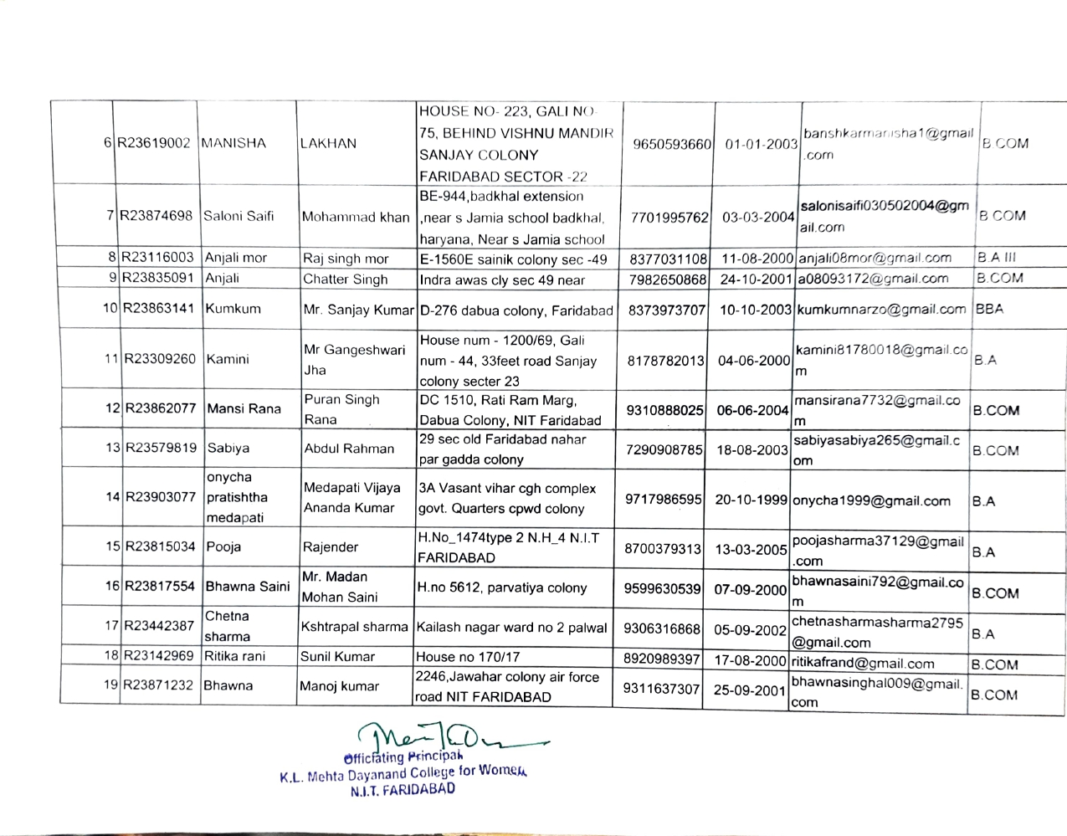

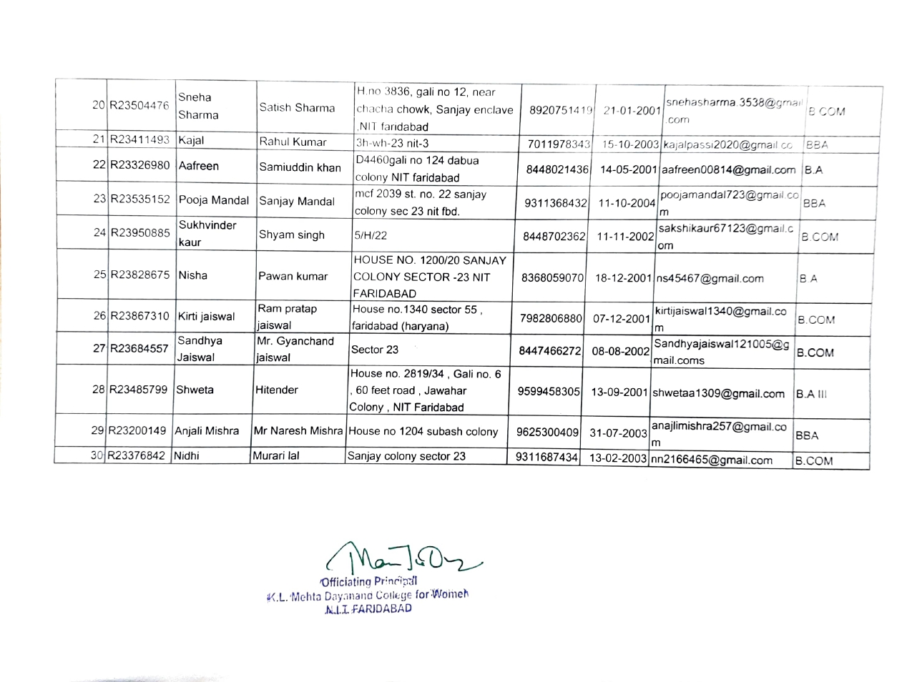

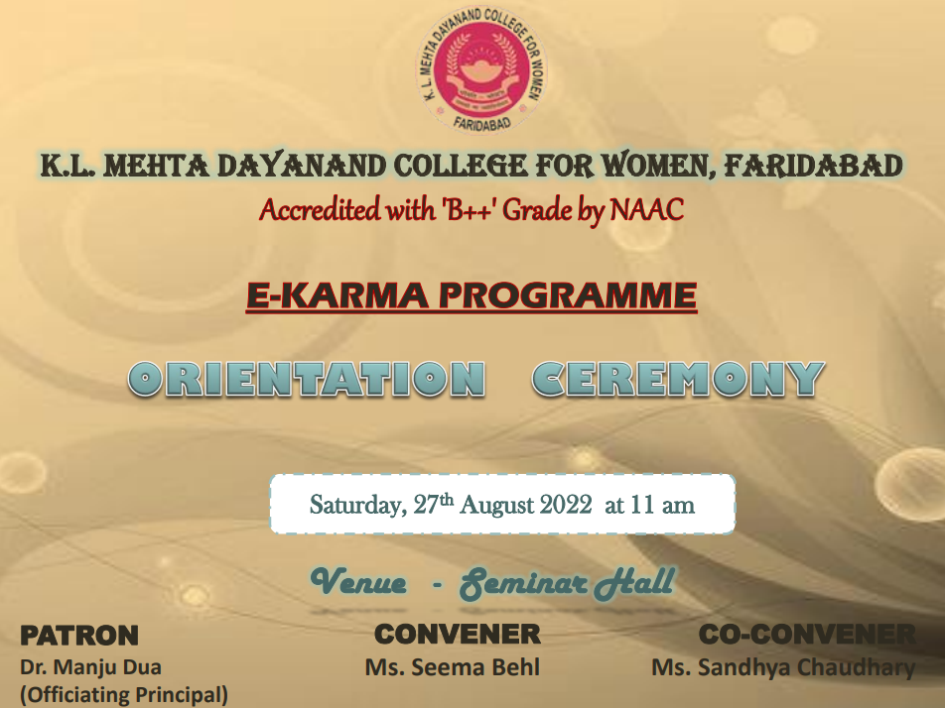
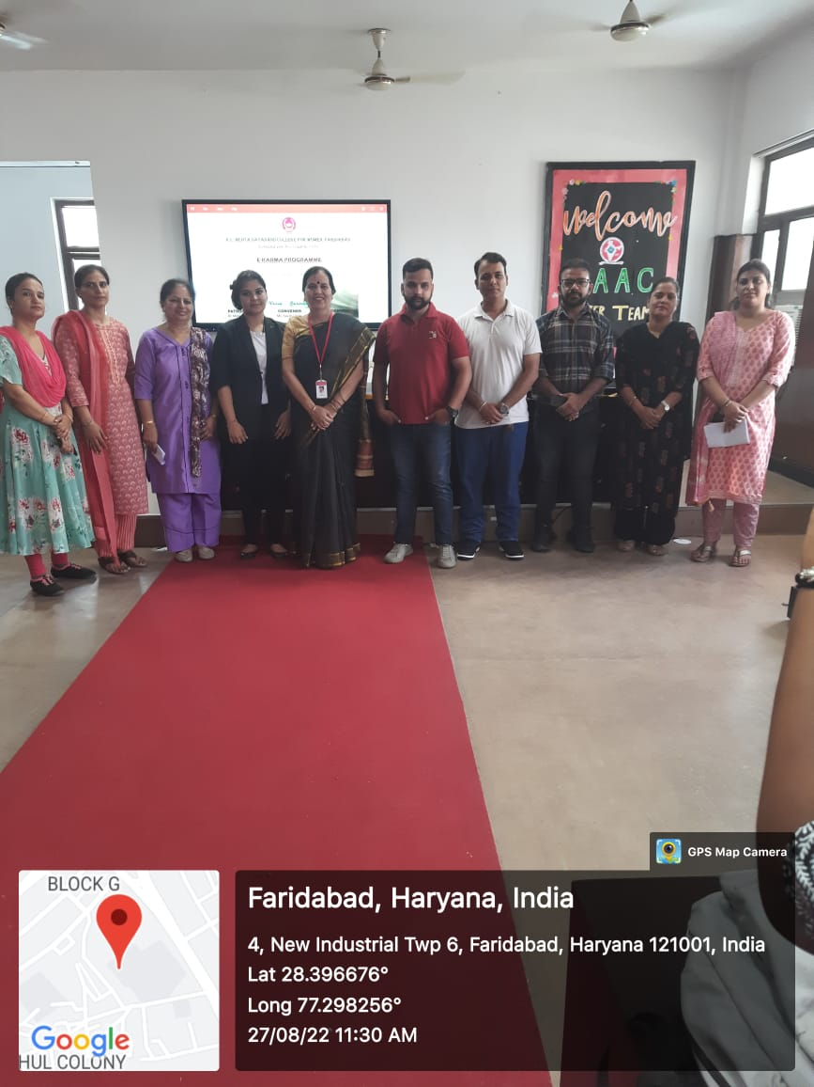

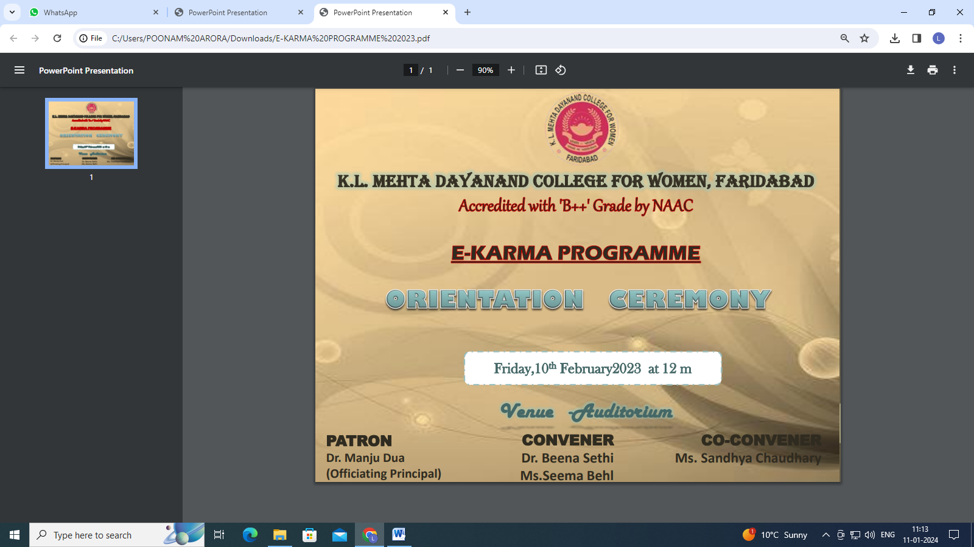

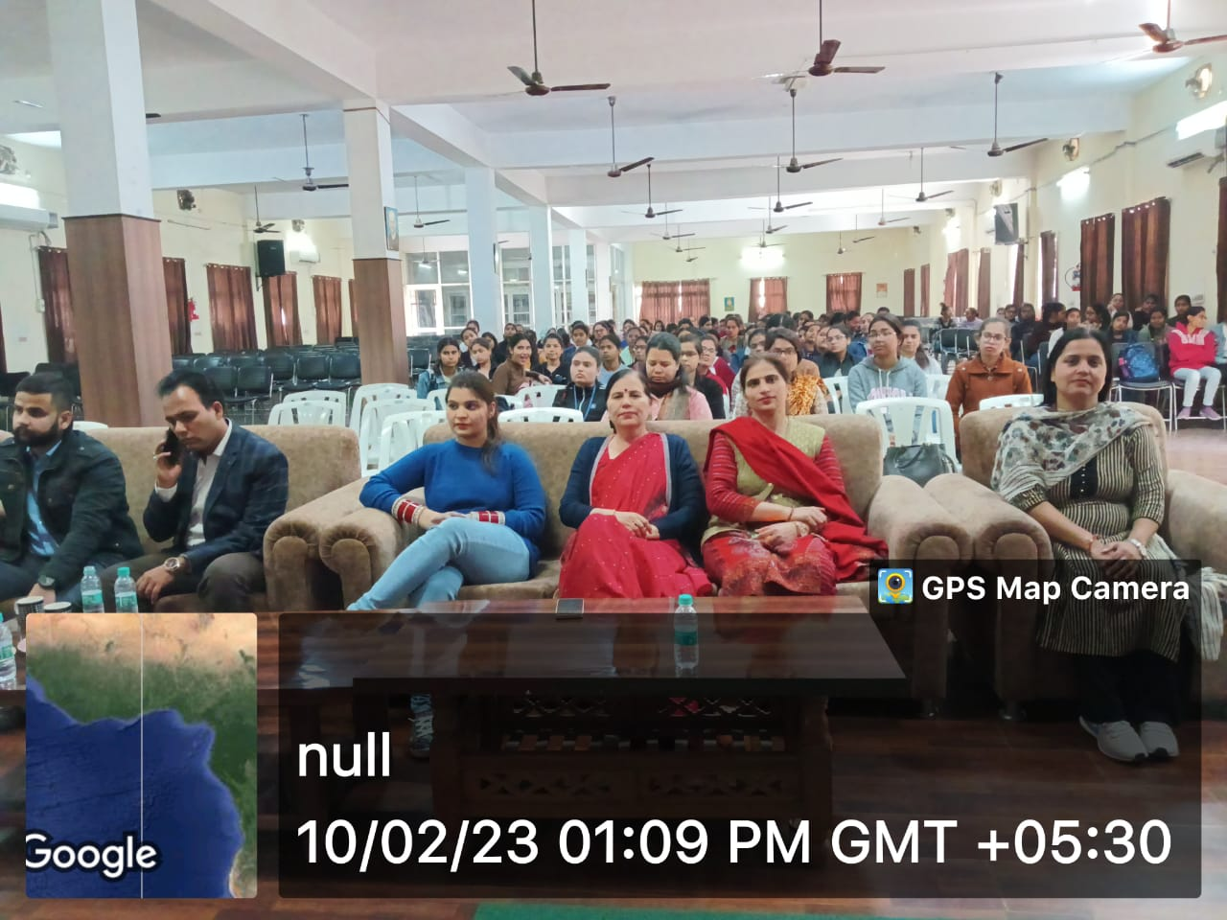

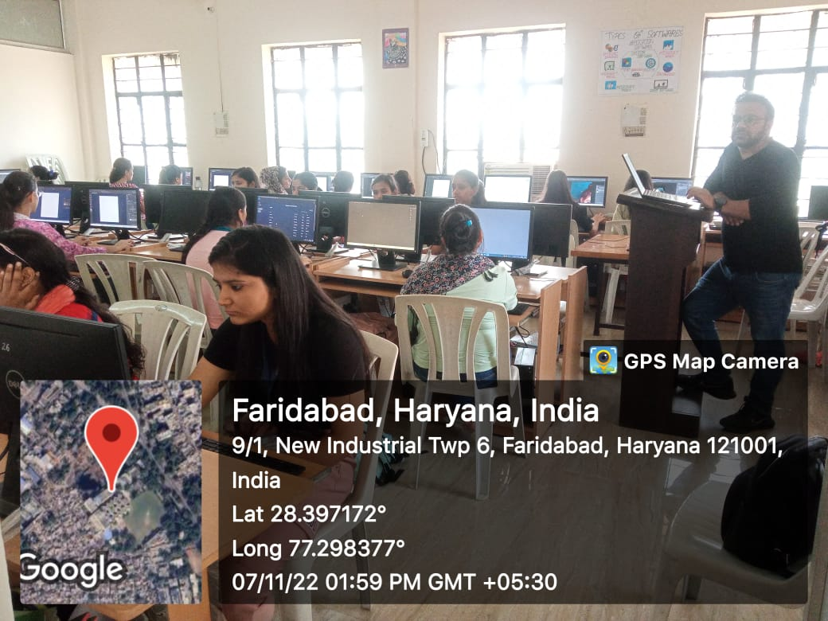

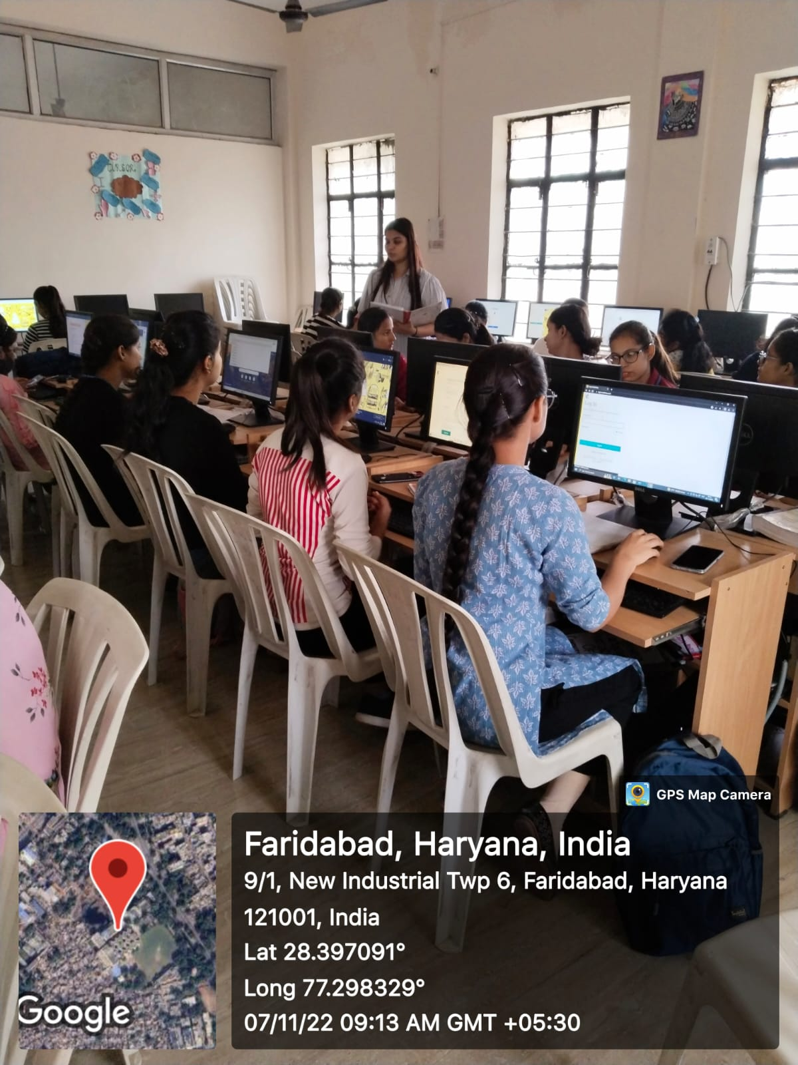
Cut and Stitch Course

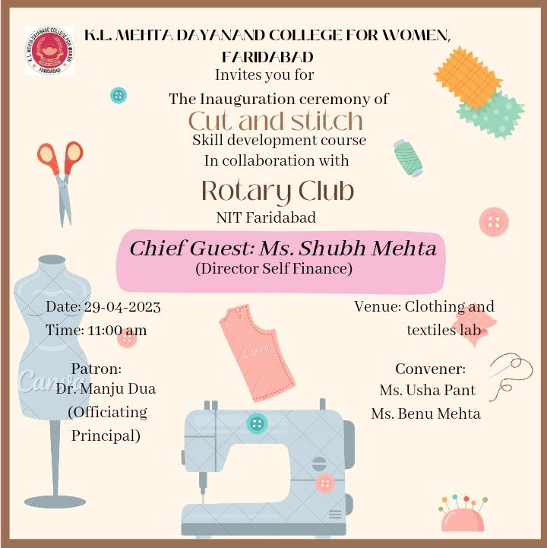

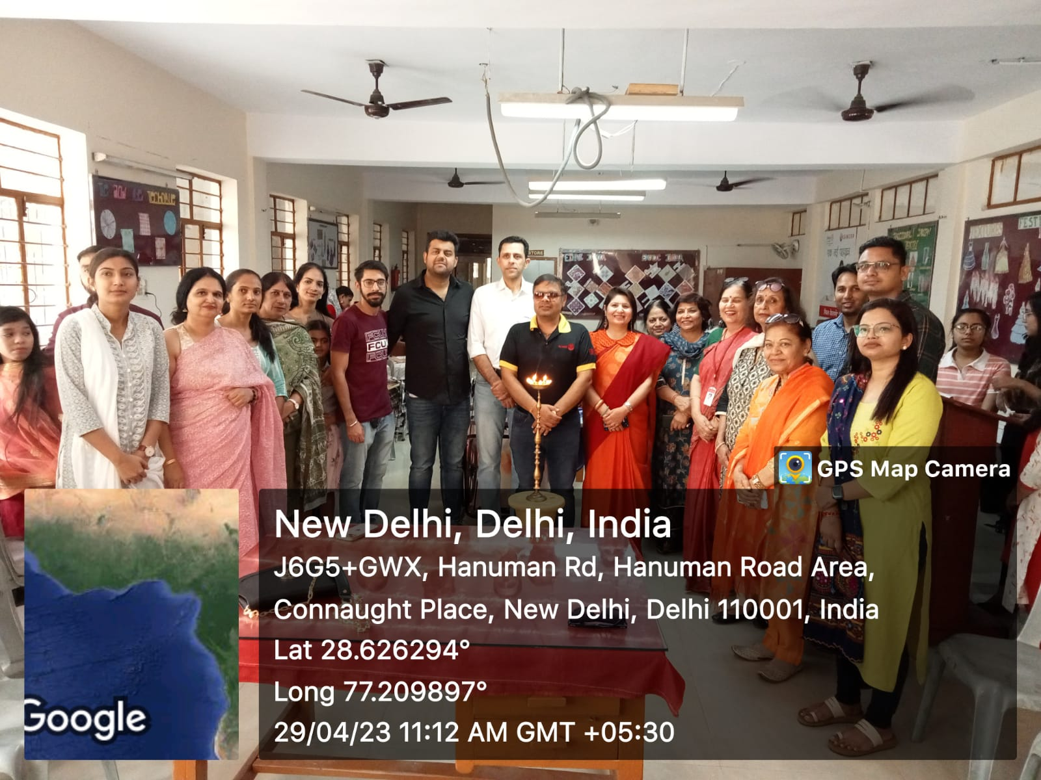

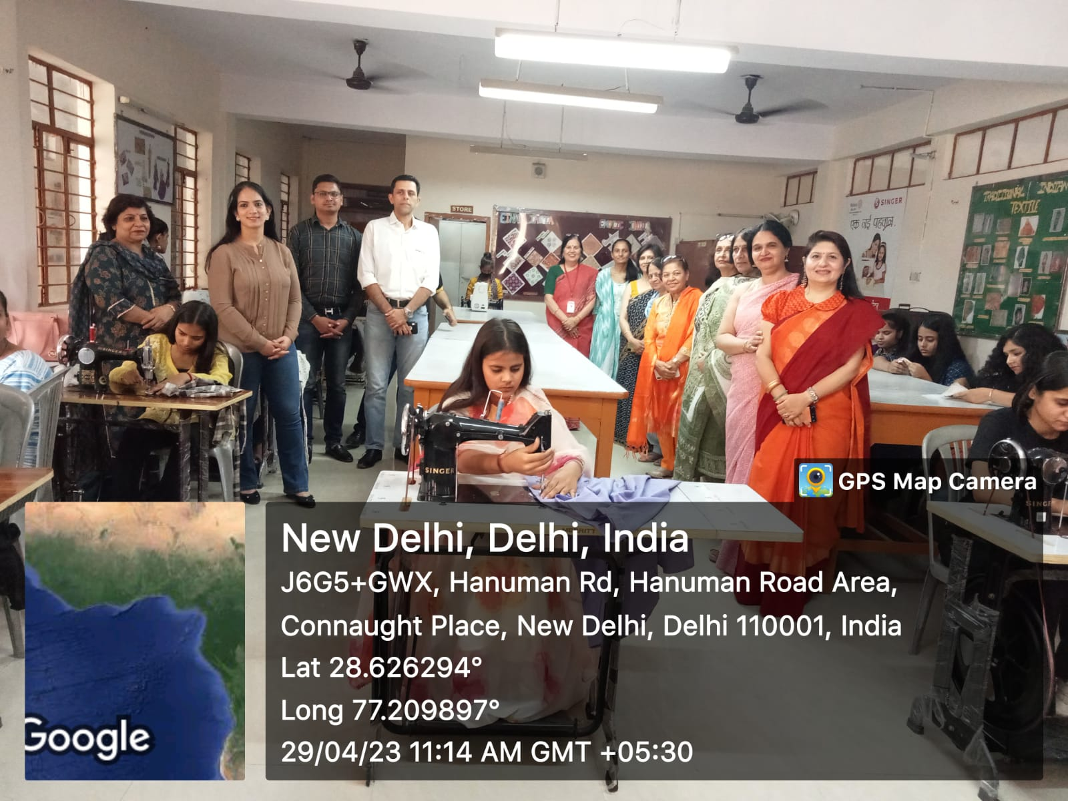

List of Students enrolled in Cut and Stitch Course

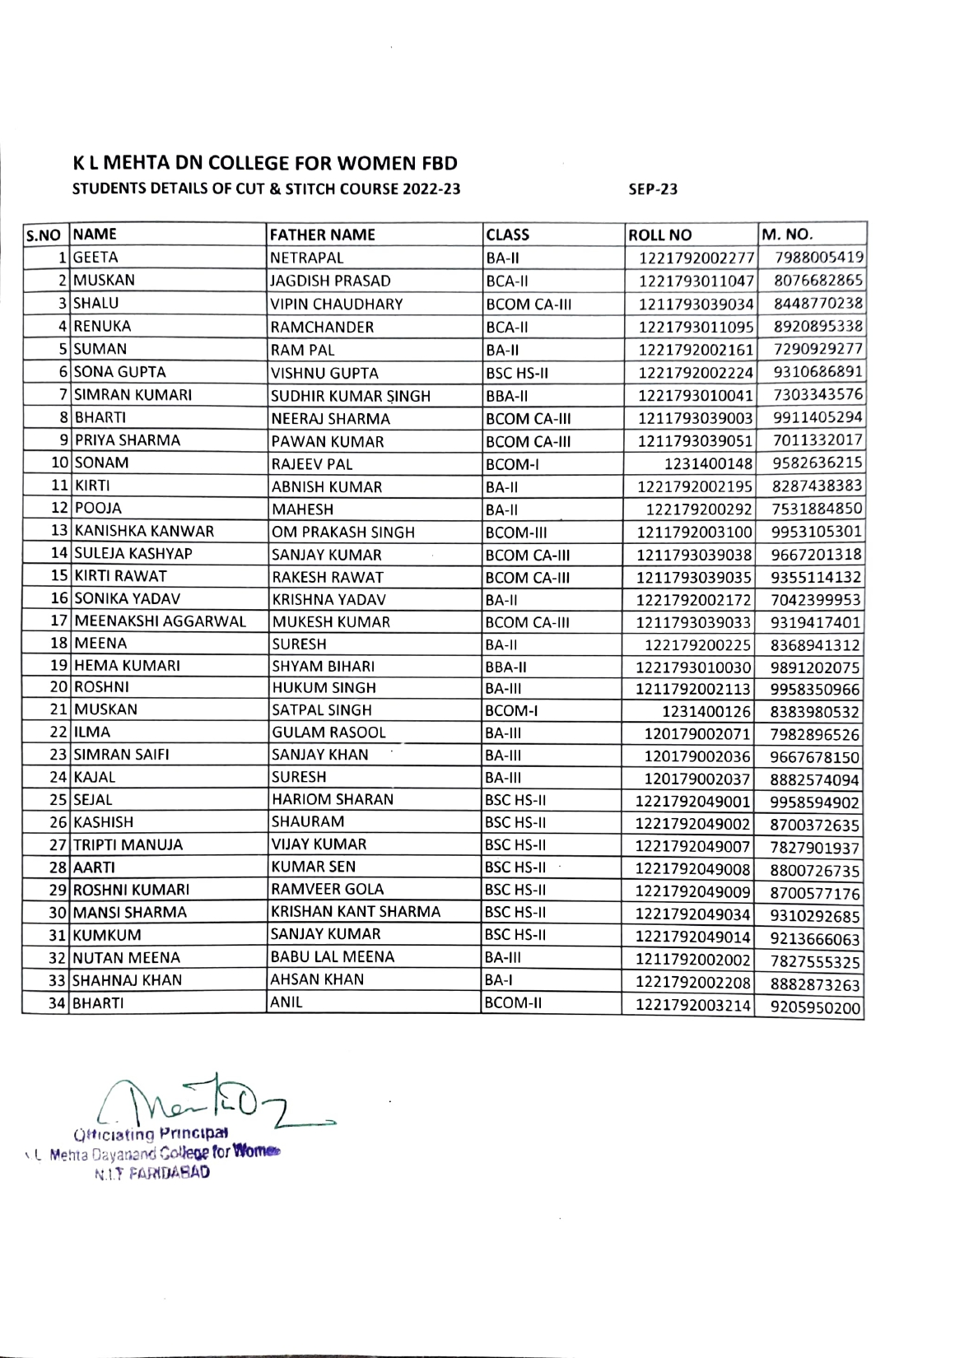

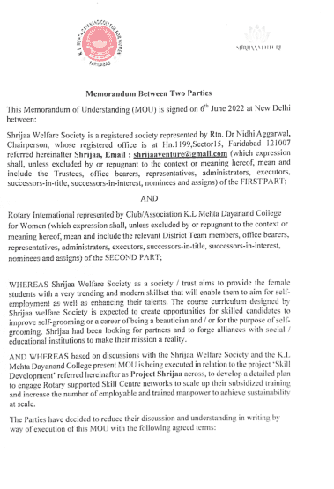
Saundarya Beauty Training Centre

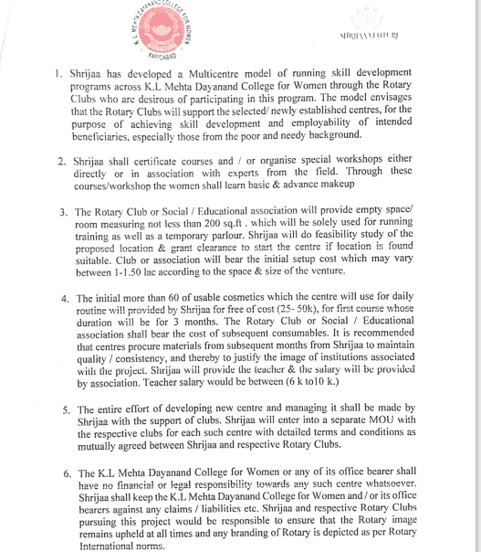

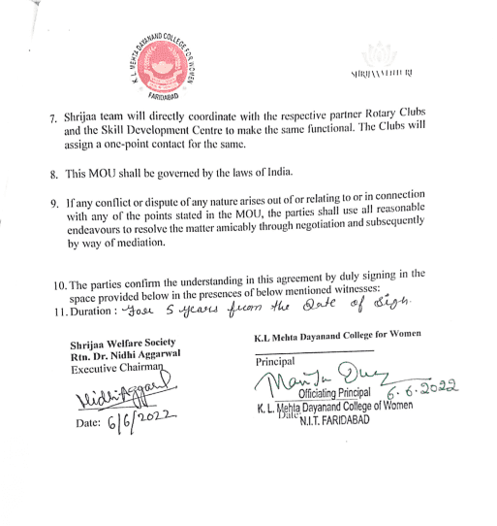

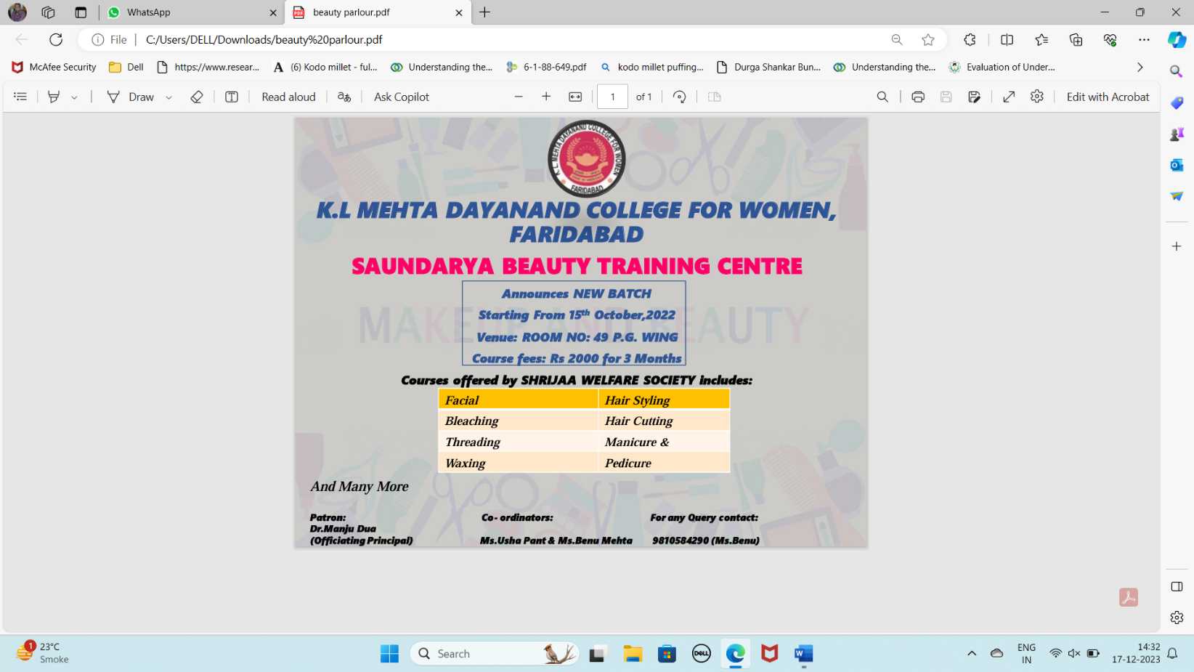

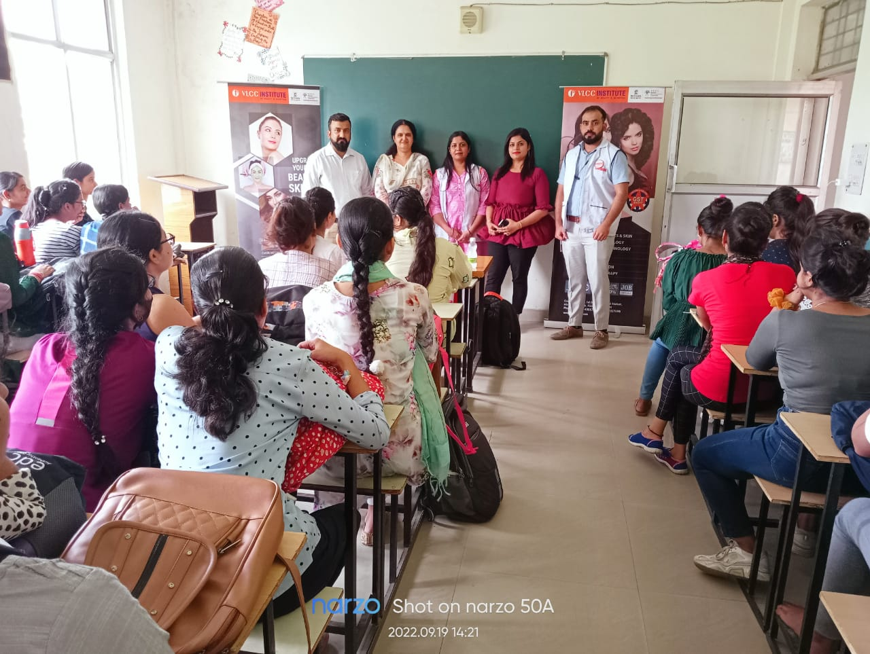

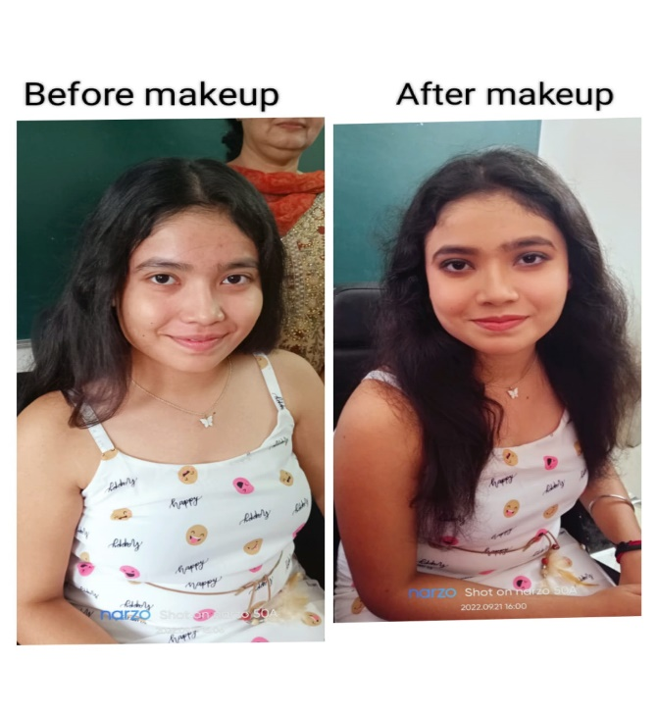
Activities of Saundarya Beauty Training Centre

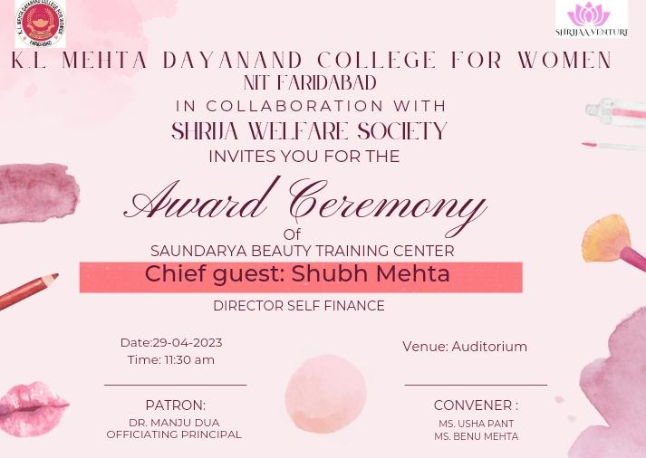

Activities of Saundarya Beauty Training Centre

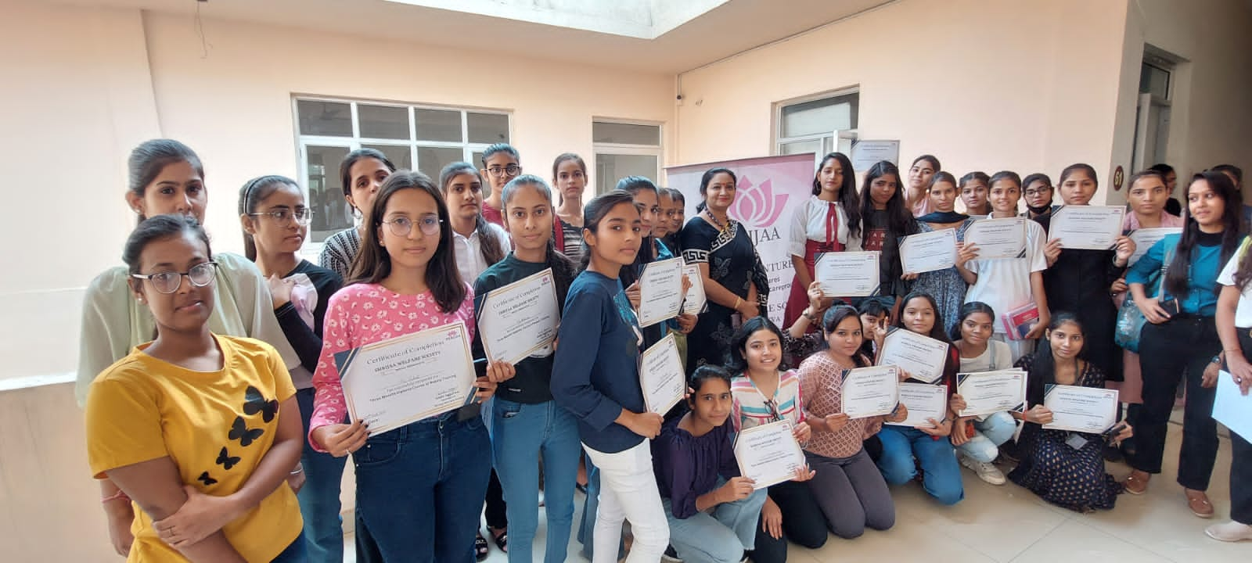

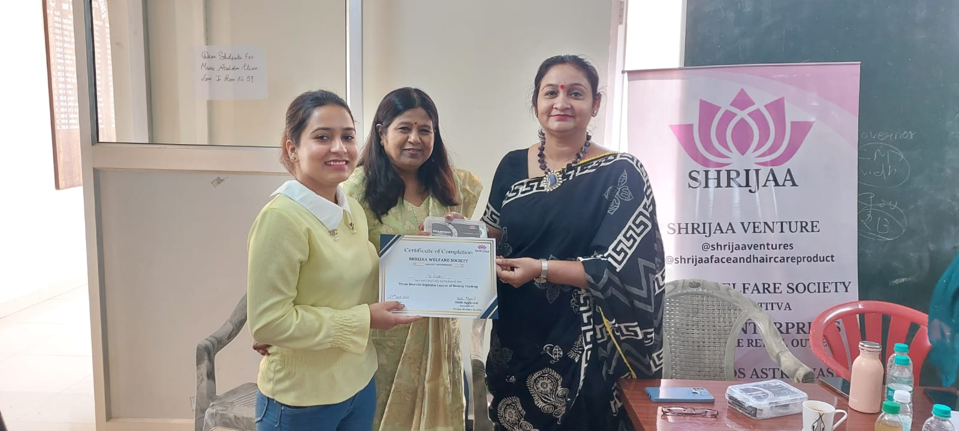

Activities of Saundarya Beauty Training Centre

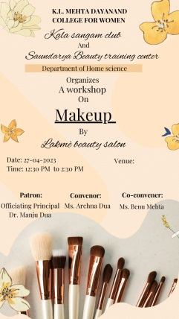
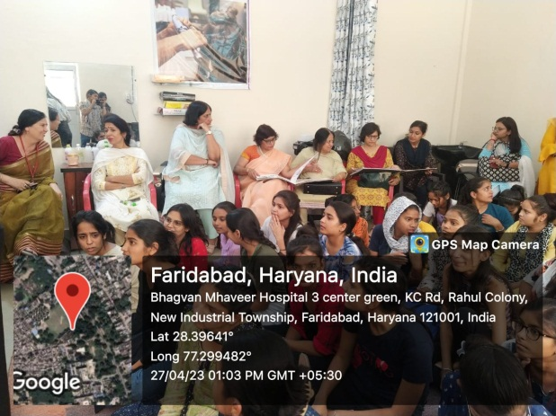

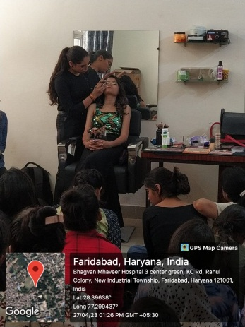

Student Enrolled In Sundraya Beauty Training Batch -1

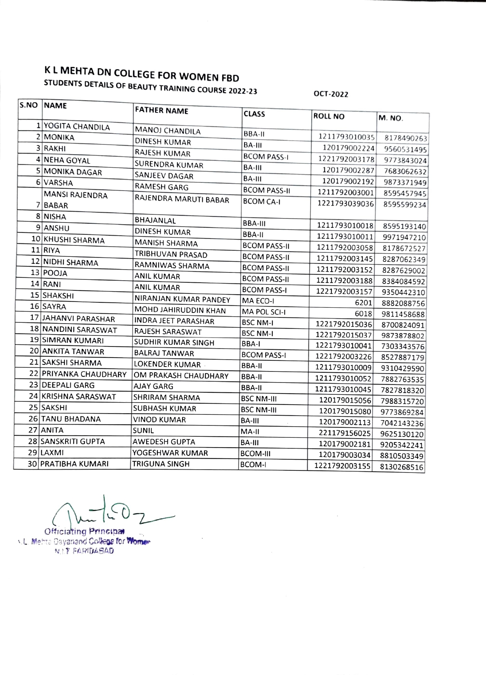

Student Enrolled In Sundraya Beauty Training Batch -2

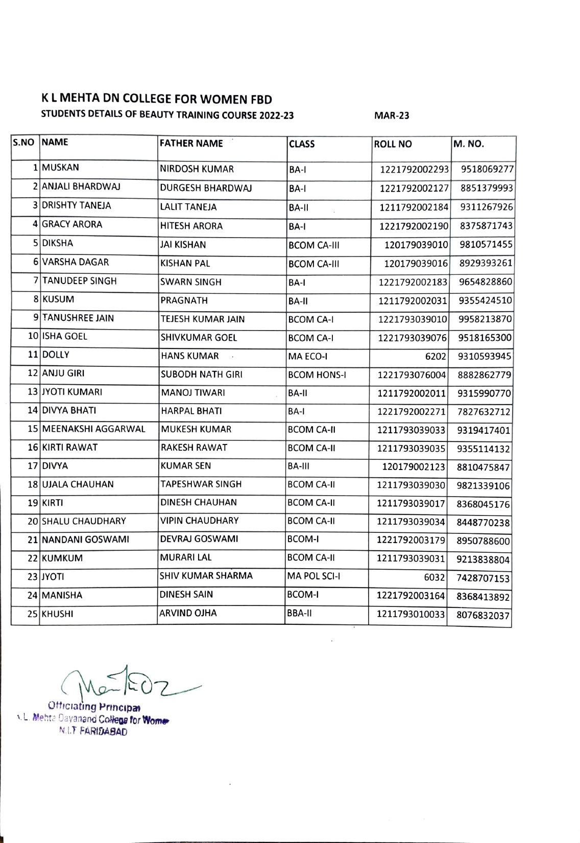

Department of Home Science (Add on courses) (2022-2023)
Orientation Program of Early Child Care Education(ECCE) and Fashion Designing

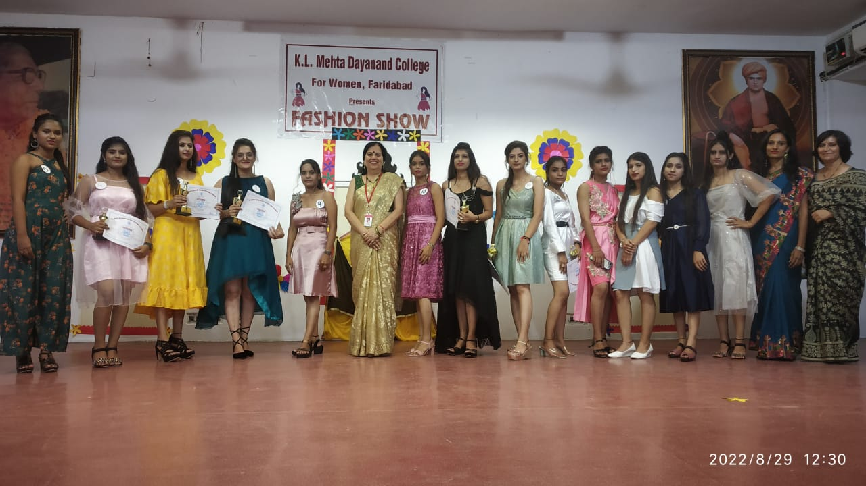

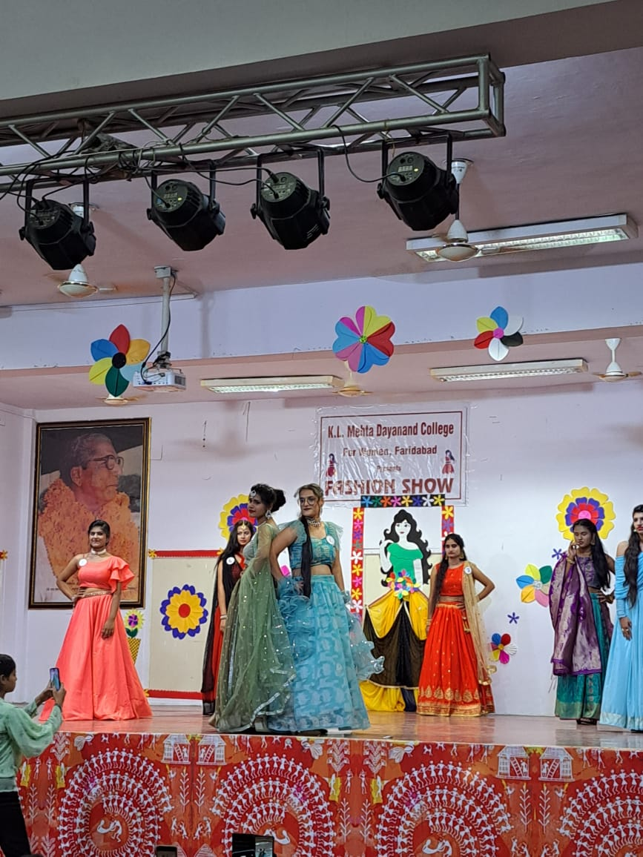

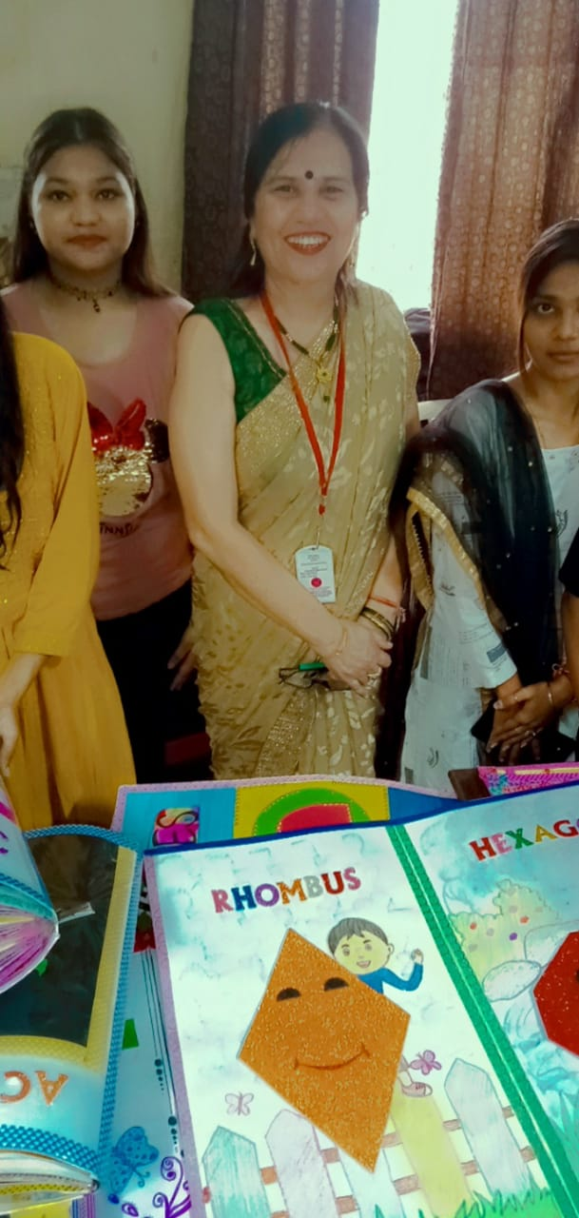

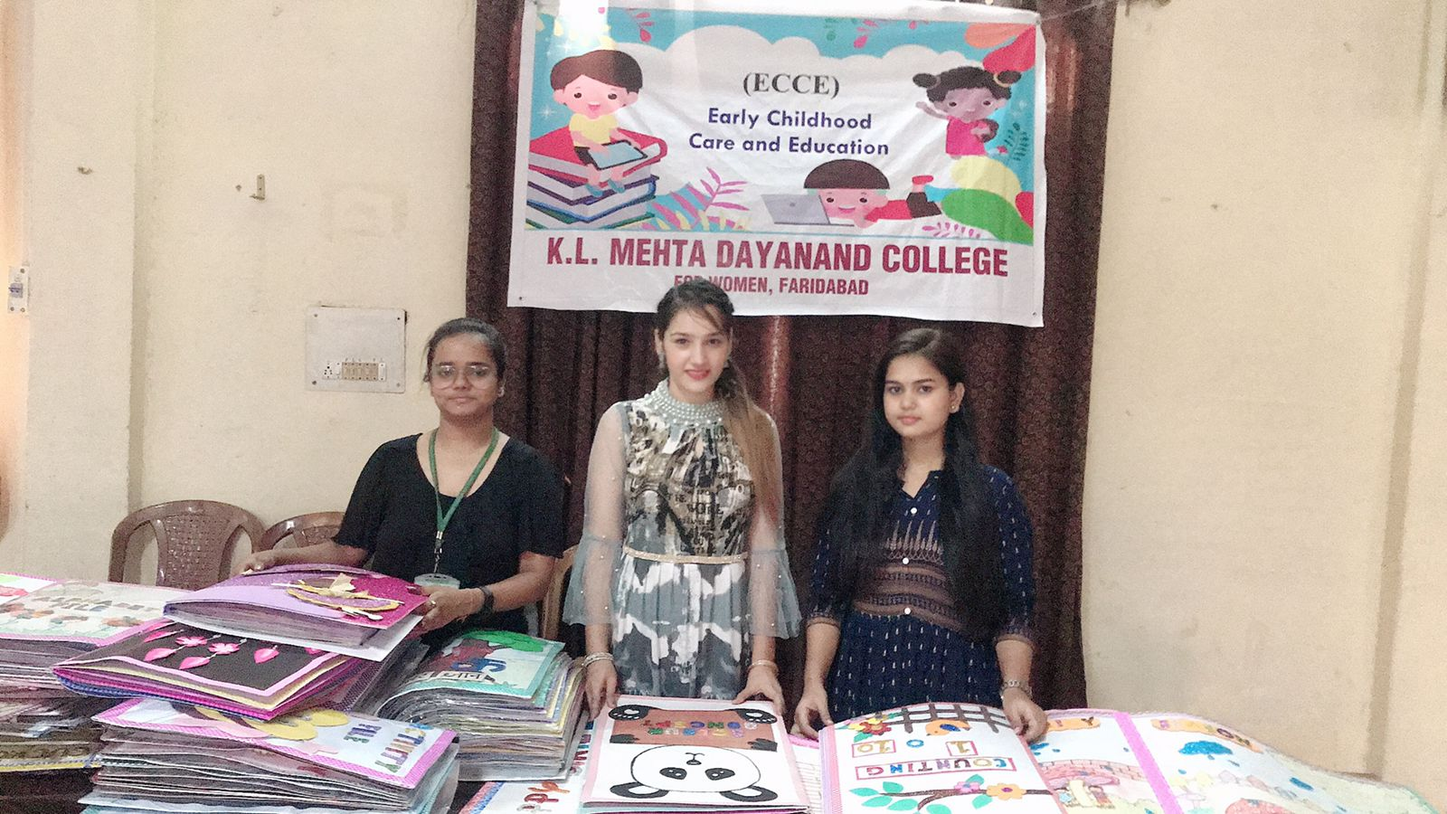

Students Enrolled In Ecce Course

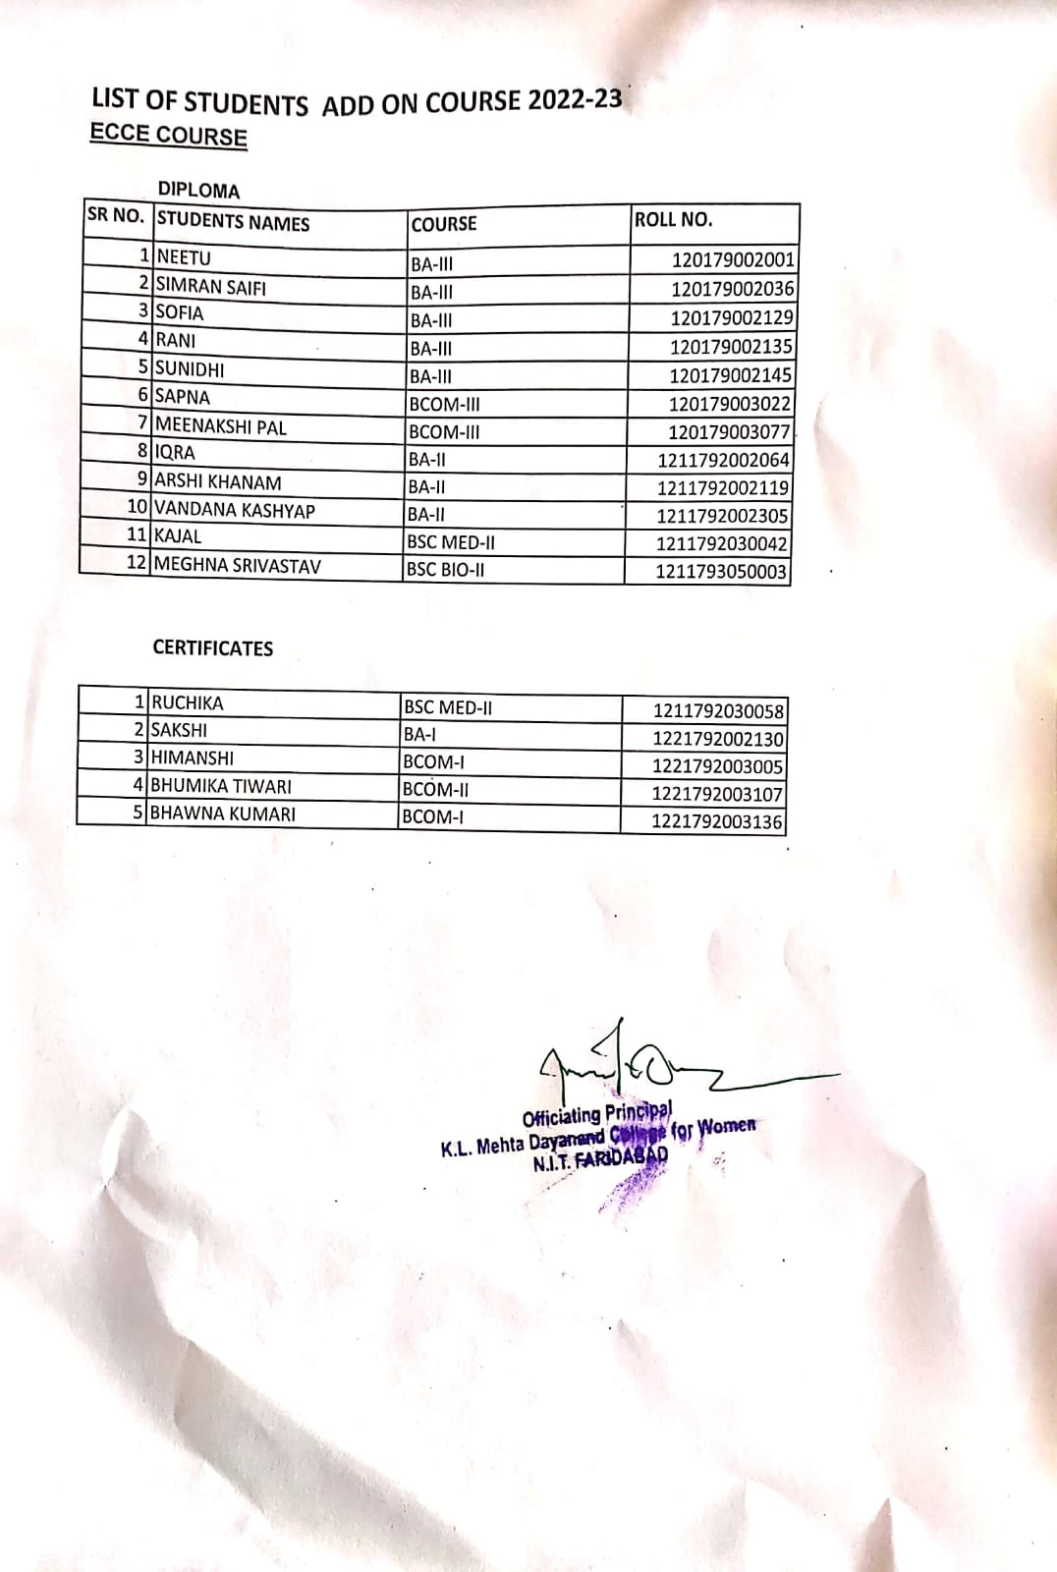

Students Enrolled In Fashion Designing Course

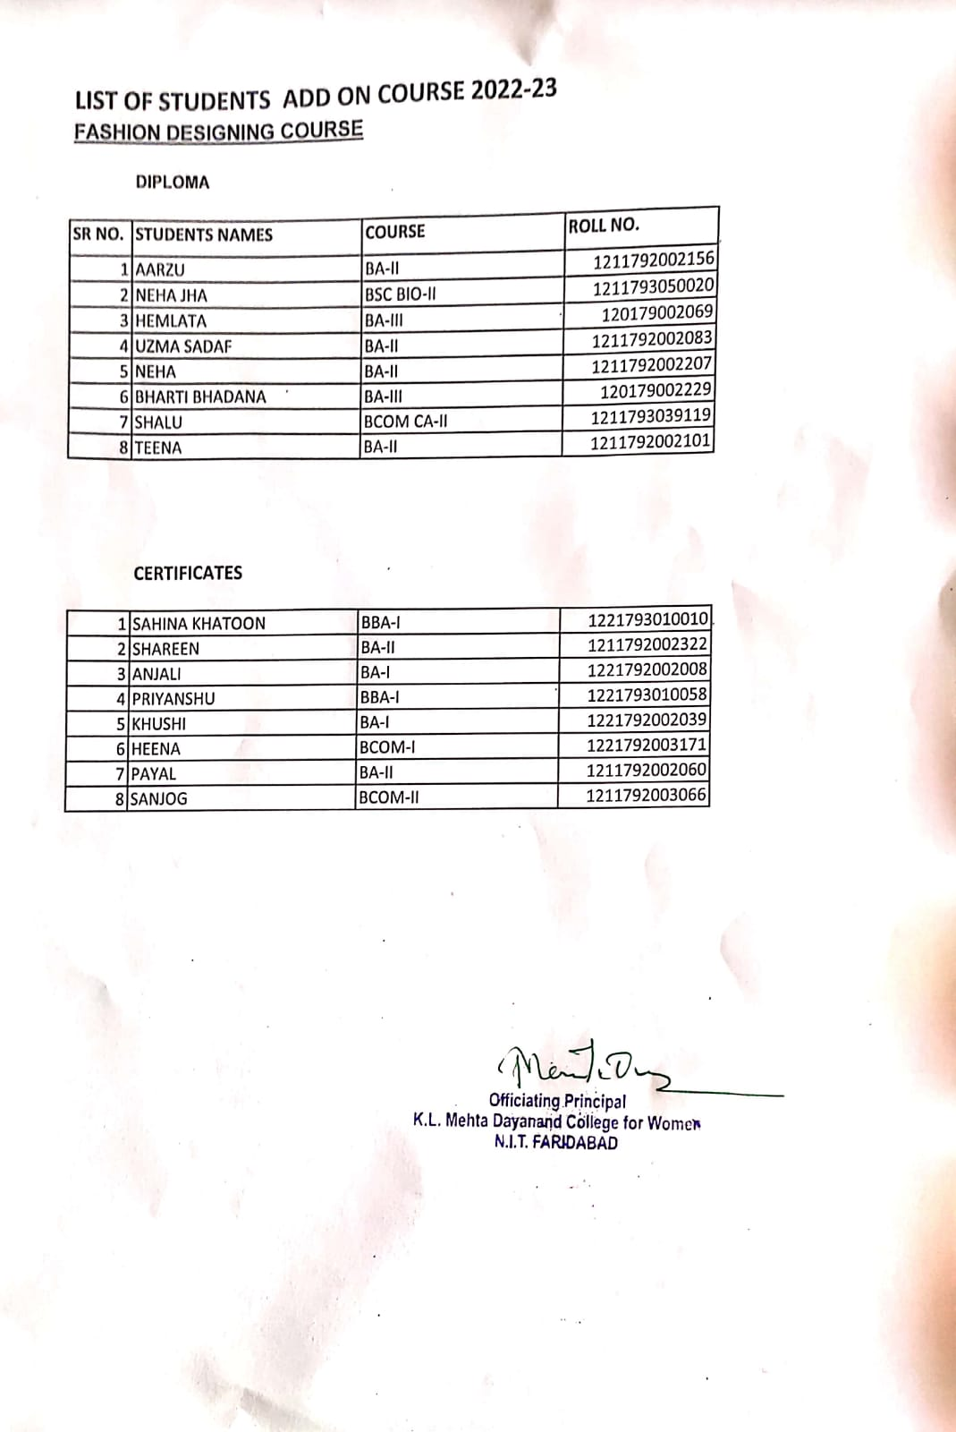

Add On Course In Accounting On Computer
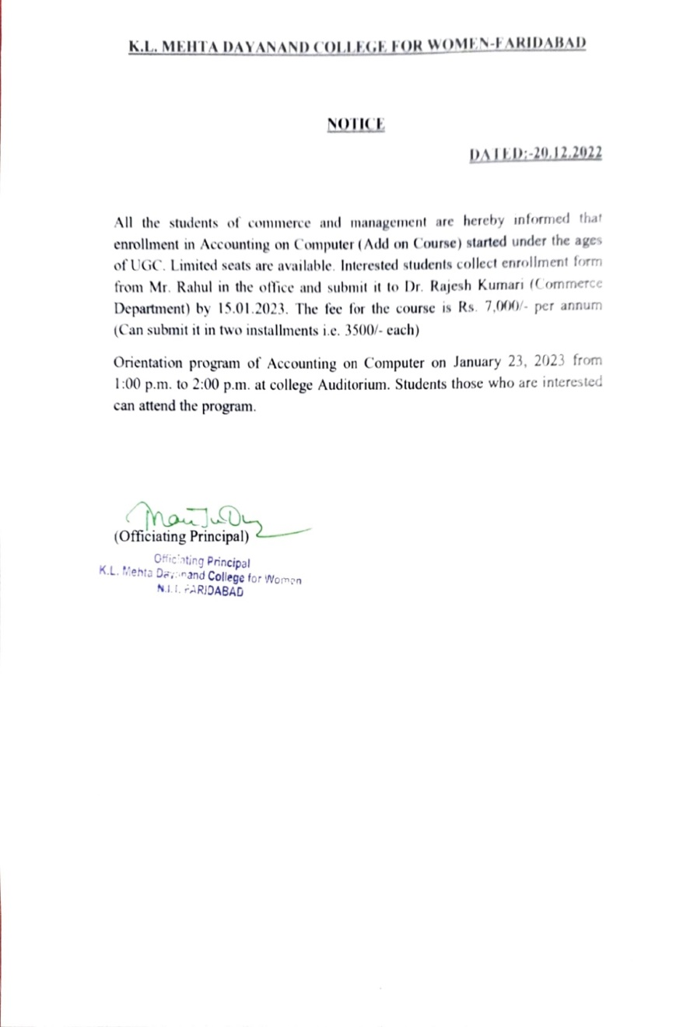

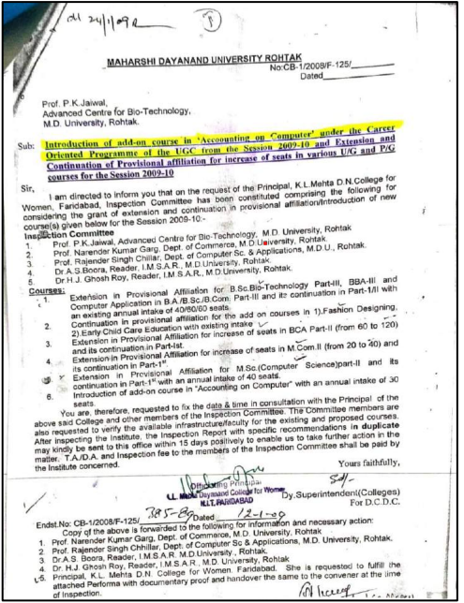

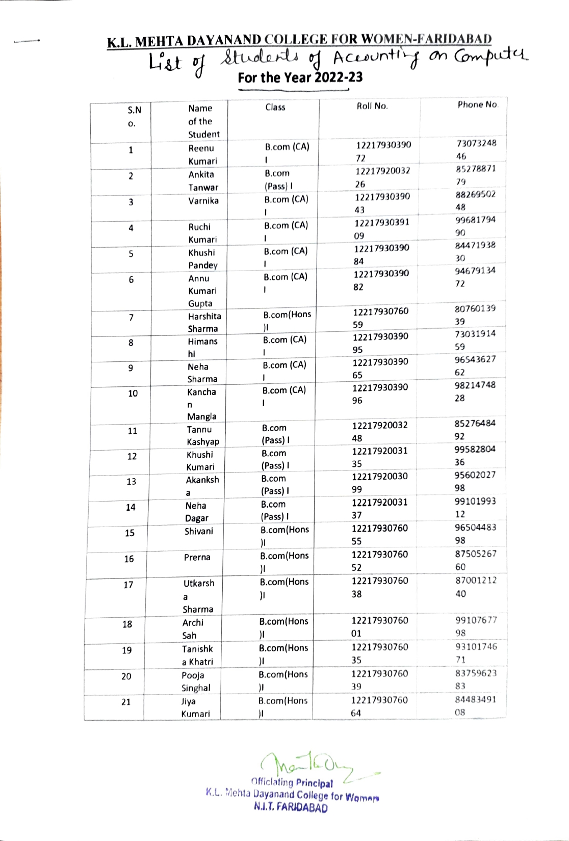

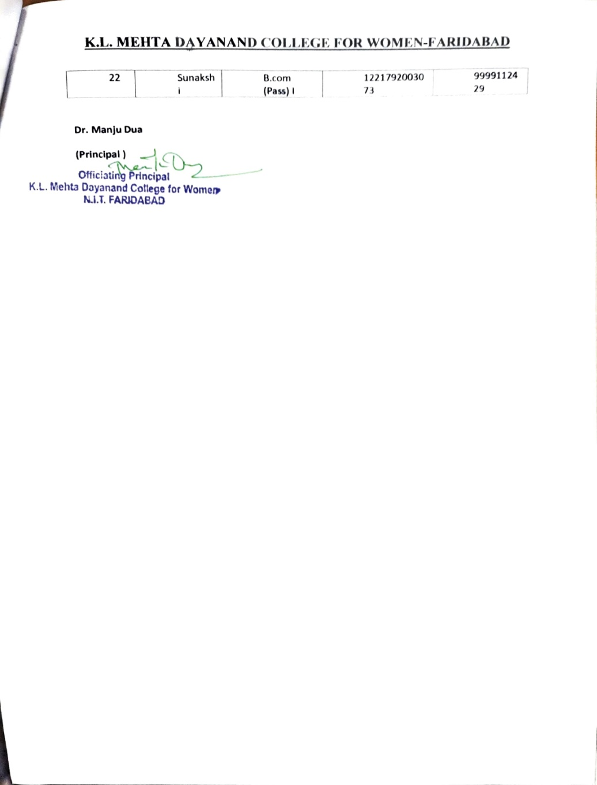

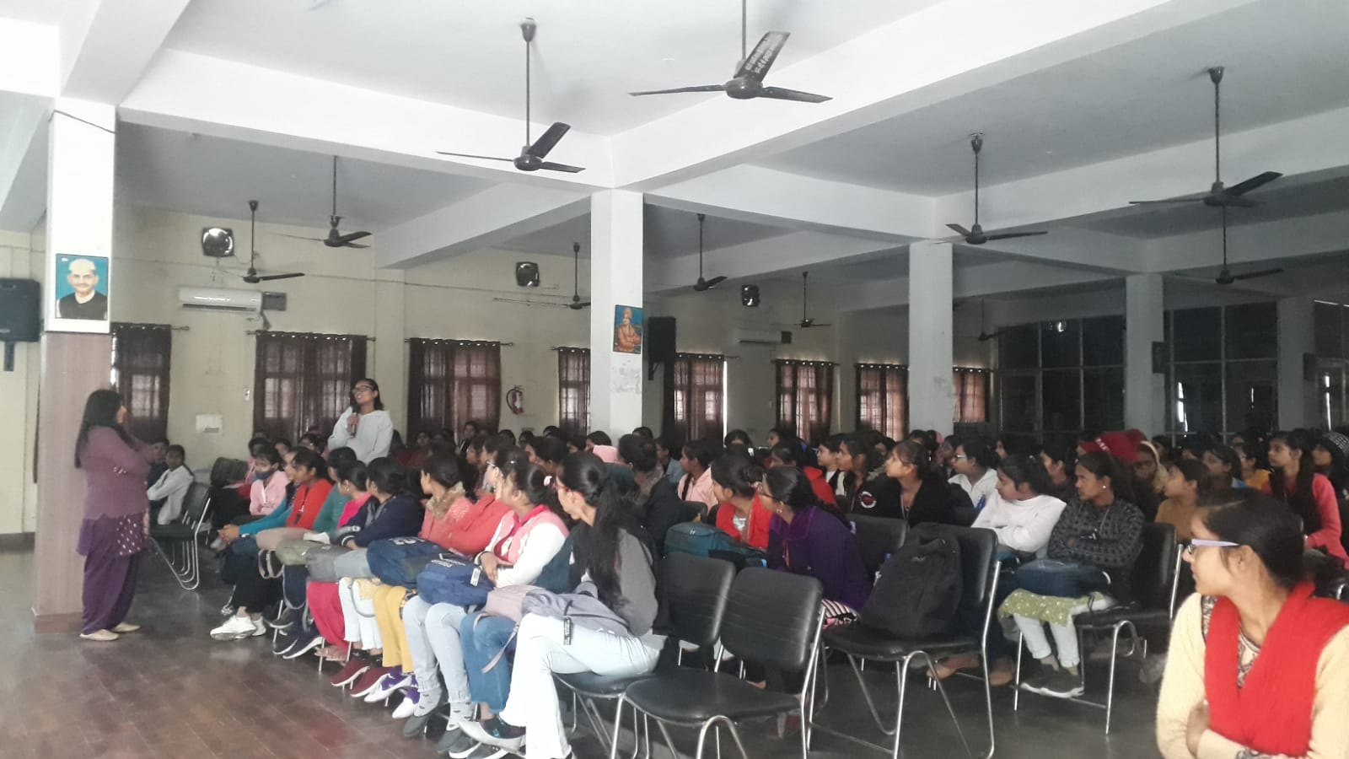

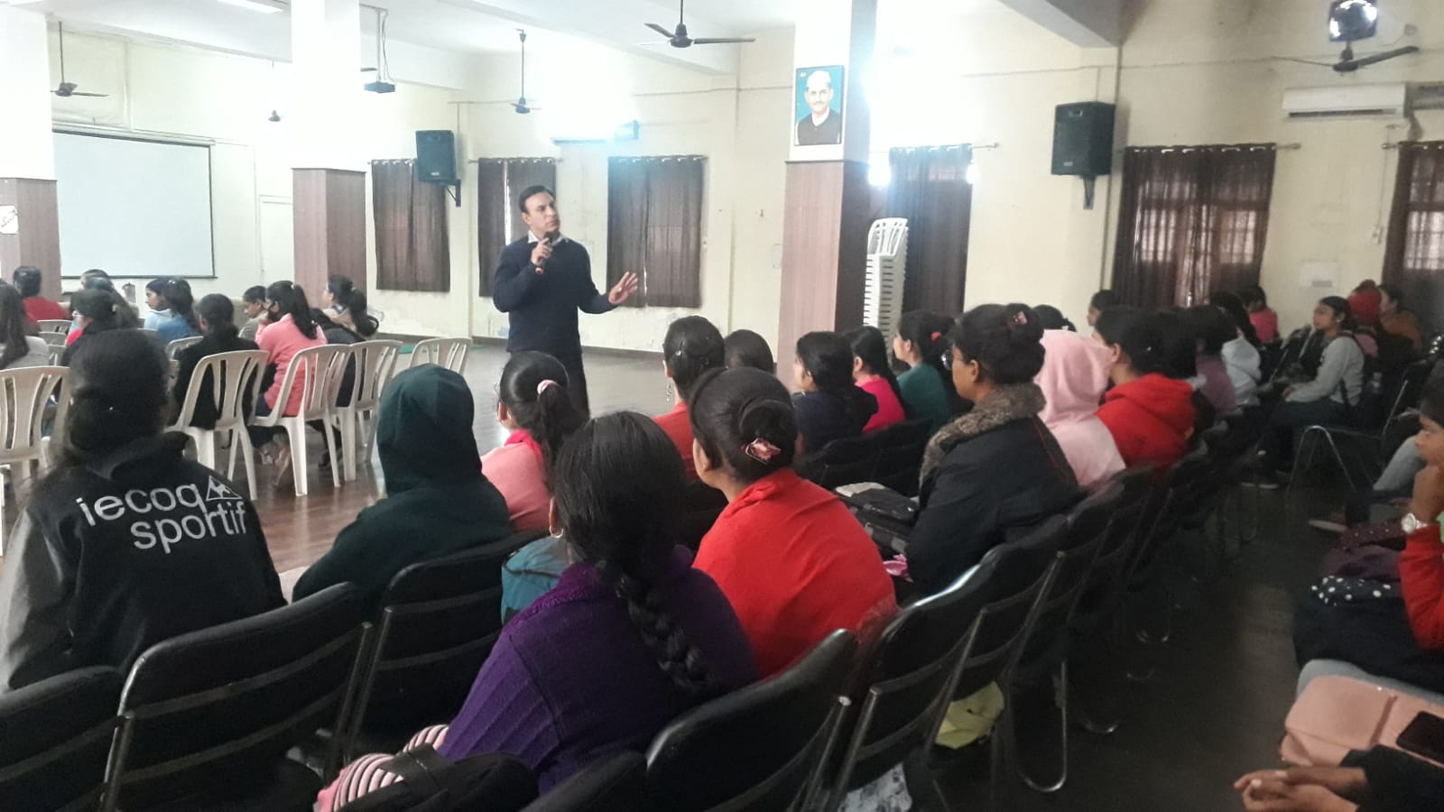

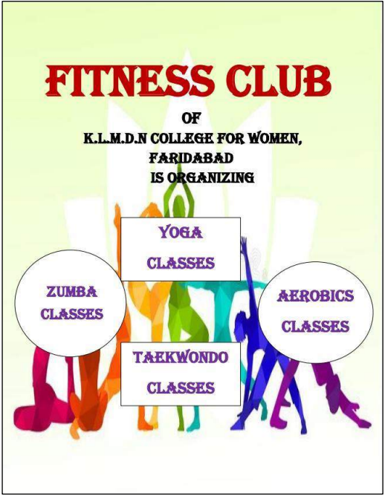

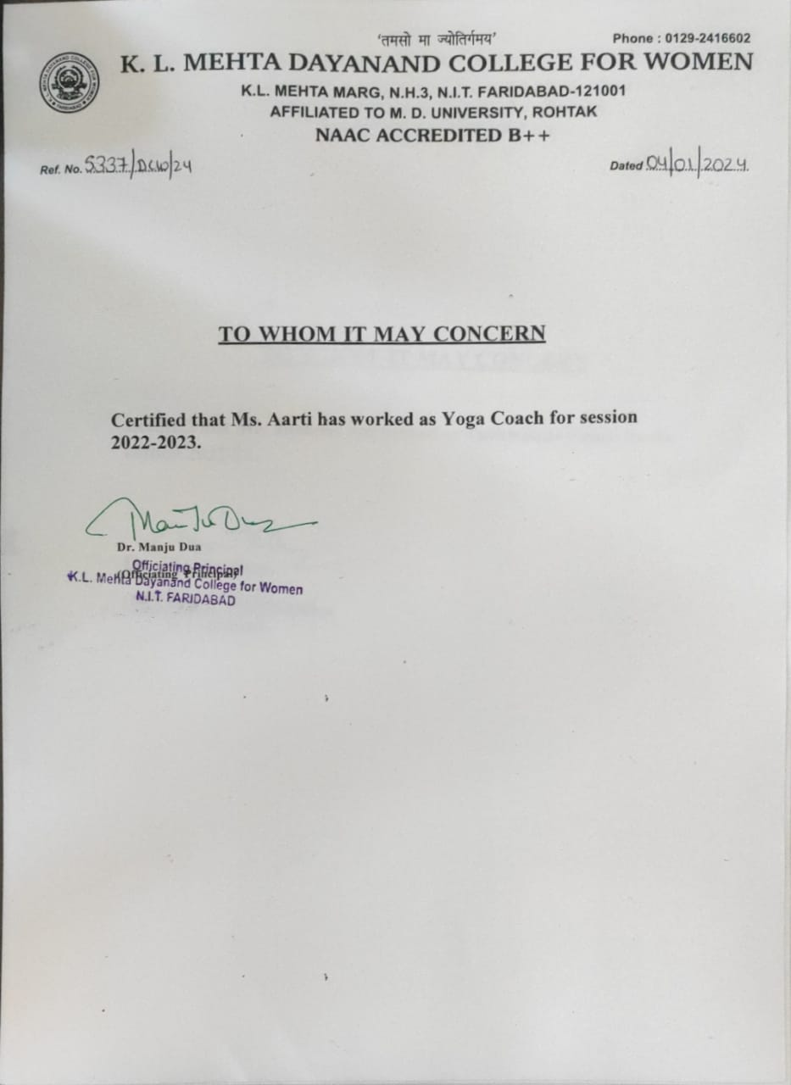

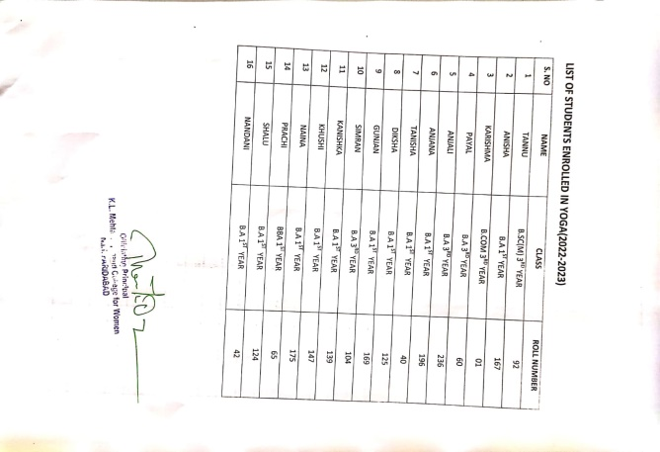

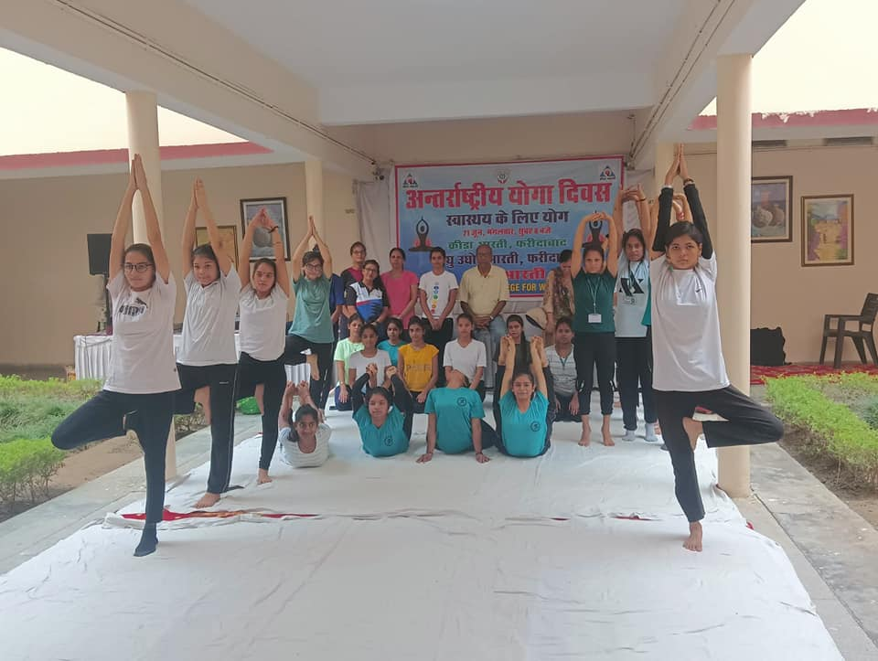

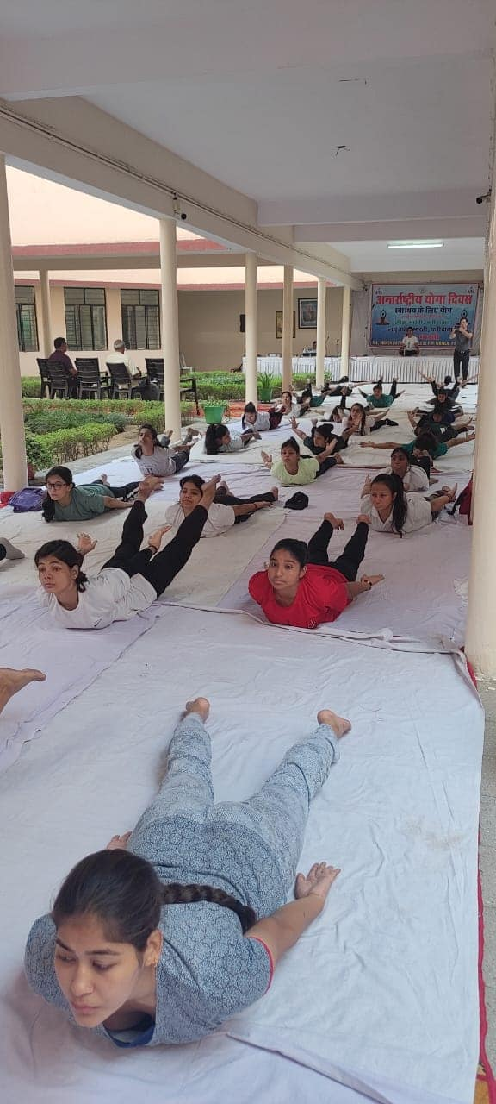

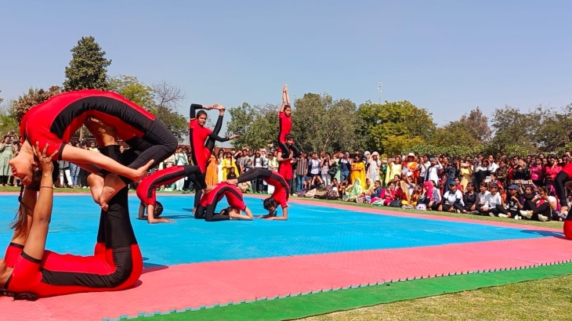

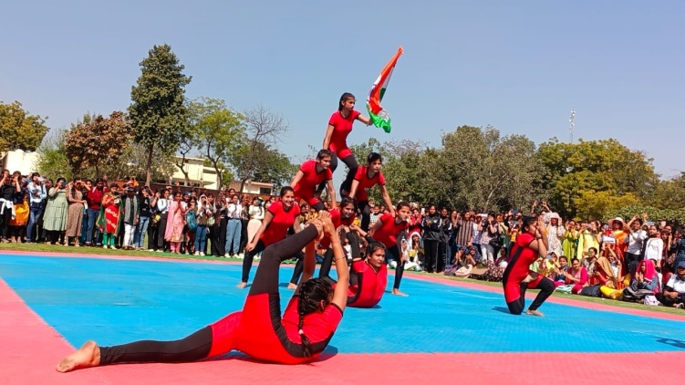

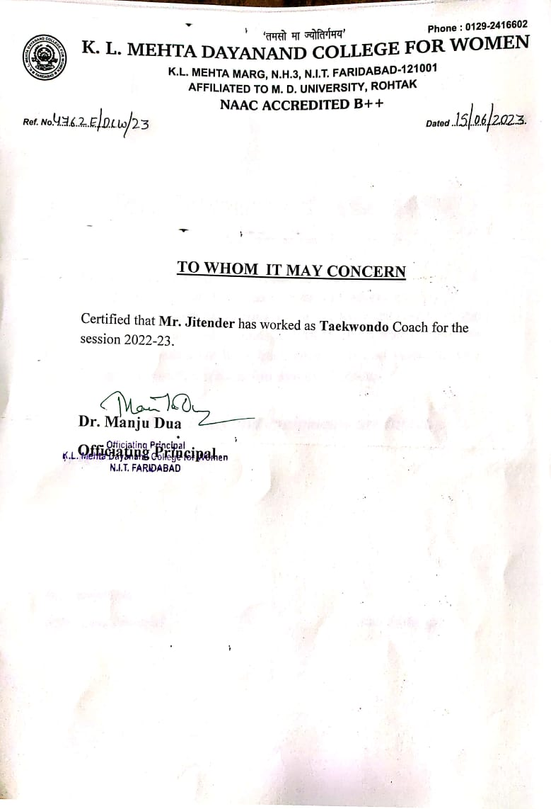

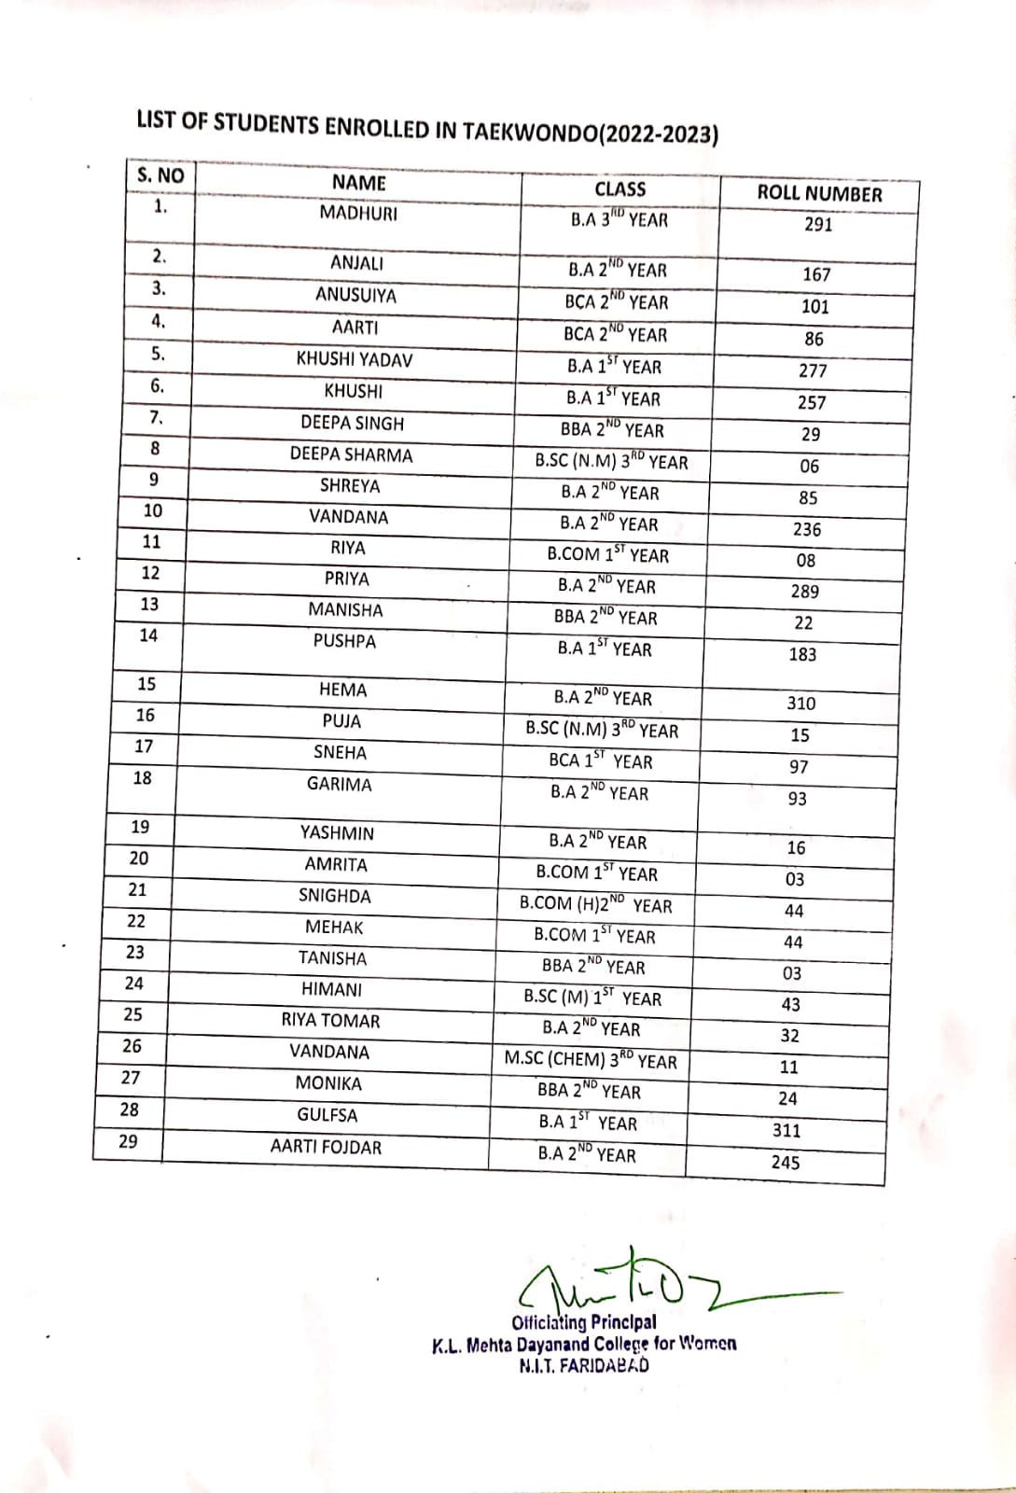

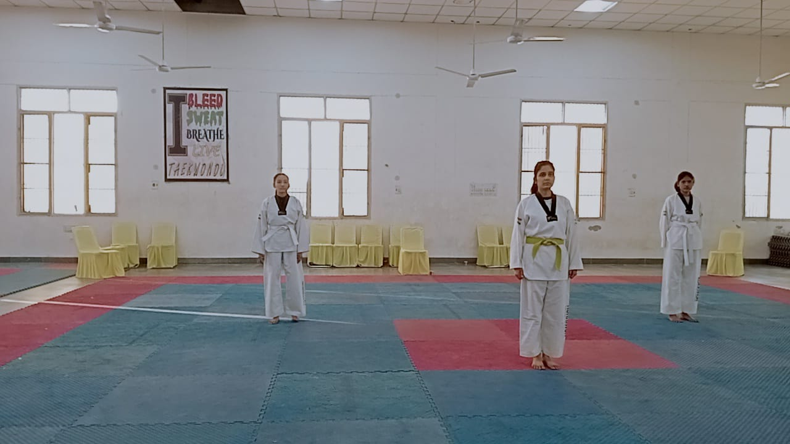

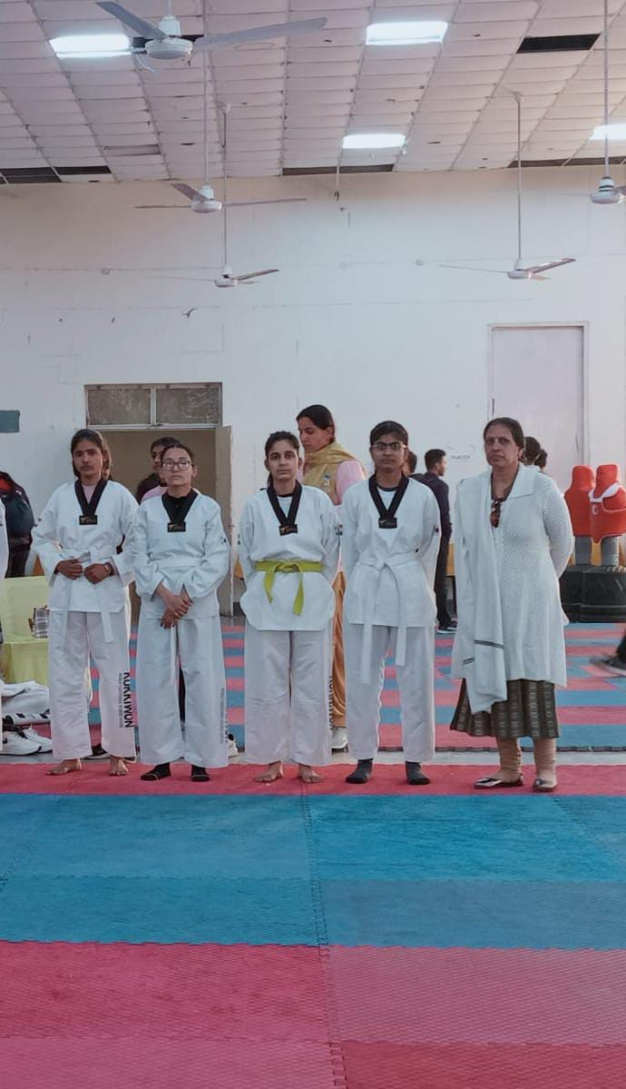

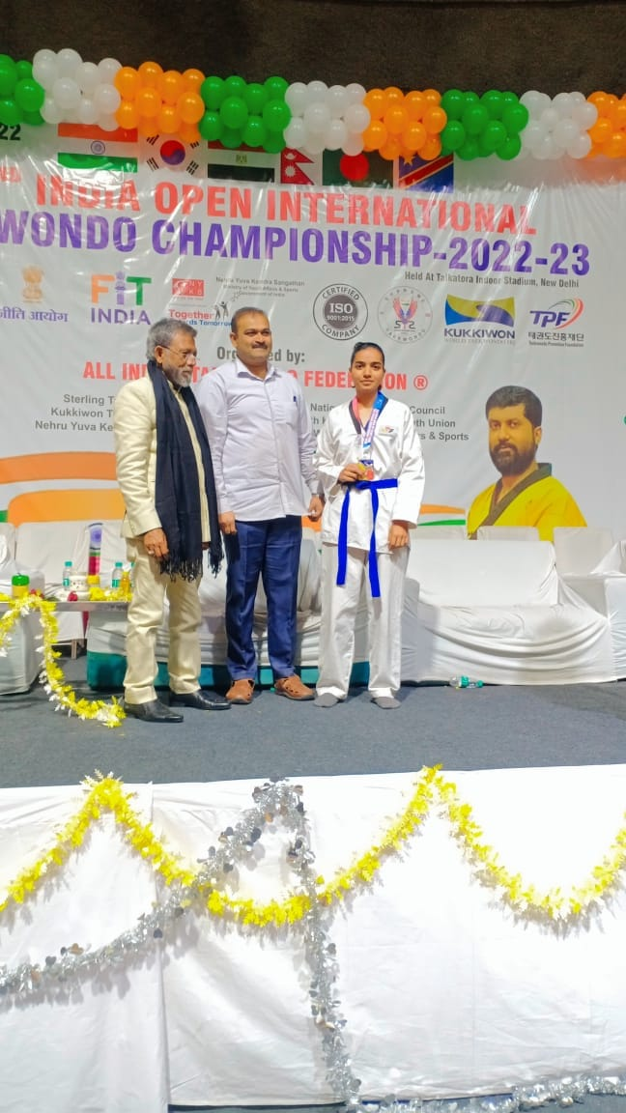

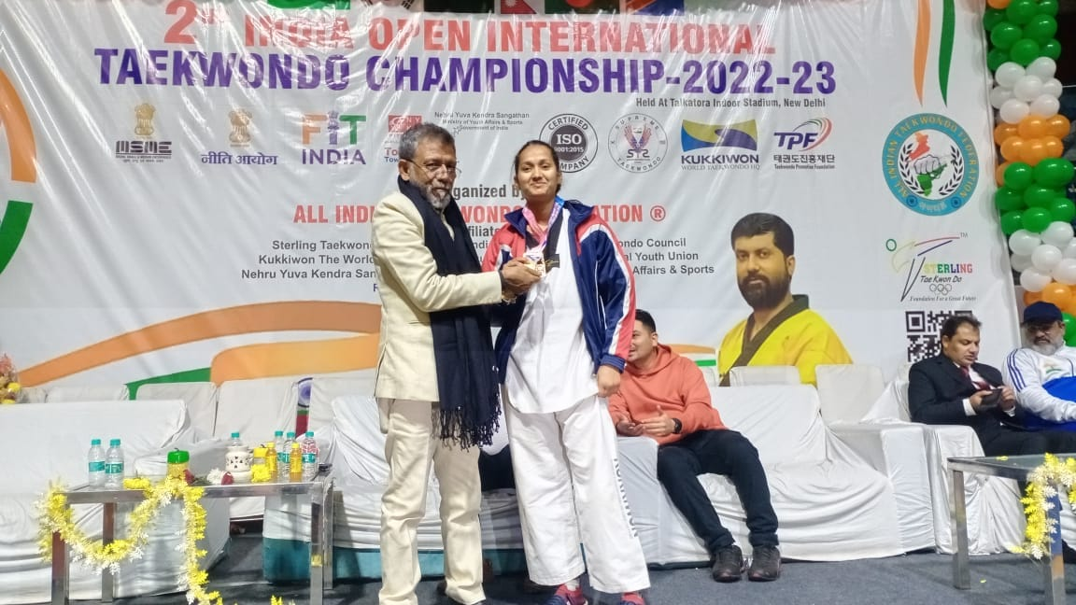

Health And Hygiene based Activities of Home Science Department (2022-2023)

Expert Talk During Breast Feeding Week ,2022
On the occasion of World Breastfeeding Week (August 1-7), Department of Home Science organised an expert talk on 6th August 2022 on the topic “Step up for breastfeeding: Educate and support” by Ms. Priyanka Pawar, Clinical Dietician at Asian Hospital, Faridabad. The talk was organized on the virtual platform for the benefit of students of BSc Home Science and BA. In order to shed light on the importance of breastfeeding for mothers, Ms Pawar told that breastfed children are more intellectual and fit and their chances of being overweight and prone to diabetes are comparatively lesser than the ones who aren’t. Emphasizing the World Health Organization recommendations of exclusive breastfeeding for the first six months of life, Ms. Archna Dua (Head of the Department) told that mothers need practical support to initiate breastfeeding as soon as possible after birth (within the first hour). Dr. Manju Dua (Officiating Principal) appreciated the efforts of the department in promoting the importance of more family-friendly policies to protect and support breastfeeding. She said that more would-be mothers should be subjected to counseling so that the practice of breastfeeding should be inculcated right from the beginning. Around 50 students of B.Sc Home Science and BA benefitted from the talk. Ms. Benu Mehta presented the vote of thanks
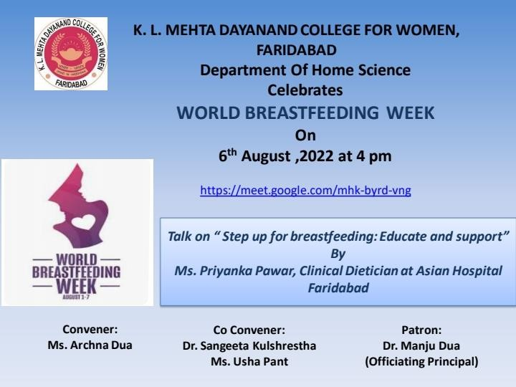

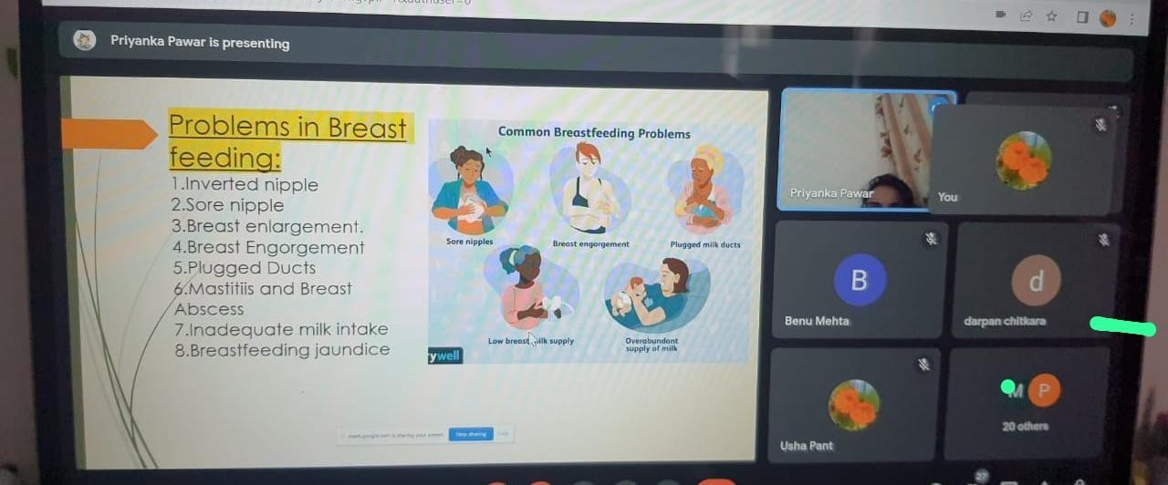
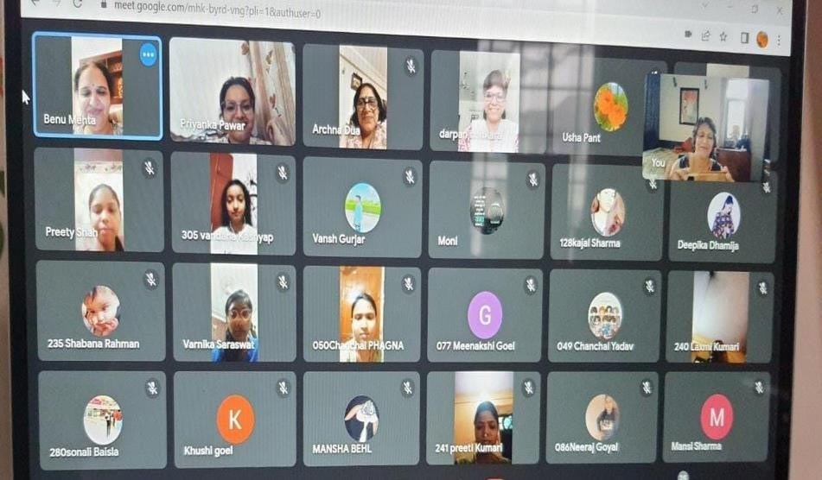

Diet Counselling Sessions During Nutrition Week

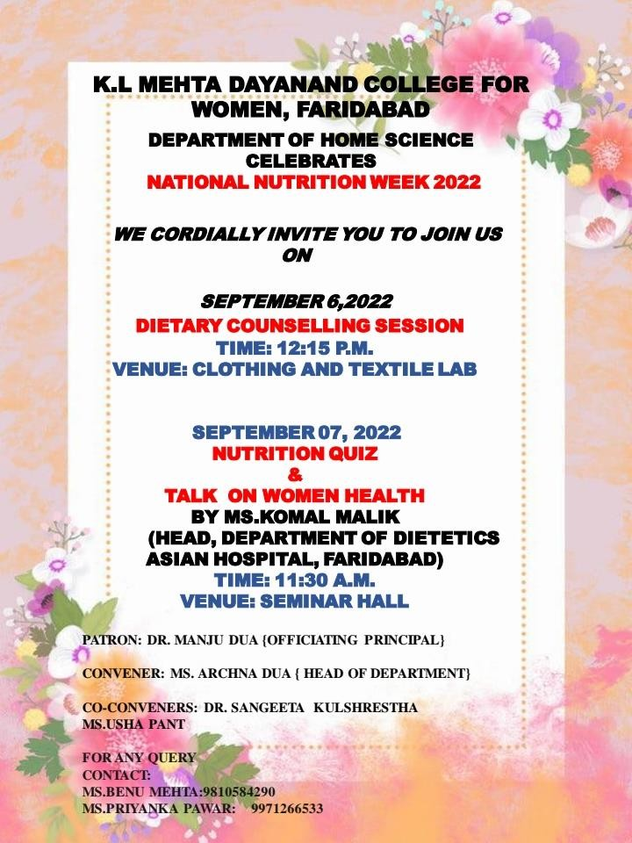

Department of Home science organised diet counselling session on 6th September 2022 in continuation of celebration of Nutrition Week. Principal Dr Manju Dua encouraged the students to adopt healthy lifestyle and eat nutritious food. Ms. Archna Dua, Head of the Department, welcomed the resource person, Ms. Neha (Clinical dietician at Asian hospital, Faridabad) and addressed the students. All the faculty members actively helped in the diet counselling session. Faculty members and students from different programmes benefitted from the session and got their BMI calculated.

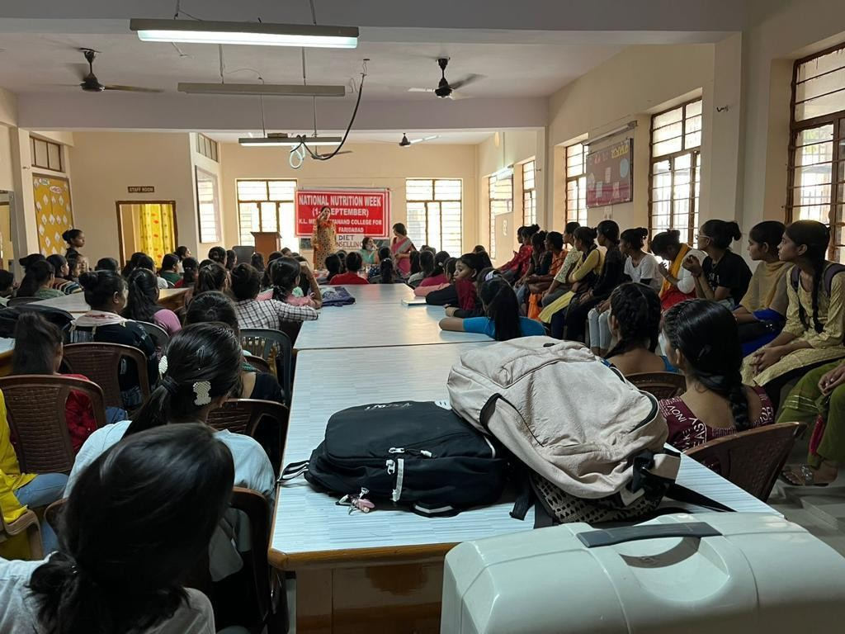

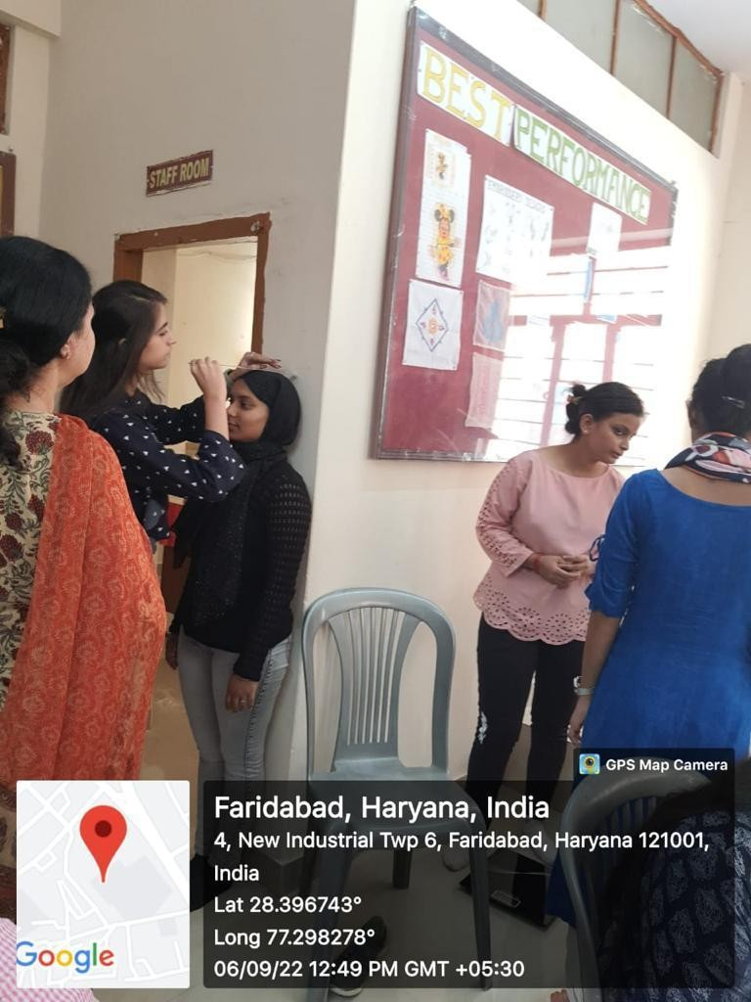

HEALTH TALK BY DT. KOMAL MALIK FROM ASIAN HOSPITAL, BLIND TEST GAME AND NUTRITION QUIZ COMPETITION
Department of HOME SCIENCE organized BLIND TEST GAME AND Nutrition QUIZ COMPETITION during celebration of Nutrition week. Our Principal Dr Manju Dua, graced the occasion and encouraged the students to participate in departmental activities. Our Head of Department, Ms.Archna Dua felicitated the resource person MS.KOMAL MALIK, HEAD DIETICIAN OF ASIAN HOSPITAL .She delivered lecture on WOMEN HEALTH AND NUTRITIONAL REQUIREMENTS DURING DIFFERENT PHASES OF LIFE. She also shared her experience of various therapeutic diets like PCOD; Weight Reduction etc. Dr.Sangeeta along with Ms.Priyanka Pawar also regulated the nutrition quiz and games for students. . All faculty of home science made the celebration a great success. The distribution ceremony. And our Principal, Dr Manju Dua gave the prizes to all the winners who actively participated in various intercollege competitions during National Nutrition Week. Mrs.usha, Ms.Benu & Ms Jyoti made the function a great success.
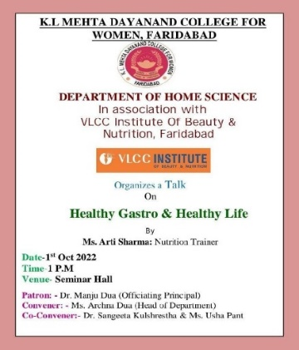
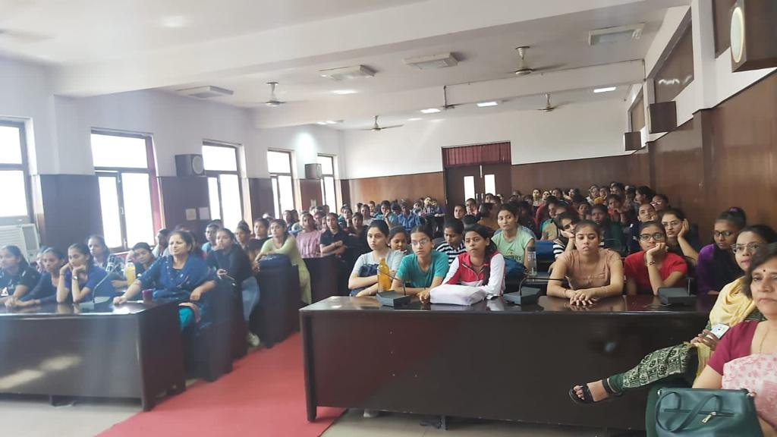
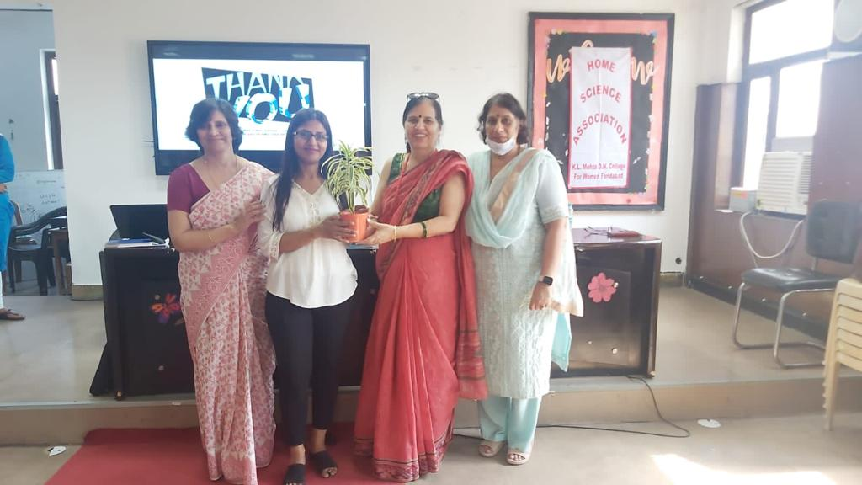

HEALTHY GASTRO AND HEALTHY LIFE

Department of Home Science in association with VLCC Institute of Beauty and Nutrition, Faridabad organized a talk on Healthy Gastro and healthy life. Principal Dr. Manju Dua, told the students about the benefits of eating healthy foods. Ms. Archna Dua (H.O.D.) welcomed the resource person Ms. Arti Sharma. Ms. Priyanka Pawar conducted the program. Ms. Usha Pant gave the vote of thanks. Ms. Benu and Ms. Jyoti helped in organizing the talk. Free vouchers from VLCC for hair cut were also distributed to the students. Ms. Aarti Sharma, nutrition trainer at VLCC, talked about importance of good bacteria and probiotics for a healthy gut. Students interacted with the speaker in the end and asked few questions

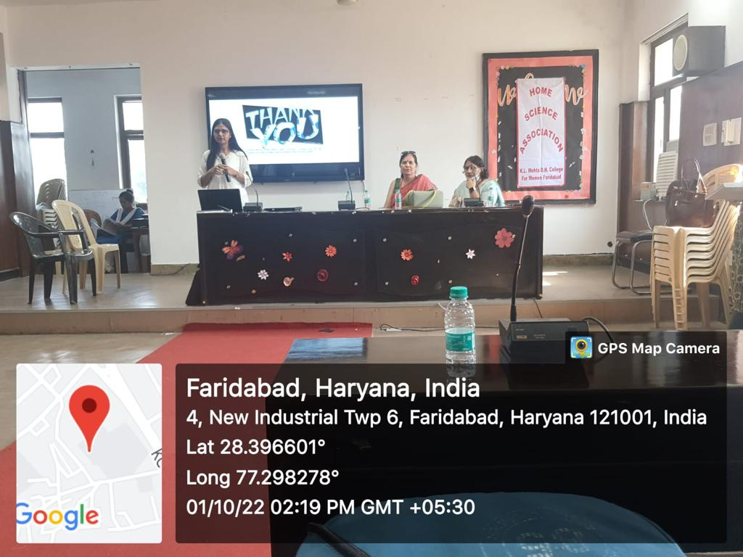
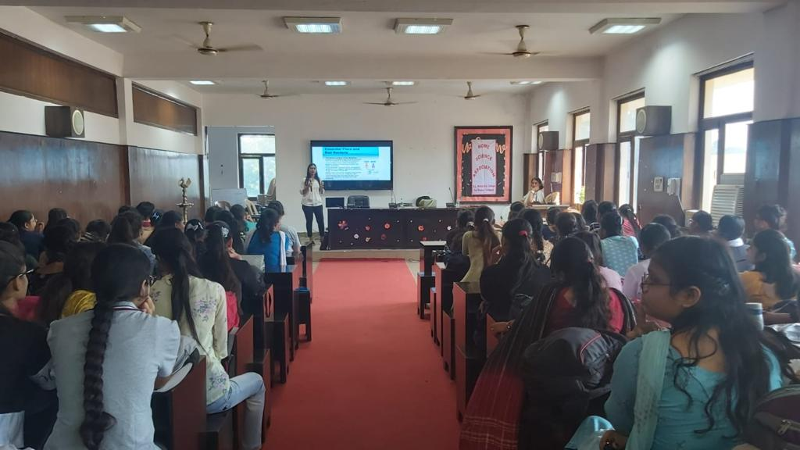

Diabetes Day

Department of Home science celebrated World Diabetes day i.e., on 14th November 2022. The theme was "Access to Diabetes Education". The objective was to create awareness among the students about diabetes regarding causes, preventive measures, diet, food habits etc. A talk was delivered by Ms. Priyanka which was appreciated by one and all present. Dr.Manju Dua (officiating principal) motivated the students to follow a healthy life style. Ms. Archna Dua (HOD, Home science) told the students to spread the message in their families and neighbourhood about diabetes care. All the staff members Dr. Sangeeta Kulshrestha, Ms. Usha Pant, Ms. Benu Mehta, and Ms. Jyoti also joined the talk.

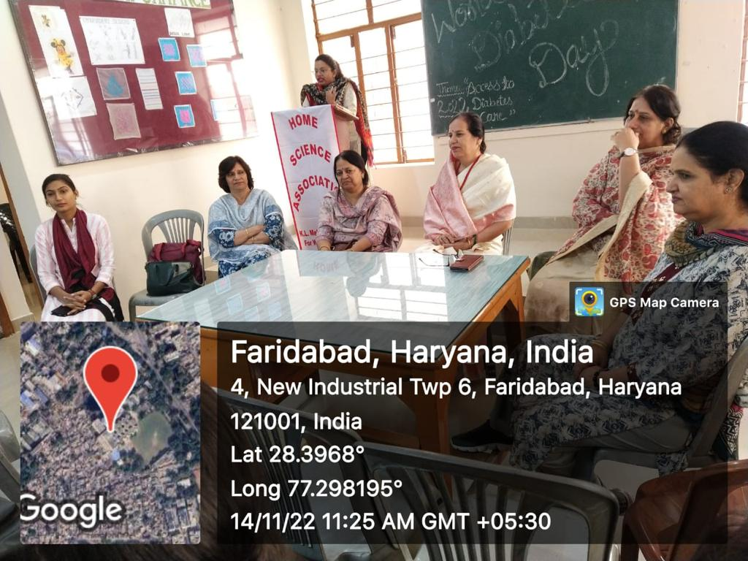

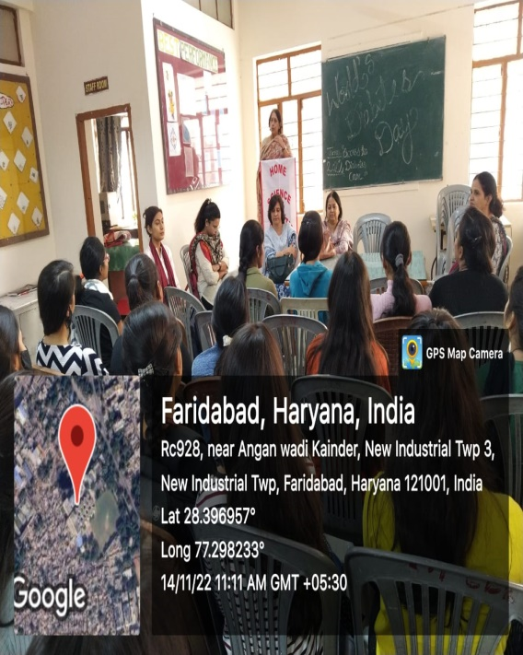

WORLD HIV AIDS DAY

Red Ribbon Club of K.L. MEHTA DAYANAND COLLEGE, FARIDABAD celebrated 1st December as a WORLD HIV AIDS DAY in collaboration with YOUTH RED CROSS SOCIETY and ROTARY CLUB. Dr.SHVETA ARYA, YRC COUNSELLORS given the lecture on HIV AIDS DAY AND ITS PREVENTION among the students. Students even made the cross chain symbolizing AIDS accompanied with their faculties. Nearly 80 students actively participated in the session. The students and the staff of the college participated with lot of the enthusiasm and zeal under the guidance of respected principal Dr.Manju Dua Ma'am. She also emphasizes on the AIDS and its prevention. Dr. Madhu Singh was the convener of the event and Ms.Priyanka was the Co-convener for the event.

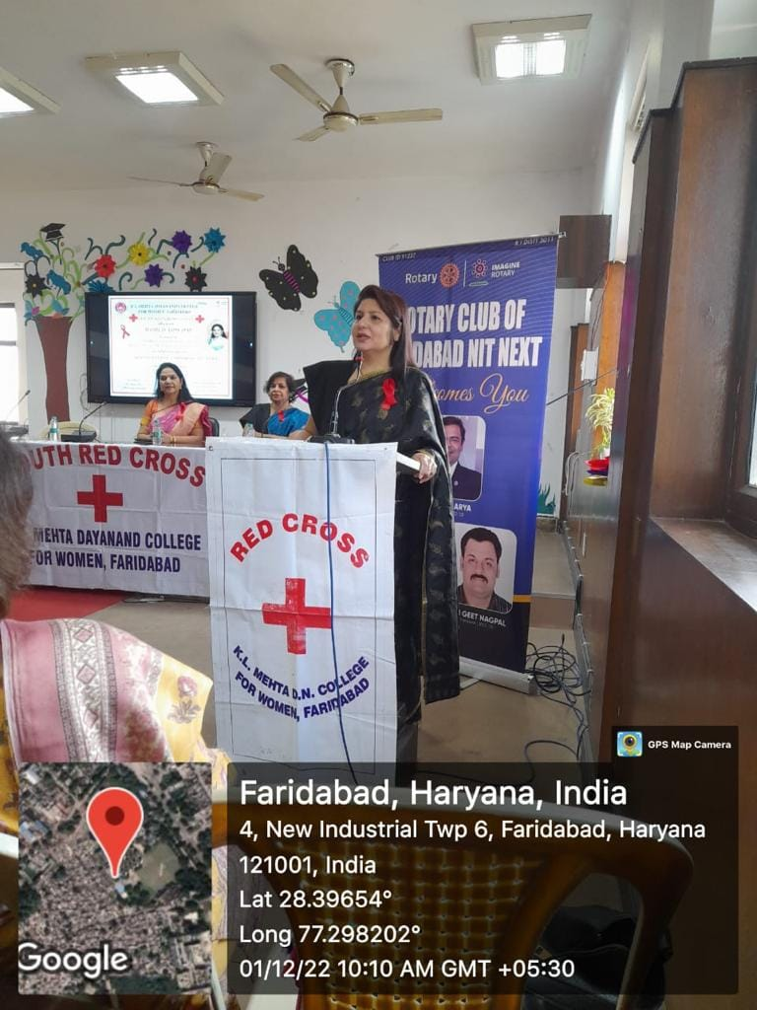

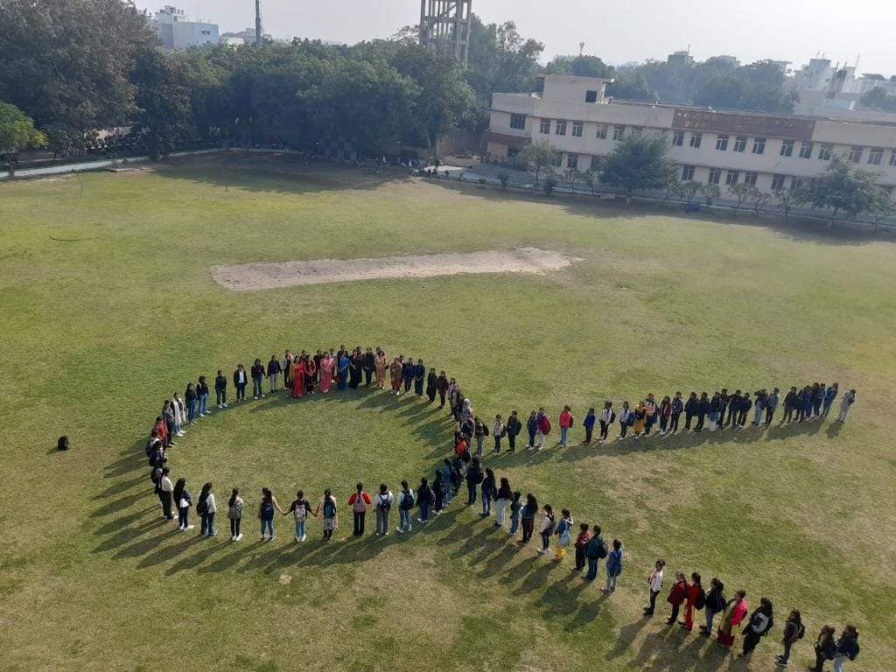

WORLD DIETETICS DAY
On the occasion of world dietetics day i.e., 10th January 2023, the Department of Home science organized webinar by Dr. Vibha Bajpaiee (senior consultant nutritionist from Dubai) .Dr. Vibha spoke on the importance of millets for a healthy life. Dr. Manju Dua (officiating principal) welcomed the guest. Ms.Archna Dua (HOD) highlighted the significance of celebrating world dietetics day. All the faculty members & students of Home science Department had joined the webinar and gained from the informative session. Mrs. Usha Pant gave vote of thanks to Dr. Vibha and appreciated students for patient listening.

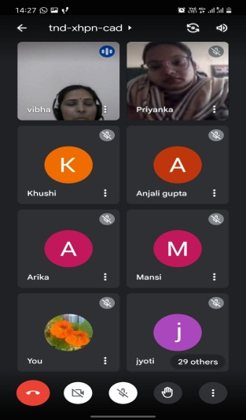
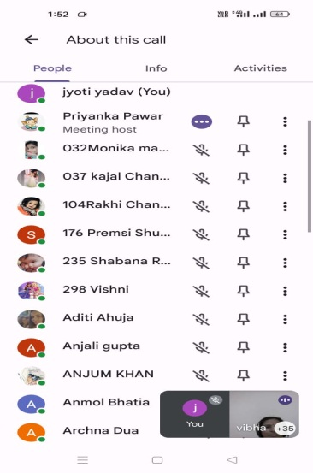

Women Cell celebrated National Girl Child Day and organized expert talk on "Women Health and Hygiene

Women Cell celebrated National Girl Child Day and organized expert talk on "Women Health and Hygiene" on 24th Jan 2023. Ms. Amrita, Diamond Director @ Modicare Ltd. , the resource person of the event, shared her expertise on importance of women health and hygiene with the students. Dr. Priyanka Bahree and Ms. Vaishali Kalra also accompanied the resource person and advised on self-grooming and self-care.Ms. Madhu Saitya convener of Women Cell, Dr. Babita Singh and Ms. Shobha Chawla co-convener of Women Cell coordinated the event. Ms. Ganga Hariharan, B.Com (C.A) hosted the event, Ms. Preeti, BCA final year managed the display on projector, Ms. Jyoti and Diksha, B.A second yr and Ms Rajkumari of B.A. final yr were in charge of photography of the event and Ms.Sakshi Jha, Ms. Ayushi, Ms.Muskan and Ms. Jasika of B. Com (Voc) final yr handled discipline. Students enthusiastically participated in the session.

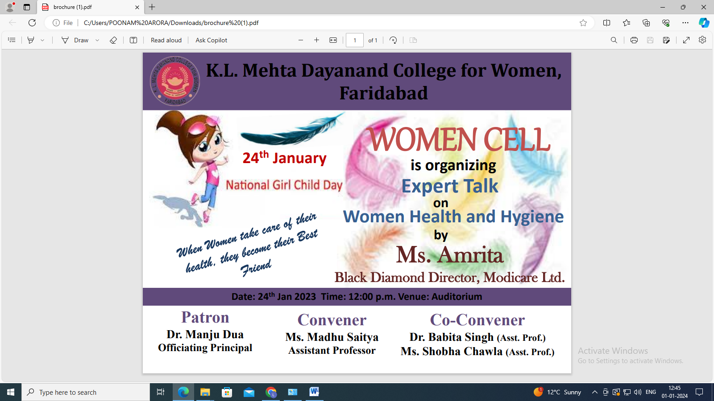

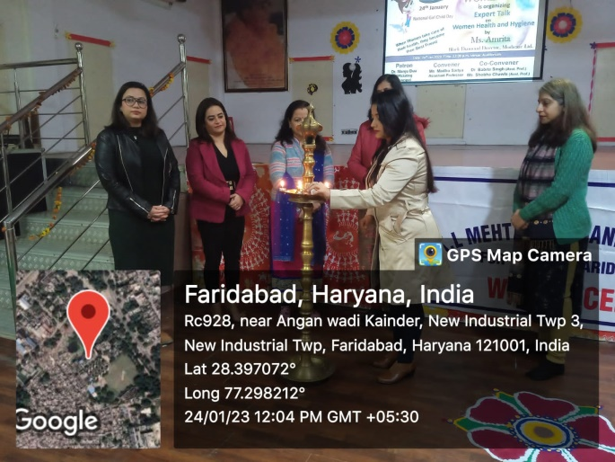
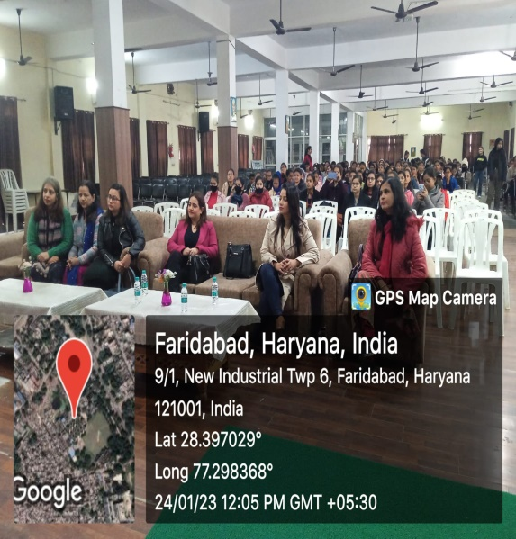

Seminar on Naturopathy
A seminar on Naturopathy was organized in collaboration with International Naturopathy Organization and Vardhman Mahavir Seva Society Faridabad on 25th February 2023. Students were advised to lead Medicine free life by following naturopathy. Around 217 students attended the seminar.

