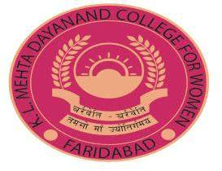

* + 1. **Average percentage of students benefitted by scholarships and free ships provided by the Government during the year**
    2. **Average percentage of students benefitted by scholarships, free ships, etc. provided by the institution besides Government schemes during the year**

**INDEX**

SUPPORTING DOCUMENTS FOR 5.1.1 & 5.1.2

**S.No. Proofs of Documents Page No.**

1. **SCHOLARSHIP PROVIDED BY STATE GOVERNMENT 3-19**

**(DGHE) CHANDIGARH**

**Post metric scholarship for scheduled caste**

* List of students benefitted through Scheduled Caste Scholarship.

1. **SCHOLARSHIP AND FREESHIPS PROVIDED BY 20-34**

**(INSTITUTION/NON GOVERNMENT AGENCIES)**

* Need cum merit scholarship
  + - List of students benefitted through Need cum merit Scholarship
    - Payment Voucher
* Scholarship to Needy students (fee concession)
  + - List of students benefitted through Needy students (fee concession)
* IMA scholarship
  + - List of students benefitted through IMA scholarship
    - Grant Letter
    - Statement of Account
* Earn while you learn Scheme
  + - Payment Voucher
    - Ledger
    - List of students benefitted through Earn While You Learn Scheme



**SCHOLARSHIP PROVIDED BY STATE GOVERNMENT (DIRECTOR GENERAL HIGHER EDUCATION)**

**POST METRIC SCHOLARSHIP FOR SCHEDULED CASTE**

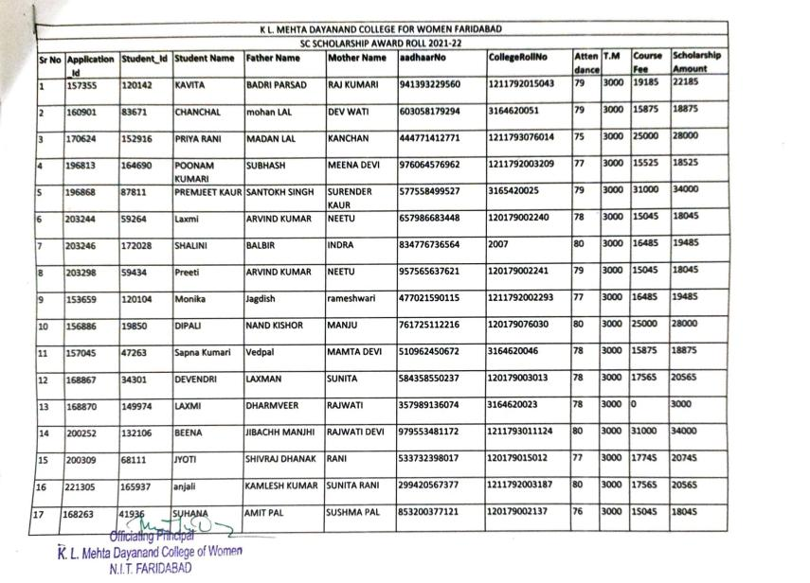**List of students benefitted through Scheduled Caste Scholarship**





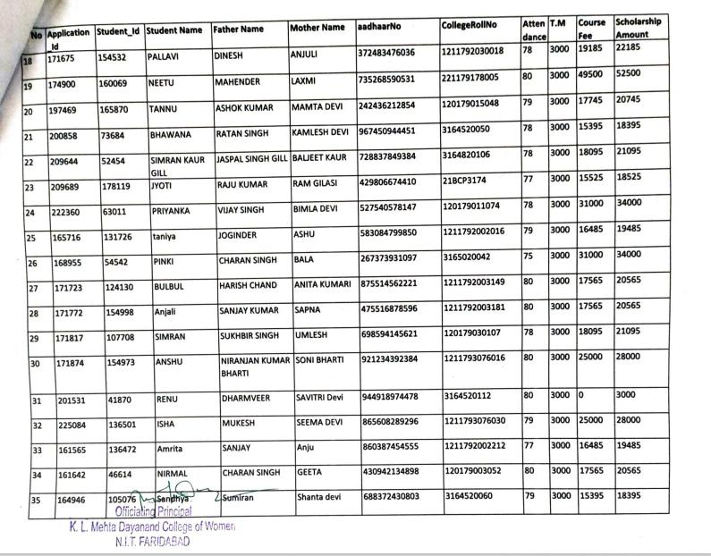





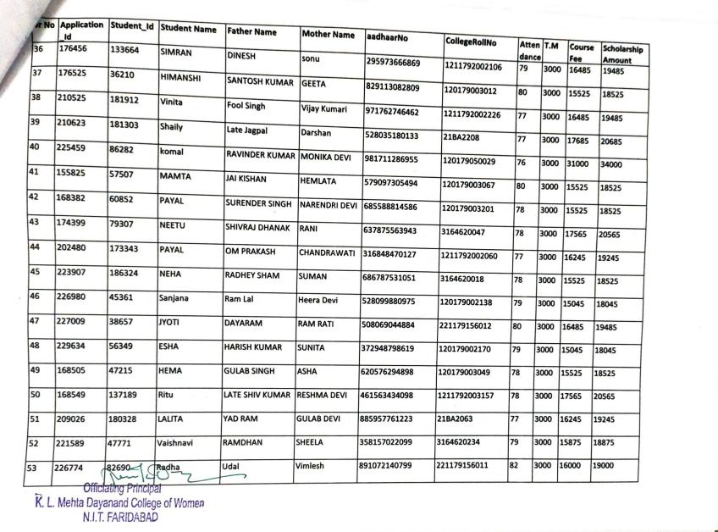





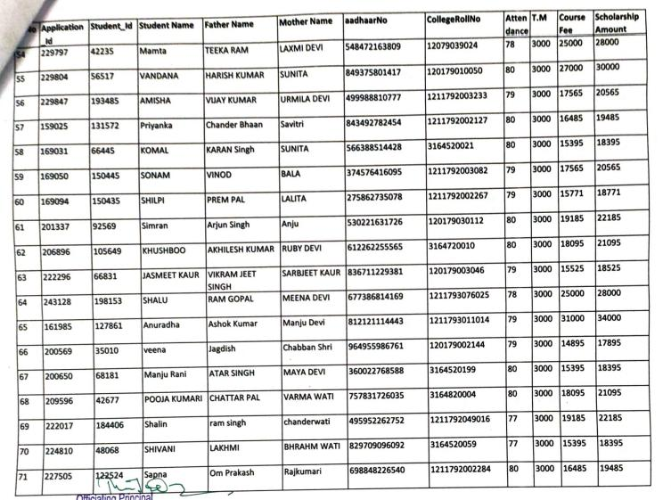





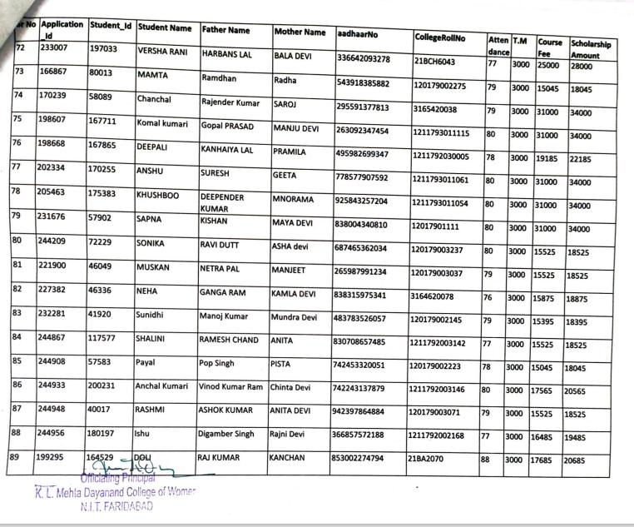





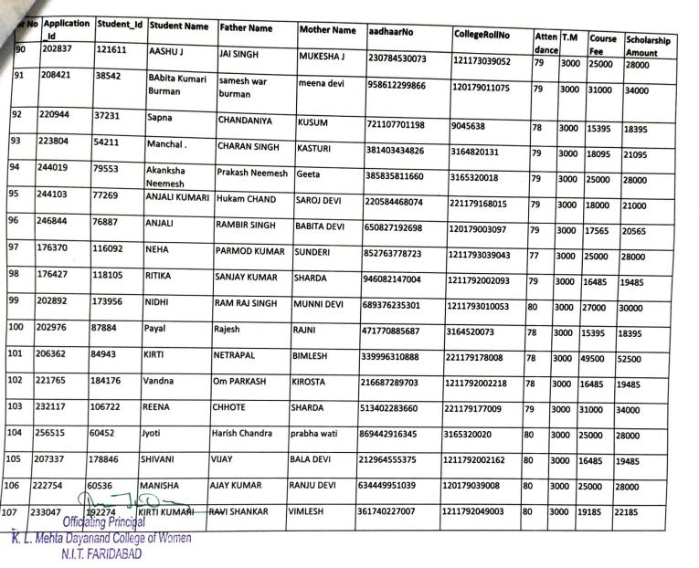



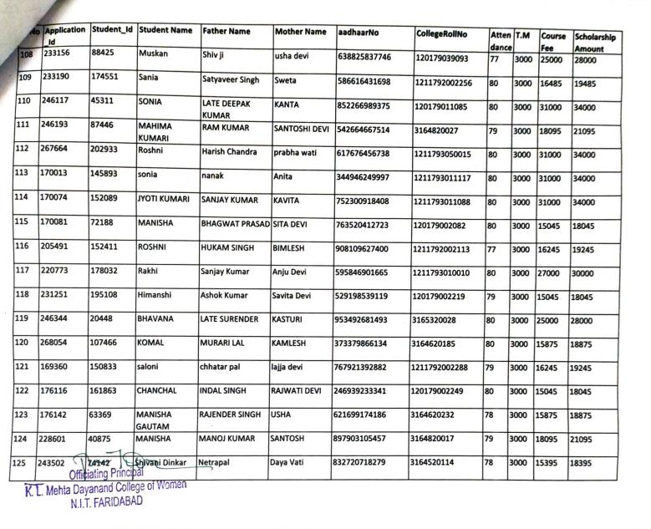





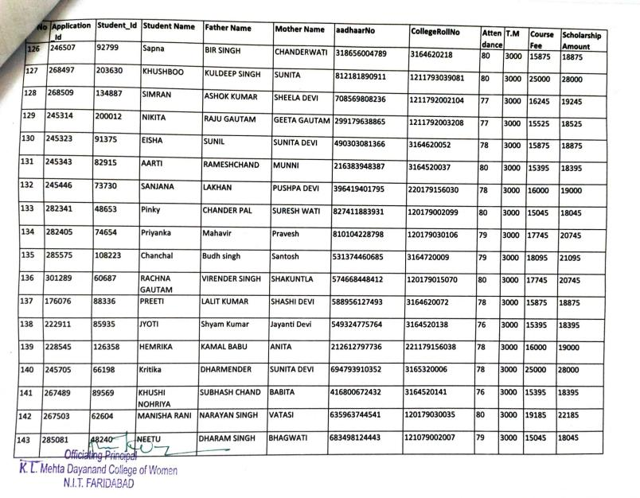





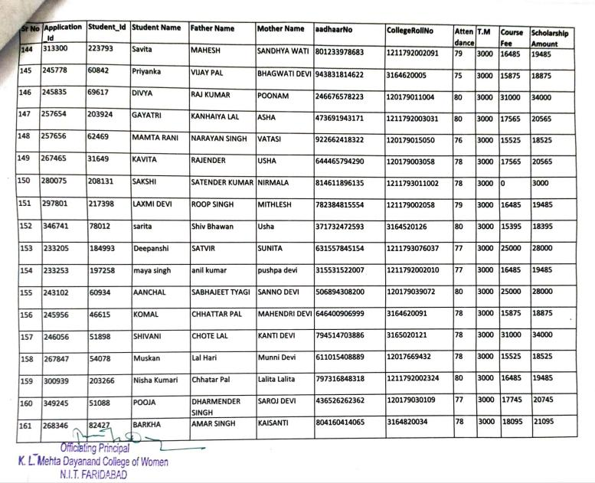





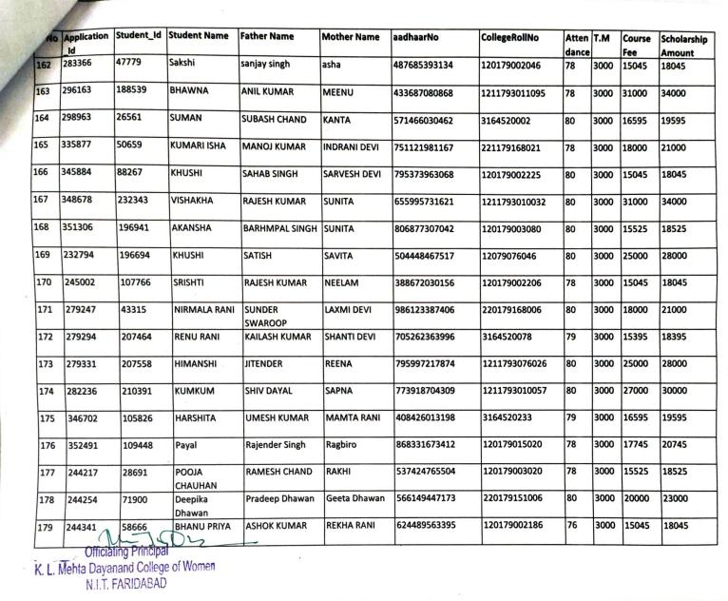





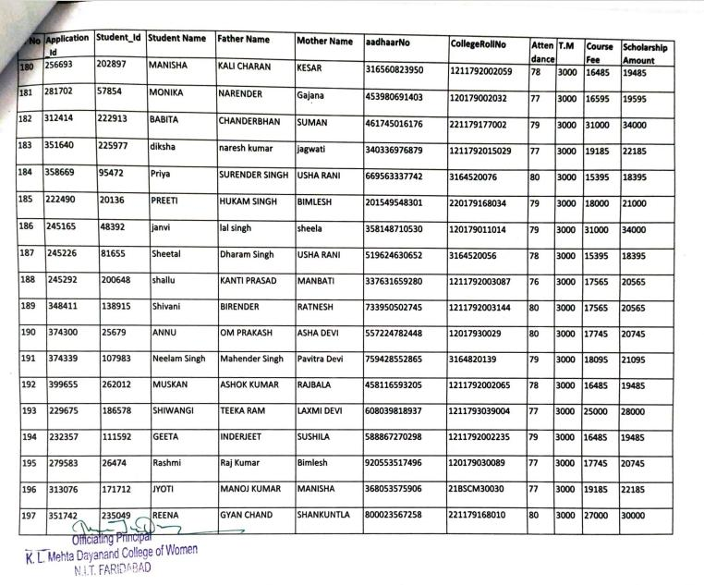





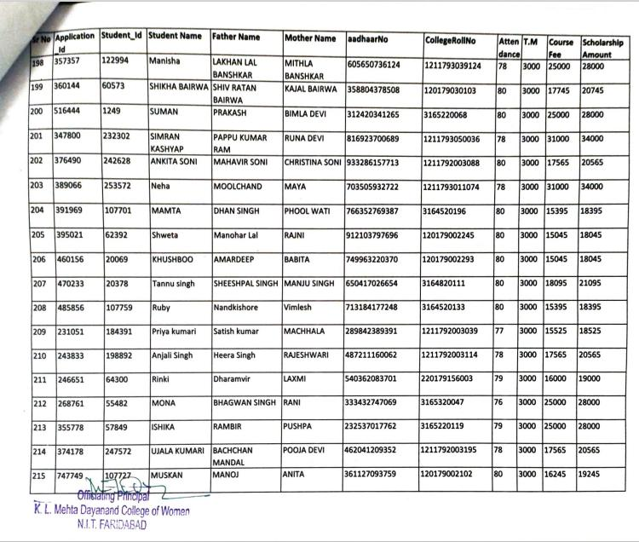





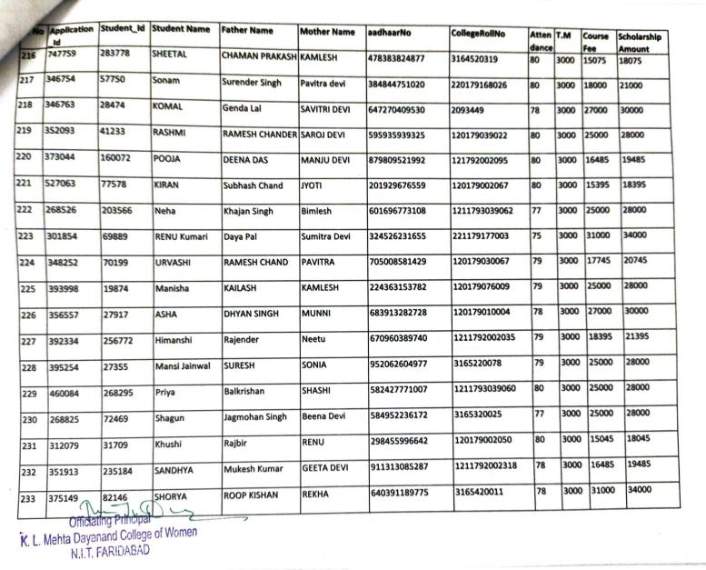



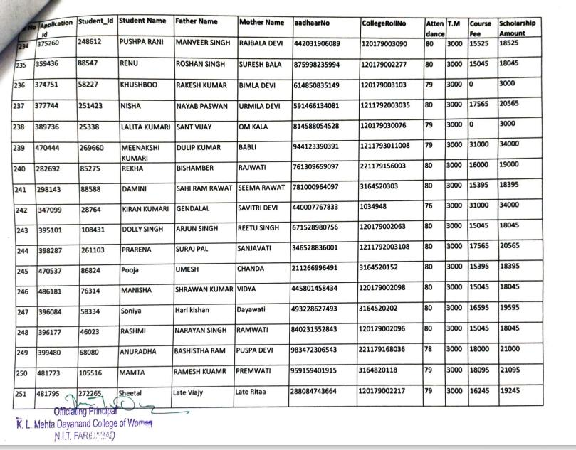





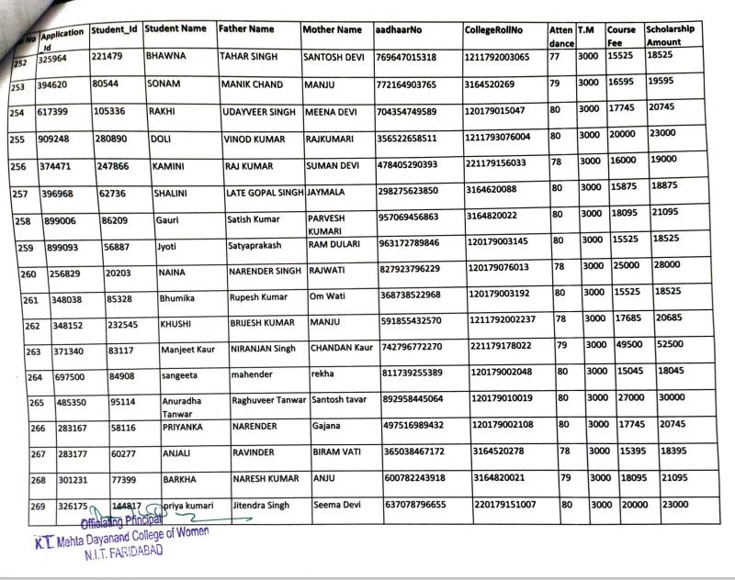





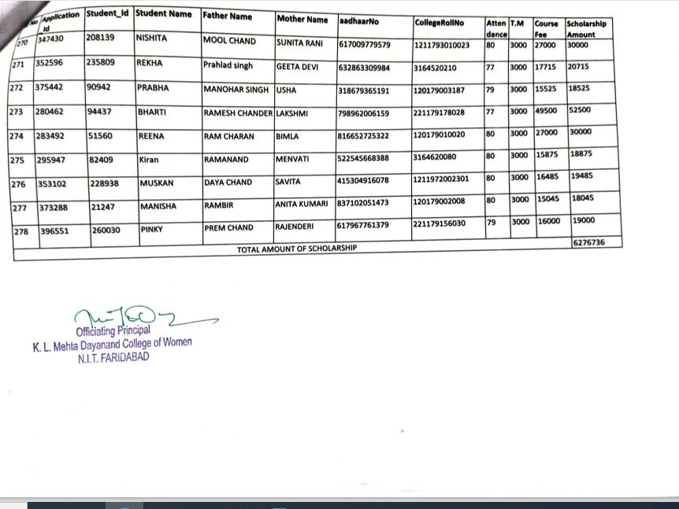





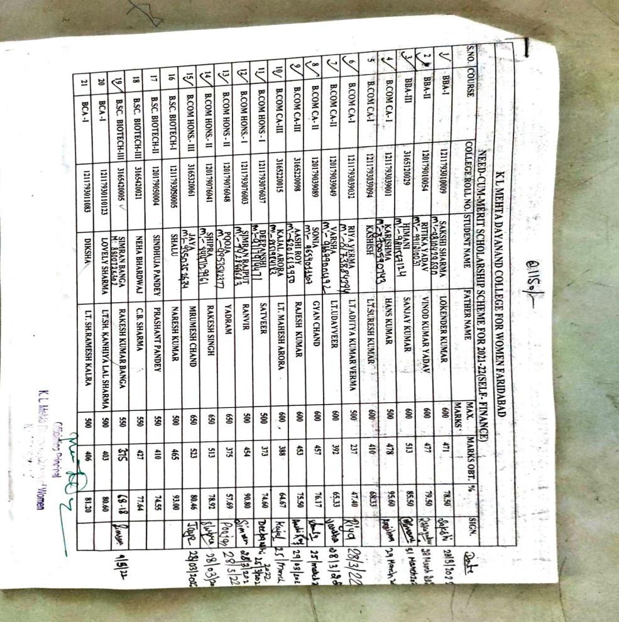LIST OF STUDENTS BENFITTED THROUGH NEED CUM MERIT SCHOLARSHIP (2021-22)





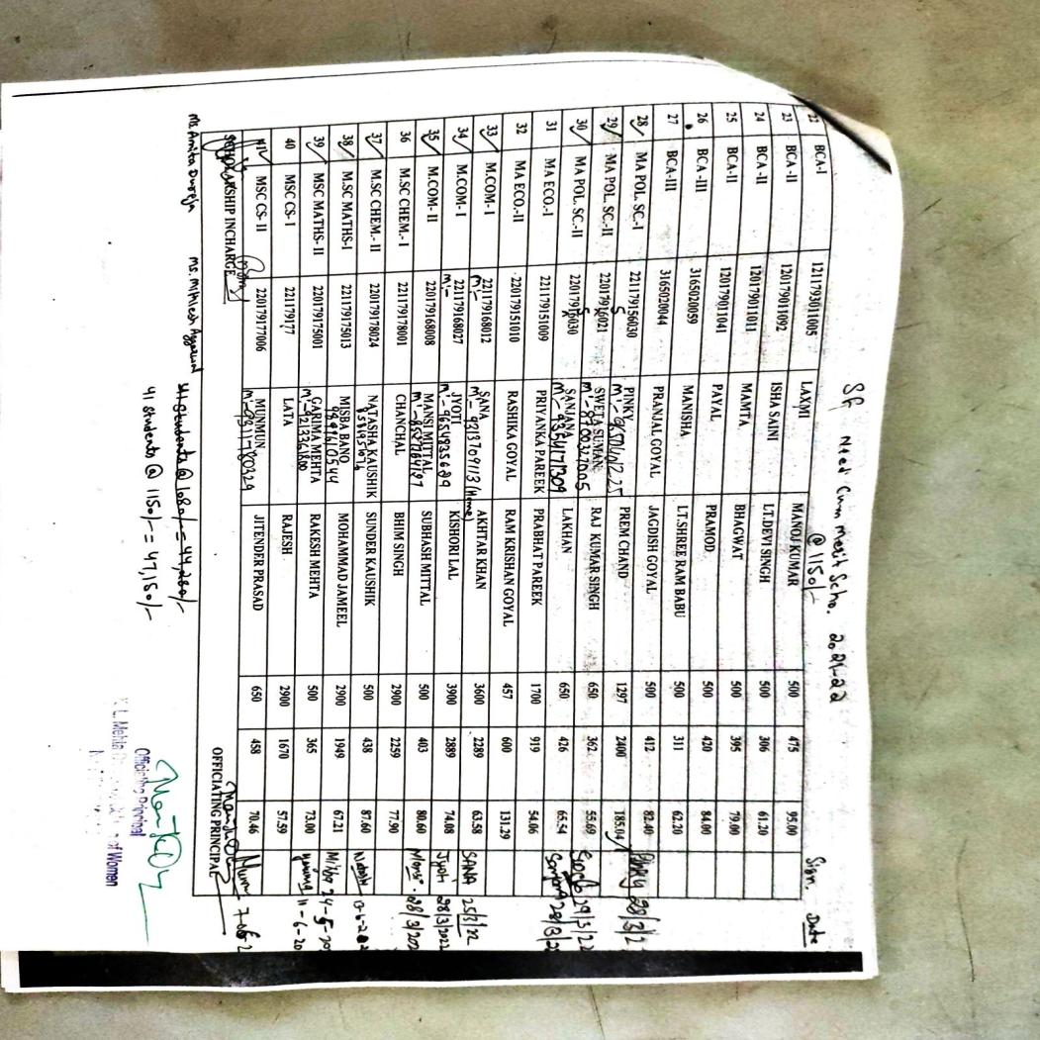





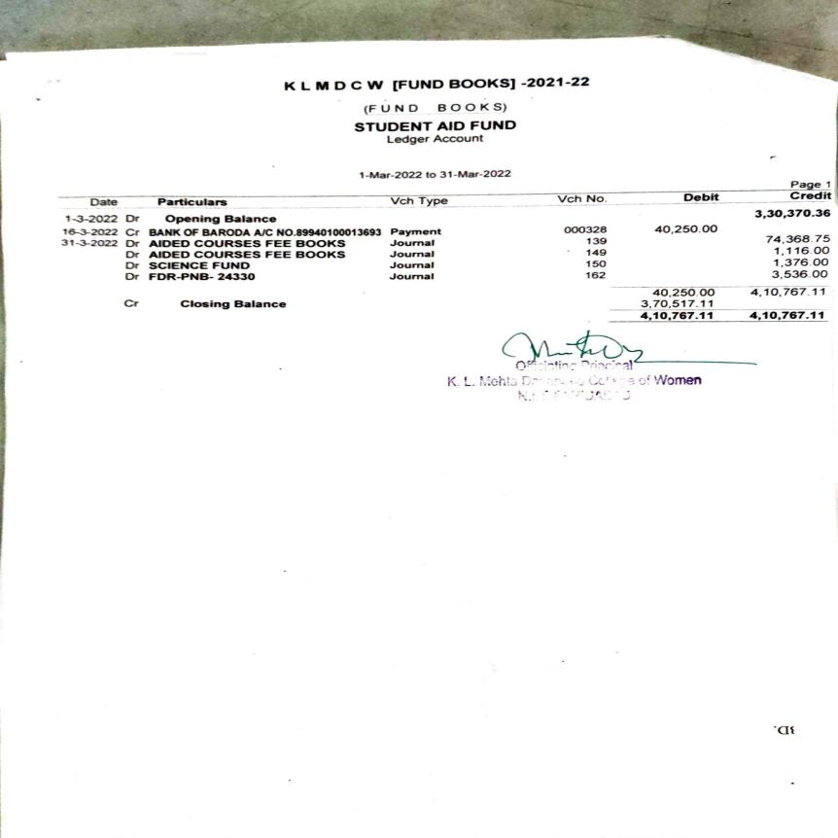















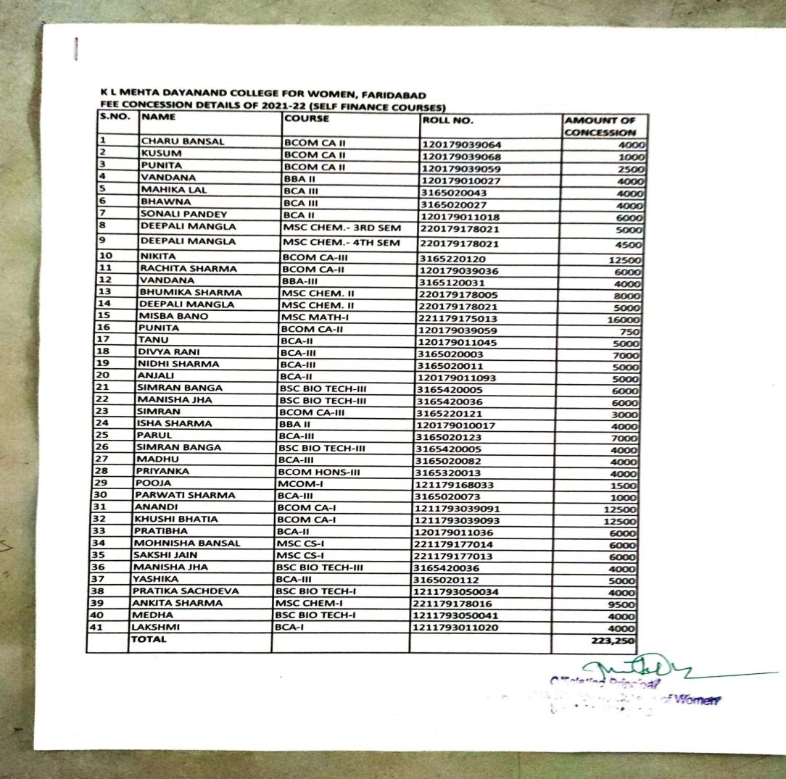

**FEE CONCESSION**



**FEE CONCESSION**

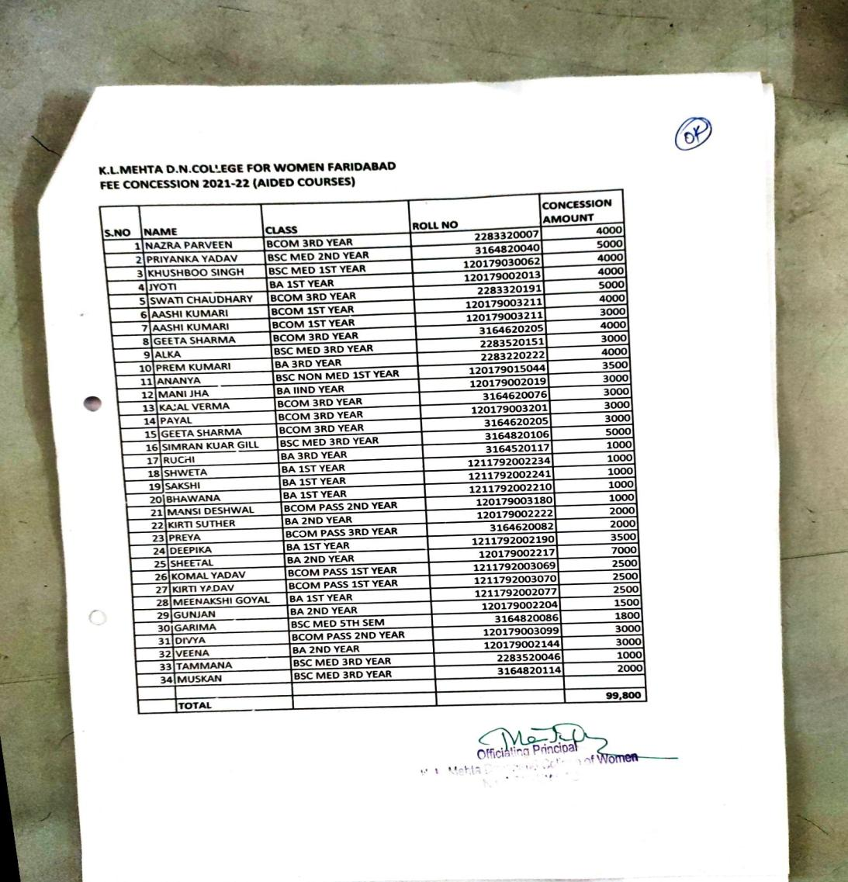





**IMA**

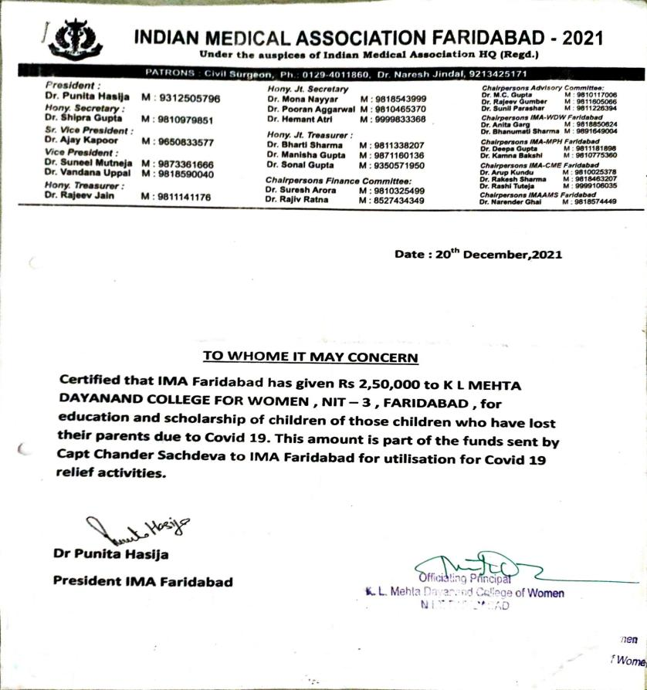







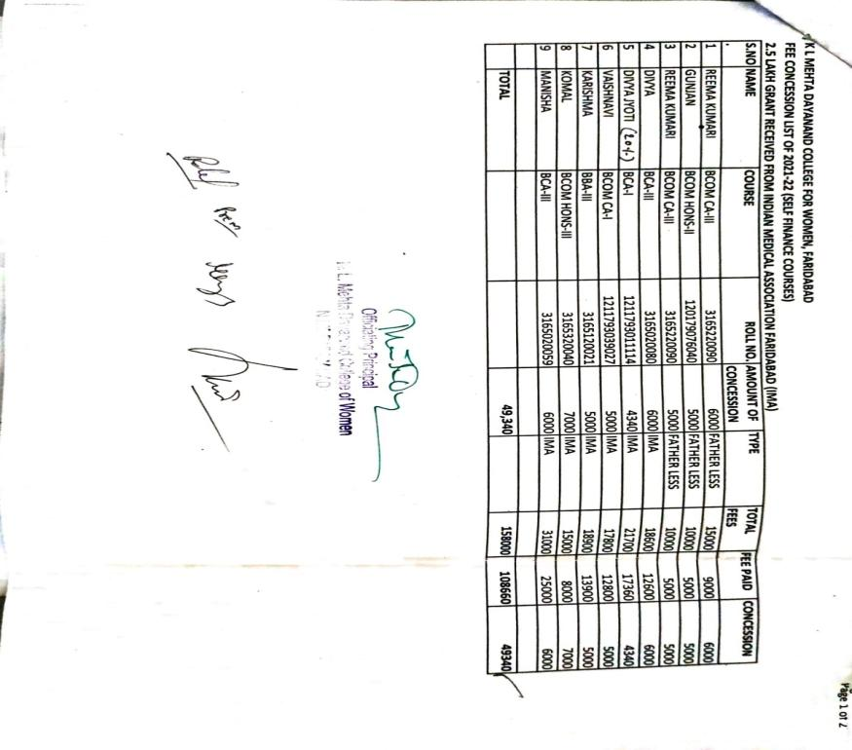

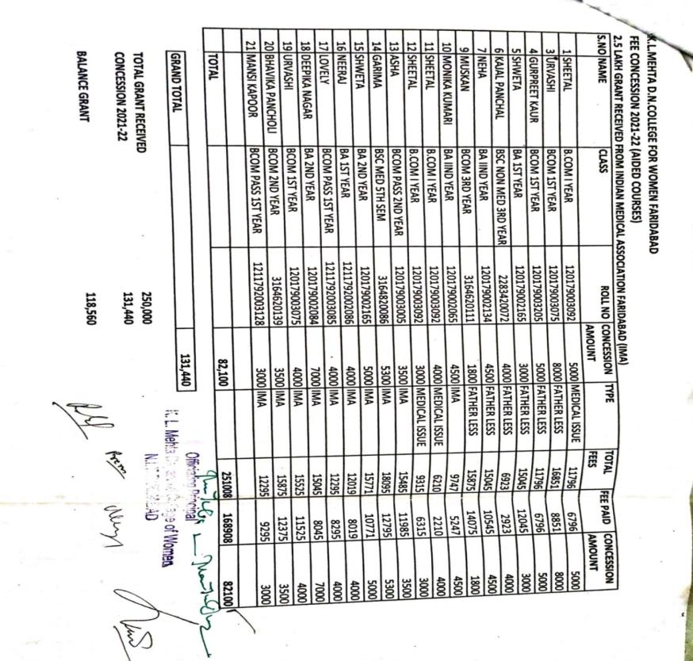



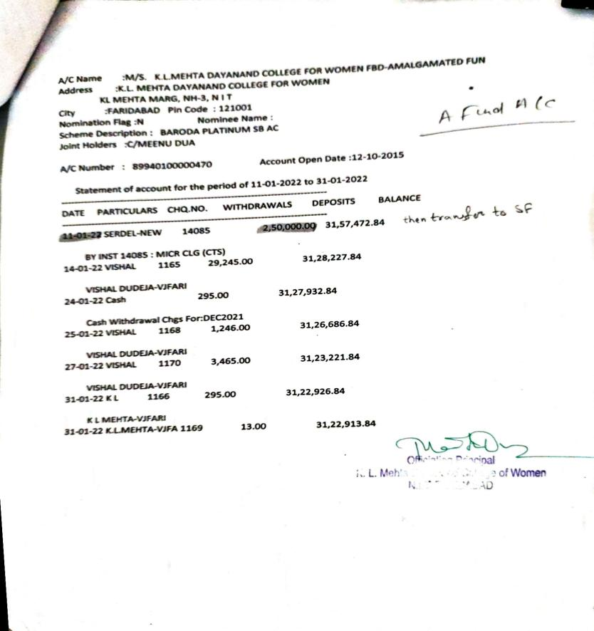



**EARN WHILE YOU LEARN**

