QUIZ REPORT 2021  K.L. Mehta Dayanand College organised online quiz competition on the topic Impact of Covid-19 on Indian Economy on 15/6/2021.We received participation of the students from different colleges, Institutions, universities across the country. The programme was conducted through online mode which is the need of epoch. We appreciate our participant’s patience and look forward for their continued interest in our further events.  Winners-  1st Subhdeep Mitra, Prafulla, Chandra College, Calicut 3rd Year,+918319320570  2nd Deepti, K.L. Mehta Dayanad College Faridabad. B.A. 3rd Year, 7827770343  3rd Ishu Bhatia, Pt. Cls Govt.PG. College Karnal BA,9468000655 | 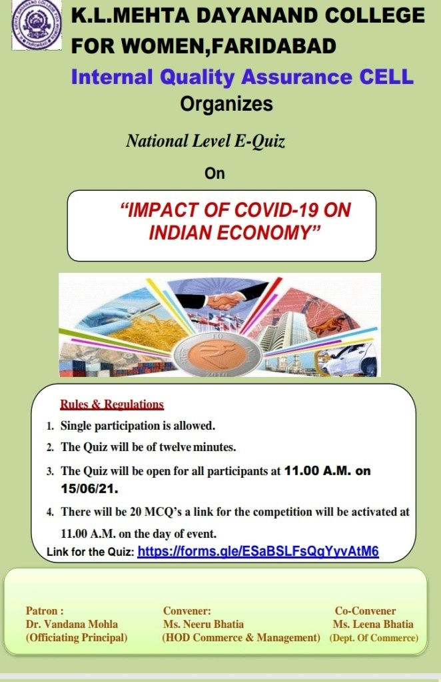 | 